Your Name
Instructor Name
Course Number
Date

Geography: World Fresh Water Supply
The naturally occurring water is regarded as the freshwater, which does not include brackish and seawater. Water acquired through icebergs, ponds, glaciers, streams, rivers, and lakes are freshwater. Though the freshwater easily becomes polluted through human activities because of some naturally occurring processes such as erosions. Freshwater is the major source for the survival of all the living beings, although some of the organisms can thrive on the saltwater, although majority mammals and plants require fresh water to survive.

Introduction
Recently the most sensitive subject which is discussed commonly is the dwindling water supply of the world but it is not completely accurate. The water amount is not reducing but the demand for water is constantly increasing. As it is estimated that the population of the world is currently almost 6 million which is going to double in 2050(Water: Lots More Information | HowStuffWorks). Furthermore, drinkable and clean water is continuously decreasing due to pollution. Acquiring fresh and drinkable water in industrialized countries is much easier and it is inexpensive as well. But freshwater is not distributed evenly all over the world. It is reported by the World Business Council for Sustainable Development that almost half of the water supply of the world is based on only nine countries, which include Brazil, Columbia, United States, India, Canada, Russia, Congo, Indonesia, and China. The urban areas require more water beyond their fundamental requirements, which is sanitation and drinking. But in the undeveloped countries, due to overpopulation, several people even do not have access to the basic requirements.
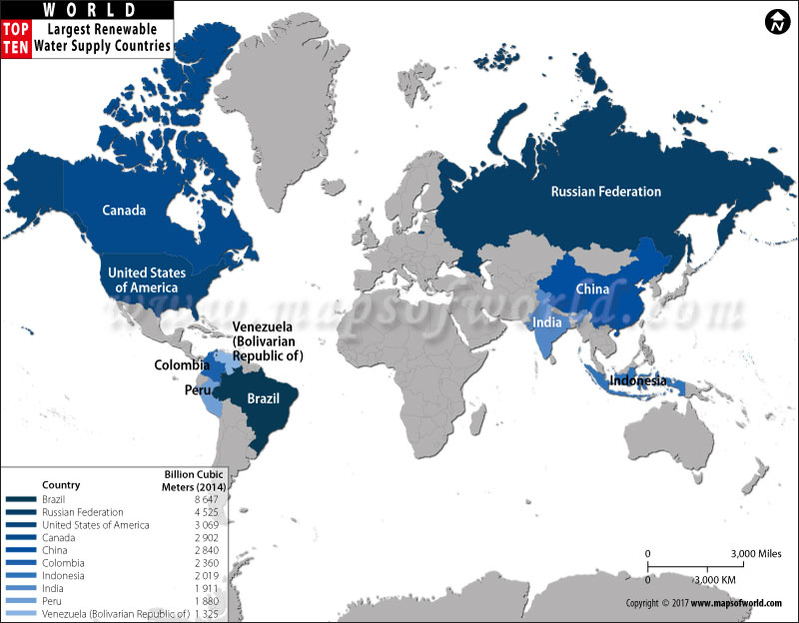
Figure 1. Major Water Supply Countries
Issue of Water Distribution
The issue of water distribution is based on economic development, wealth and political boundaries. For example, in Mexico City, almost 9% of the total population utilizes 75% of the water and because of the crumbling infrastructure means that over half of the water during supply lost through evaporation and leakages(Water: Lots More Information | HowStuffWorks). Another reason is the rapid increase in population, in most of the developing countries, clean water is not enough to fulfill their basic requirements as well as they cannot afford the necessary supply infrastructure(“How Water Works”). For instance, it is reported by WHO that most of the people in China suffer from freshwater shortage as well as most of the underground rivers and lakes are polluted(How the World Health Organization Works | HowStuffWorks). Almost 700 million Chinese have access to water that does not fulfill the standards set by WHO. The Middle Eastern countries utilized the least amount of water each person as there are very few freshwater natural resources. In comparison to the Middle East, the United States utilizes a higher amount of water. It is reported that in 2002, per person in the U.S. used almost 60,000 cubic feet water(“How Water Works”). Although even in the United States, there are regions and states which does not contain enough water supply according to their population. The Florida coastal region has saltwater in a huge amount that the freshwater pipes are entered through the land area that resulted in political disputes on the water supply control.
About 97% of the earth is covered by saline, while only 3% is based on freshwater; it implies that freshwater has a low concentration of dissolved solids and salts. Almost 69% is based on icecaps and glaciers, while the other 30% is the groundwater, which is held at underground rock crevices and soil and the remaining 1% is based on the other sources and surface water. The 87% of the surface water consists of lakes, 11% in swamps and only 2% rivers(“The World’s Fresh Water Sources”).
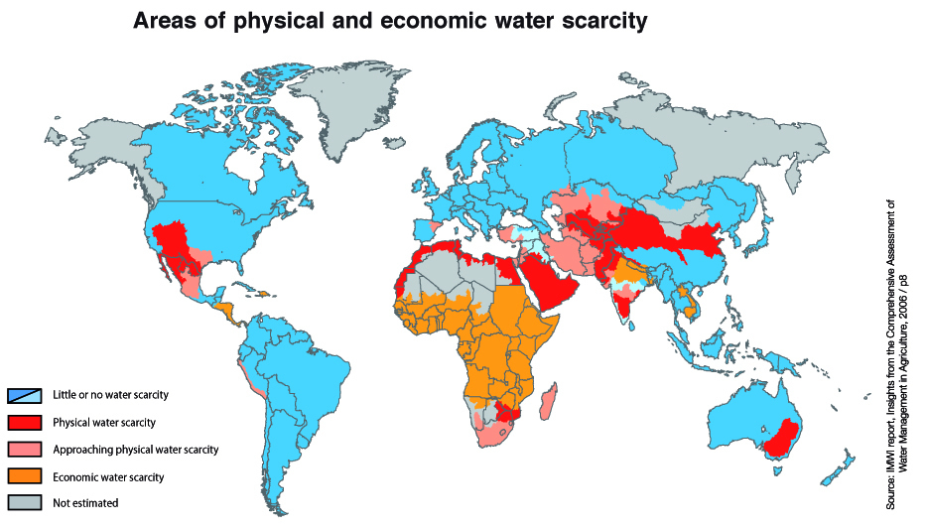
Figure 2. Water Scarcity Representation of Countries
The water is supplied to the commercial organization, public utilities, and through individuals by the system of pipes and pumps. According to UNICEF, it is reported that in 2010, almost 56% population of the world have access to the piped supply of water by house connections. Although 13% do not have access to these sources as they mostly utilize unprotected springs, wells, canals, rivers, and lakes to fulfill their water requirements. Particularly, clean water is the one which is not polluted from fecal matters which is the most important requirement for public health. The destruction of sanitation infrastructure and water supply happened due to the major floods, war and earthquakes posed the major threats which produce severe diseases that are even life-threatening. Water can be acquired through various locations after proper treatment which includes surface water, groundwater, and seawater after the treatment of desalination. The steps for the water treatment consist of purification, fluoridation, and chlorination. This treated water then flowed through gravity and pumped towards the reservoir. The sewage water after treatment can be used for industrial purposes and irrigation.
Geographical Coverage
Various water utilities gave services in the single city, municipality, and town. Although, in various countries, municipalities are further associated with regional, multi-jurisdictional and inter-municipal utilities that benefit through the scale of economies. In the U.S. it has taken the special purpose districts forms that might have individual taxing authority. The example of it is WASA, the Washington D.C. utility services as well as Maryland State various localities. In Wales and England, the sewage and water supply is supplied through almost ten companies of the region. Few of the smaller countries such as the developed one have service providers who provide services in the whole country or major towns and cities. Most of the national service providers are located in Central America and West Africa but also present in Jordan, Tunisia, and Uruguay. In the rural areas, water is not usually provided through utilities but from the organizations based on the community that mostly covers various villages. The 90% of the urban sanitation services and water supply are handled through the public sector which is owned by the local authorities and state. In low and middle-income countries, such publicly managed and owned water providers might be inefficient because of political interference which leads to low productivity of labor and over-staffing. The reason that we are still facing issues in acquiring clean water, as well as sanitation, represents that the authorities of public water were not working well. Although some model the best public management form. According to the former PM of Japan, "Public water services currently provide more than 90 percent of water supply in the world. Modest improvement in public water operators will have an immense impact on the global provision of services."
The government must make arrangements for both the private and public utilities which could take various forms. The governance should define relationships among service providers, regulatory entities and customers. The financial autonomy of the service providers must also be determined for maintaining assets and for providing high-quality services. The system of water supply must be covered through ICS (International Classification of Standards)(Kurian and McCarney).
Conclusion
The water resources are irregularly distributed in time and space due to under pressure political interference and changes in major population’s results in the increased demand for water. The access towards reliable data on the quantity, quality, and variability of water considered as the necessary foundation of the water resources sound management. Also, it is noticed that the freshwater resources distribution required political commitment. It is also required to make better decisions based on the management of water resources.

Work Cited
How the World Health Organization Works | HowStuffWorks. https://health.howstuffworks.com/medicine/healthcare/who.htm. Accessed 2 Dec. 2019.
“How Water Works.” HowStuffWorks, 18 Oct. 2007, https://science.howstuffworks.com/environmental/earth/geophysics/h2o.htm.
Kurian, Mathew, and Patricia McCarney, editors. Peri-Urban Water and Sanitation Services: Policy, Planning, and Method. Springer Netherlands, 2010. www.springer.com, doi:10.1007/978-90-481-9425-4.
“The World’s Fresh Water Sources.” The 71 Percent, 23 July 2017, https://www.the71percent.org/the-worlds-fresh-water-sources/.
Water: Lots More Information | HowStuffWorks. https://science.howstuffworks.com/environmental/earth/geophysics/h2o8.htm#Cossi. Accessed 2 Dec. 2019.

