Authentication
[Author Name(s), First M. Last, Omit Titles and Degrees]
[Institutional Affiliation(s)]

Author Note
[Include any grant/funding information and a complete correspondence address.]

Authentication
Password manager is an encoded digital arch that stores the login information used to access websites, apps, and other services. If we use the same login information at multiple websites, a network breach can make them all susceptible, and easy passwords are not problematic to break. A password manager solves all such problems by creating unguessable and complex passwords for your accounts. It saves them all in an encoded vault and fills login forms for the client automatically (Seitz, 2018). There are many password management applications available, and I am choosing two to discuss:
1) LastPass
2) Dashlane

Features of LastPass
- Stores unlimited logins
- Automatic form completion
- Generates security breach alerts
- Generates strong passwords: can change old passwords automatically, and change multiple passwords at once
- Offers free version
- Base price beyond free: $36 per year
- It works with Windows, Linux, MacOS, Android, iPad, iPhone. Internet Explorer, Chrome, Safari, Firefox, Edge, and Opera.
- One-to-one sharing
- Secure notes
- Multi-factor authentication
- LastPass Authenticator
- Dark web scan
- Credit monitoring

Features of LastPass Dashlane
- One-click password generation: It can automatically change old passwords, and change multiple passwords at once
- Automatic form completion
- Digital wallet feature
- Offers free version
- Base price beyond free: $59.88 per year
- Ability to store notes for future reference
- Receipt capture
- Inbox scan
- Dark web scan
- VPNs
- Credit monitoring
- Generates security breach alerts
- Identity theft insurance
- It works with Windows, Linux, MacOS, iOS, Android, iPad, iPhone. Internet Explorer, Chrome, Safari, Firefox, Edge, and Opera.
Both tools are easy to use, but I found that Dashlane automatically logs into my web domains much normally than LastPass, and because of VPN, Dashlane is very easy to use. On the other hand, LastPass halts the browser, stops processing scripts, and constantly fails to save changes to the arch.
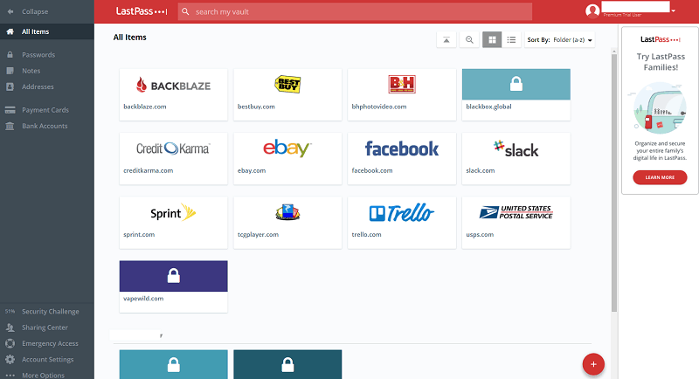
Figure 1: LastPass interface
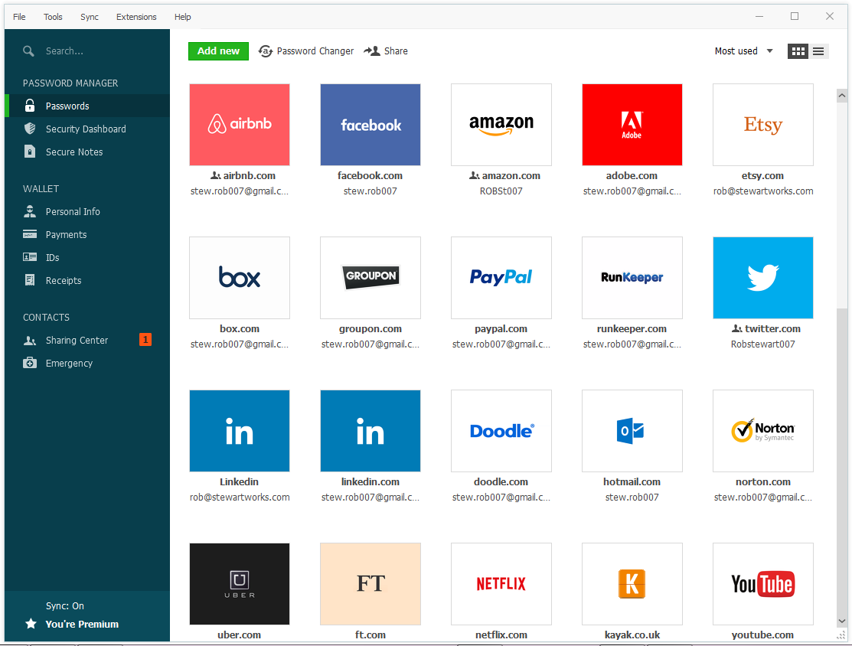
Figure 2: Dashlane interface
In September 2019, LastPass announced that its servers experienced a hack or intrusion. Tavis Ormandy, who is a security investigator for Google’s Project Zero, described the nature of the issue is architectural, that it would need substantial time to solve, but the company resolved this problem before known publicly (Ellis, 2019). In the world of internet, security issues occur frequently, and we need a password manager to cater this problem. Although a Password management application breach also occurs but not regularly. They are a source of security of passwords, and I still recommend select one of the secure password management systems to make your accounts secure.

References
Ellis, W. (2019, September 11). Are Password Protectors Safe? List of Every Major Breach. Retrieved from privacyaustralia.net: https://privacyaustralia.net/are-password-protectors-safe/
Seitz, T. (2018, April 26). Supporting Users in Password Authentication with Persuasive Design. Tobias Seitz.

