[Author’s Name]
[Subject]
[Date]

Iterative Evolution
Iterative evolution A recurrent evolution of parallel or analogous structures in the growth of the same focal line. Studies have shown many examples from the record of iterative evolution. The evolutionary obscurantism is perhaps owed to the superseding morphogenetic regulation applied by specific regulatory genes. Evolution is a process of variations among populations that occur through a process of natural selection (Neumuller and Smears). Genetic drift is a process that occurs on variations. It was believed that genes that are most surviving in nature would be able to grow and selected for natural selection (Neumuller and Smears). Various studies have shown that iterative evolution involved the development of parallel structures, for example, Aldabra Rail was a species that got extinct and disappeared and shockingly it appeared (Zhao et al.). Therefore, supporting the evidence that iterative evolution is true.
Evolutionary studies have evaluated fossils and identified that various species that extinct some in previous eras may have developed in the same locations with identical features (Slater). It is assumed that evolution is a process that occurs through natural selection whereas iterative evolution is coming back of similar species in the same locations (Neumuller and Smears). The phenomenon needs to be evaluated of assessed through processes or theories however, it needs an ancestral origin (Neumuller and Smears). This concept needs to appraised based on evolutionary processes and theoretical evaluation (Neumuller and Smears). Several theories have been assessed to observe the changes and variations among species that occurred through evolution. An infrequent procedure that comprises the evolution of a sorts' analogous structures from similar ancestral ancestries however at changed times (Neumuller and Smears). This shows that subsequently a species is acknowledged as vanished, a novel species may perhaps appear in the same place with tremendously similar features (Zhao et al.). This shows that the phenomenon needs an identical ancestry.
Various contradictions occur in the theory of iterative evolution such as it needs an identical or common ancestor whereas studies have proved that there is no similar or common ancestor for species (Zhao et al.). The singular problem existing in accomplishing the true existence of these ideas has a concept of common ancestor however, it has been also observed that several species may also exist to support the idea of iterative evolution (Psillos and Kariotoglou). This is, therefore, an evolution that still needs further investigation and examination at a different level to completely support the idea and concept if iterative evolution.
Aldabra Rail was evolved from a species twice named white-throated rail that became the ancestor. It took 20000 years for the Rail to redeveloped into a new species and evolved from this species (Neumuller and Smears). De-extinction is a process of extinction of a species but has a concept of re evolving from ancestors (Neumuller and Smears). Similarly, cloning is a scientifically defined process for the breeding of selective genes of species (Psillos and Kariotoglou).
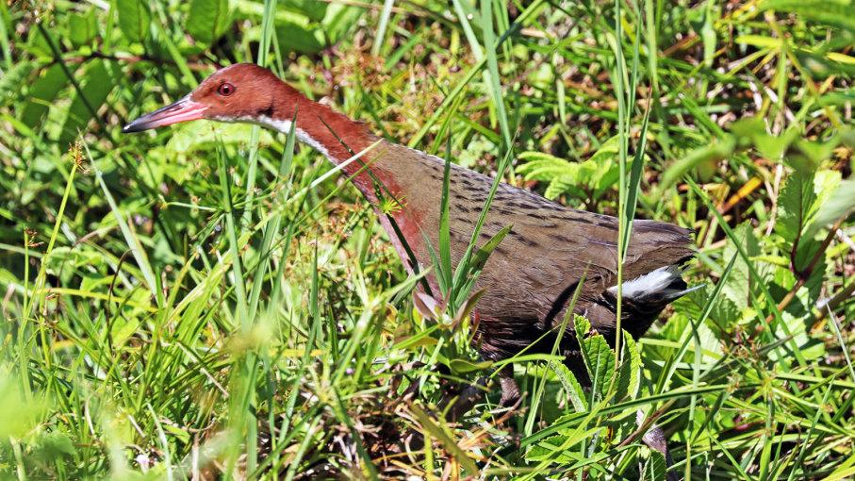
Figure 1 Albara Rail
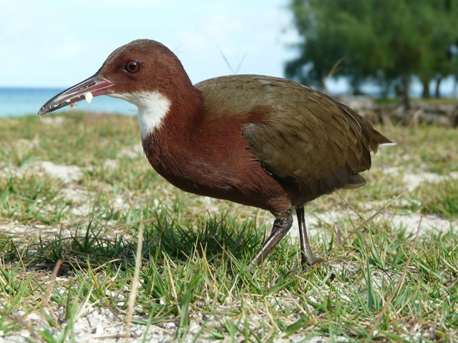
Figure 2 Albara Rail
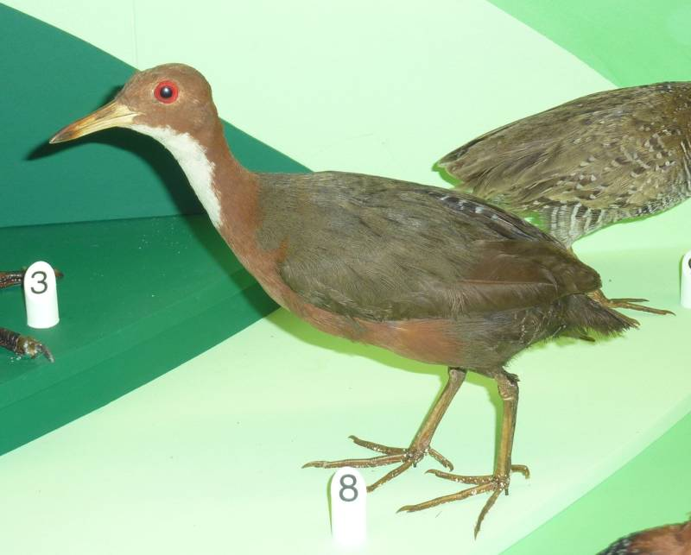
Figure 3White Throated rail
The development of similar structures or species is a process that is common with de-extinction (Neumuller and Smears). The process of iterative evolution does not exist in the laboratories as the process needs an ancestor and selection of species randomly (Neumuller and Smears). The other theory that supports the iterative evolution is the reappearance of species de-extinction. Further research is strongly recommended in the repetitive discipline to evaluate and appraise the process of iterative evolution.
The theories have been assessed to perceive the changes and variations among species that occurred through evolution (Neumuller and Smears). An occasional technique that comprises of the evolution of a species' analogous structures from the similar ancestral ancestries through at changing times. This shows that subsequently a species is acknowledged as vanished, a novel species may conceivably appear in the same place with tremendously similar features. This displays that the phenomenon needs an identical ancestry (Zhao et al.). However, the concept of a common ancestor is not proved yet. The difficulty with this iterative evolution theory is that it needs a common ancestor (Psillos and Kariotoglou). No common ancestor of any creature has ever been found. The knowledge is pure assumption and unsubstantiated extrapolation from exponents of evolution, who do not understand what the given definition can or cannot lead to - what their claims about the process would look like in reality (Neumuller and Smears). Hence, studies have evaluated the concept of various theories that favor and support the evidence of iterative evolution.
Conclusion
Several theories still denied the concept of iterative evolution however, studies have shown that the knowledge of iterative evolution is vast, extensive and controversial among various researchers (Neumuller and Smears). Therefore, iterative evolution needs further detailed analysis of the analogous structures and evolution processes need to be studied in-depth to understand the concept of iterative evolution (Neumuller and Smears). The concept of evolution as a process of variations among populations that occur through a process of natural selection is identical with iterative evolution which also exists on natural selection (Neumuller and Smears). Genetic drift was the other process that occurs on variations of genes. It was believed that genes that are most surviving in nature would be able to grow and selected for natural selection and is the reason to promote the concept of iterative evolution (Neumuller and Smears). Various researchers have shown that iterative evolution involved the development of parallel structures, for example, Aldabra Rail was an example of a species that got extinct and disappeared and outrageously it achieved the iterative evolution (Zhao et al.). Therefore, supporting the evidence that iterative evolution is true.
Work Cited
Neumuller, Martin, and Iain Smears. “Time-Parallel Iterative Solvers for Parabolic Evolution Equations.” SIAM Journal on Scientific Computing, vol. 41, no. 1, 2019, pp. C28–51.
Psillos, Dimitris, and Petros Kariotoglou. Iterative Desing of Teaching-Learning Sequences. Springer, 2016.
Slater, Graham J. “Iterative Adaptive Radiations of Fossil Canids Show No Evidence for Diversity-Dependent Trait Evolution.” Proceedings of the National Academy of Sciences, vol. 112, no. 16, 2015, pp. 4897–902.
Zhao, Liutao, et al. “Iterative Evolution of Feature Space in Text Classification.” 2015 8th International Congress on Image and Signal Processing (CISP), IEEE, 2015, pp. 1210–14.
(Mancini, Mark. “Iterative Evolution: Did the Aldabra Rail Evolve Twice?” HowStuffWorks Science, HowStuffWorks, 31 May 2019, science.howstuffworks.com/life/evolution/iterative-evolution.htm.)
(Irving, Michael. “Extinct Bird Resurrected as Evolution Starts over Again.” New Atlas, 13 May 2019, newatlas.com/extinct-bird-reappears-iterative-evolution/59639/.)
(“The“The Bird That Came Back from the Dead.” ScienceDaily, ScienceDaily, 9 May 2019, www.sciencedaily.com/releases/2019/05/190509101916.htm.)

