Lab Report
Student’s Name
Institution
Date

Introduction
The wet acid deposits known as acid rain in meteorology is regarded as the fallout from the soil particles. The rain is regarded as acidic when the pH content is less than 5.1. In a normal situation, the pH value normally consists of distilled water, and dust and therefore, pH value range between 5.1 and 6.5. Under this condition, the water will be declared acidic. The purpose of this experiment is to determine the acidity of the environment using the rain gathered from the environment. This study focus on the rain gathered from Sarasota County to investigate the presence or absence of acid rain within Sarasota County. The report, therefore, contains the materials and methods applied, result and raw data obtained from the study, graph and the data summary.
Materials and methods
The experiment was conducted using gathered water from Sarasota County. The data used for the experiment was obtained through sarasota.wateratlas. The components were selected, and the data generated in excel which was then analyzed to determine the acidity content of the water. The selection and analysis of the data were based on Near Real-Time Data, Water Atlas, Water Body Type, and Parameter. The water body used was Stream, and parameter pH and the Sarasota County Water Atlas.
Result and Raw Data
The result of the study indicates a unique trend. Based on the analysis of the data, the result shows that the pH value of water changes based on the time, Actual Latitude, Actual Longitude, Date, and Time. It is established that when the time changes the pH value of water also changes as well. As illustrated in Table 1 below, the pH of the stream water used changes based on the time which the sample was take\n. It also indicates that the pH increases as time goes.
Actual Latitude | Actual Longitude | Sample Date | Parameter | Result Value
27.04512 | -82.4193 | 3/3/2005 10:45 | pH | 7.43
27.04512 | -82.4193 | 3/3/2005 11:00 | pH | 7.45
27.04512 | -82.4193 | 3/3/2005 11:15 | pH | 7.47
27.04512 | -82.4193 | 3/3/2005 11:30 | pH | 7.48
27.04512 | -82.4193 | 3/3/2005 11:45 | pH | 7.49
27.04512 | -82.4193 | 3/3/2005 12:00 | pH | 7.53
27.04512 | -82.4193 | 3/3/2005 12:15 | pH | 7.57
27.04512 | -82.4193 | 3/3/2005 12:30 | pH | 7.57
27.04512 | -82.4193 | 3/3/2005 12:45 | pH | 7.53
27.04512 | -82.4193 | 3/3/2005 13:00 | pH | 7.55
27.04512 | -82.4193 | 3/3/2005 13:15 | pH | 7.61
27.04512 | -82.4193 | 3/3/2005 13:30 | pH | 7.63
27.04512 | -82.4193 | 3/3/2005 13:45 | pH | 7.65
27.04512 | -82.4193 | 3/3/2005 14:00 | pH | 7.6
27.04512 | -82.4193 | 3/3/2005 14:15 | pH | 7.69
27.04512 | -82.4193 | 3/3/2005 14:30 | pH | 7.59
27.04512 | -82.4193 | 3/3/2005 14:45 | pH | 7.71
27.04512 | -82.4193 | 3/3/2005 15:00 | pH | 7.74
27.04512 | -82.4193 | 3/3/2005 15:15 | pH | 7.75
27.04512 | -82.4193 | 3/3/2005 15:30 | pH | 7.75
27.04512 | -82.4193 | 3/3/2005 15:45 | pH | 7.77
27.04512 | -82.4193 | 3/3/2005 16:00 | pH | 7.78
27.04512 | -82.4193 | 3/3/2005 16:15 | pH | 7.78

Table 1: the result of the experiment (ph Value)
Graph
In the graph1 below, it is illustrated that the pH value of the Alligator Creek decreases day by day and hour to hour. It can be concluded that as the day goes the water gets polluted and therefore, the ph level of water increases as well. The pH level of Alligator Creek on 4/1/2005 is different from the pH value of the Alligator Creek on 10/1/2005, which is a clear indication of the change of pH level water on a daily basis.
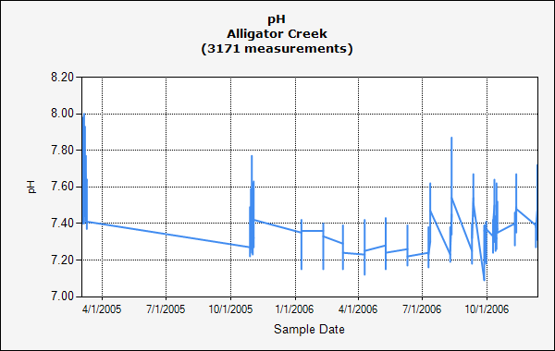
Graph 1: pH value
Summary
The data collected from the Sarasota Country Water Atlas indicates that the pH level of the Alligator Creek has decreased over a period of time. The analysis of the trend line of the data from 2005 to 2006 indicates a clear decline in the pH value which means that there is acidification of the water body. However, a deep analysis of the day by day pH value indicates that the data does not seem too different day to day or hour to an hour and therefore, it shows that there is a fall after a long term of pH concentration. It is also established that the acidity of the water bodies in Sarasota County decreases as the time goes in a day. It means that in the early days, the water is more acidic and the acidity decline towards the end of the day. This could be as a result of several factors such as human activities such as pollution and other activities.
In the early days, there are little human activities such as air pollution, erosion of soil from the agricultural industry, fossil gas and other gases produced as a result of human activities. This means that human plays a major impact on the change of pH level of the water body as the day goes and hour to hour. The change of pH value hour to an hour could be a result of industrial activities in the region. Industries produce gases such as nitrogen which mixed with water to increase the acidity of water. With the high increase of production the pH level of water increases and therefore, the water becomes more acidic.
However, there are government regulations which are required to be complied with to help in reducing the number of gases produced. First, people are required to use green energy which does not produce gases. Industries are also required to reduce the dependency on fossil and other nonrenewable energies to help in reducing the producing of gases such as nitrogen to the atmosphere, which in return pollute the water bodies, hence increase the acidic content of the water.

