Title page
Labs

Lab 1 Living in carbon world
1A: Trace pathway of carbon from atmosphere into tress
Carbon that plants receive is transmitted from atmosphere. Carbon is released to the forest through a biological process. Photosynthesis is the initial step by which plants capture carbon dioxide and then transforms it to organic molecules. These molecules act as building components for the growth of plants. Carbon molecules is existing in the dry biomass of plants. Carbon molecules are stored in biomass as plants grow. In trees carbon is used for the development of new biomass. Biomass is connected to the roots, stems and branches. Mitochondria decomposes the organic material that releases carbon dioxide to the atmosphere. Even when plant dies the carbon is locked in the soil that survive for hundred and thousands of years.
1B: Carbon in local trees
I conducted the experiment of measuring carbon dioxide in the three local trees. The trees are quite young.
Trees | D | a | b | M(kg)=aD^{b} | Kg of carbon
Red Maple | 9.5 | 0.09 | 2.51 | 25.9 | 13.5
Sugar Maple | 9.5 | 0.09 | 2.51 | 25.9 | 13.5
American basswood | 12.5 | 0.09 | 2.59 | 65.5 | 34.5

1C: Carbon compound transformation
I have done vinegar experiment for findings the presence of carbon. By adding some amount of vinegar to the baking soda I observed fizzing occurred. This confirmed the presence of carbon dioxide. I passed the straw from the hole of jar cap to an empty glass. When I poured some vinegar and spoon of baking soda in the jar, CO₂ gas passed from the straw to empty glass. Carbon dioxide is heavier than air so it stayed in the glass.
1D: Carbon and fossil fuel
I watched a video on YouTube shared by National Geography that explains how human activities are changing the chemical composition of the atmosphere. The video depicts that increased reliance of the society on fossil fuels is releasing toxic gases in the environment that include carbon dioxide, nitrous oxides, methane and chloroflouro-carbons. These are known as greenhouse gases and constantly heats the temperature. As more heat is entrapped in greenhouse gases, the temperature of earth continues to increase. The graph reveals that human activities such as burning of fossil fuels by industries for generating energy has released large amount of carbon dioxide. The warming of planet is due to release of greenhouse gases in atmosphere. The changes in climate is affecting every aspects of human life such as food, health and weather.
https://www.youtube.com/watch?v=G4H1N_yXBiA

Lab 2 Carbon on move
2A: Forest carbon cycle
I learned that food webs and carbon cycle are closely linked to each other. Photosynthesis transmit carbon molecules to grass. Every living being contain carbon. Primary consumers eat carbon that is transmitted through food webs. I examined a rabbit eating grass is also consuming carbon. This indicates that carbon has moved through food webs. Carbon leaves animal body through respiration only when they die and after that it decomposes. Decomposition is the process that transmits carbon from dead organic matter to the forests. This reveals that carbon can move from decomposed matter.
2B: Global carbon cycle
Carbon is abundant in the universe that moves freely across reservoir. Rocks have stored massive amount of carbon while the remaining carbon is in the atmosphere, oceans, soil, plants and fossil fuels. Caron is released from reservoir through carbon cycle that are working to prevent earth’s carbon for getting to the atmosphere. Warmer interglacial periods and changes in the earth’s temperature have increased the rate of carbon cycle that were responsible for maintaining balance. At faster rates these cycles more 10¹⁶ to 10¹⁷ grams of carbon each year. This means that the rates are increasing that is threatening for the earth.
2C: Carbon cycle feedbacks
The interconnectedness of the earth system indicates that changes in any single component of earth’s climate system will affect the level of earth’s equilibrium. Feedback loops explain effects that trigger or initiate changes to the climate system. This indicates that changes in any part of carbon cycle system are linked to other parts. A positive feedback loop works when change occurs in the same direction. While a negative feedback loop works in opposite direction. This indicates that chances in carbon cycles are linked.
Lab 3 Carbon in atmosphere
3A: Carbon is a gas
The compounds that exist in atmosphere and have relationship with greenhouse effect include carbon dioxide (64%), Methane (17%), other gases (12%), Nitrous oxide (6%) and Fluorinated gases (1%). This indicates that the largest compound is carbon that with other gases is trapped in earth’s atmosphere. These gases are non-reactive with each other but get energy in the form of heat from sun. Human activities accelerate the release of greenhouse gases.

3B: My life story
The graph shows how relationship between carbon dioxide and ice ages changed throughout history. Comparing the period from 800,000 to 100,000 depicts that the level of CO₂ didn’t changed significantly. Only slight changes are noted with respect to ice ages this is because the glaciers were not melting at excessive rates as they are now. While in 2018 the level of carbon dioxide is raised at the rate of 407.8 ppm on average. This reflects massive increase in the release of carbon dioxide. This reveals that the changes in the levels of CO₂ occurred mostly in the last 50 years.
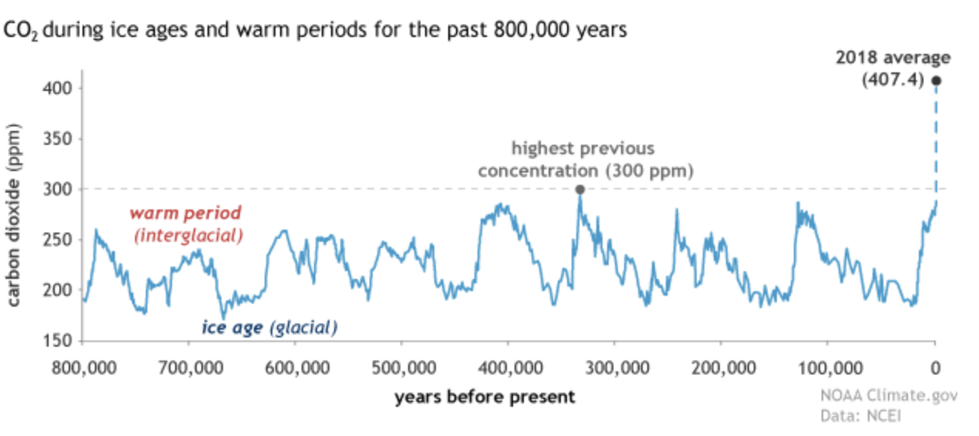
3C: Keeping track of CO₂ in todays atmosphere
The recent data on CO₂ levels depicts that it has risen at a constant rate. The graph depicts the changes in the level of carbon dioxide from 1980 to 2020. There have in consistent rise in the level of carbon dioxide. While peak is reached at 2020. This is due to the negative impacts of human activities such as burning of fossil fuels and deforestation. Current trends also suggest further increase in the CO₂ level. Massive changes are recorded in current period compared to three million years ago. This is also due to the fact that increase in temperatures has caused melting of glaciers.
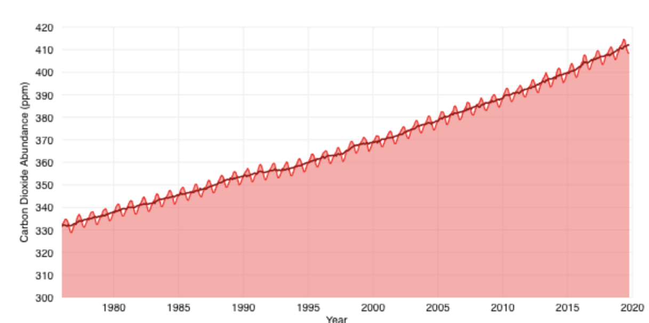
Lab 4 Deforestation and the climate cycle
4A: Changes in forest cover
I viewed the video on deforestation in Amazon rainforest published posted by BBC. Amazon is the largest tropical forest in the world that contain millions of trees. While deforestation was controlled by the law enforcement after environmental advocates raised concerns for saving planet. Forest loss is a significant problem because each year hundreds of trees are burned. Amazon rainforest fire of 2019 caused death of numerous trees. This is the planet’s largest source for biodiversity but under threats due to the production of soy. It is also possible that the land will loss much of its trees for soy production. The food we eat threatens the Amazon forests because it is predicted that much of the land covered will lose its trees.
It is possible to stop the deforestation of amazon by Inga tree also known as miracle tree (Cockburn, 2019). These trees can grow in poor soil resulting from the slash and burned land. These trees enhance soil fertility and help growth and survival of other species. The trees not only save the forest but will also provide food for the community. Evidence has suggested that these trees are effective source for fixing nitrogen in the soil and also provide nutrients to the plants. These trees will save ecosystems and play crucial role in saving the forests.
Ouro Verde (Green Gold) Institute suggested burning farming methods can be adopted for offering corridors for the wildlife in Amazon. The institute has also taken initiative for setting more Inga trees.
https://www.bbc.com/news/world-latin-america-49971563

4B: Global forest watch
Global Forest Watch will be used for researching changes based on the research questions.
Lab 5 Soil and the carbon cycle
5A: Soil, carbon and microns
Soils play significant role in carbon cycles. Living organisms and bacteria takes in carbon including plants. Photosynthesis is the process by which carbon dioxide is released in the atmosphere. As plants grow, shoots and roots and created that fall and become organic matter for the soils. Microbes get food from this dead organic matter that created carbon dioxide by respiration. Burning of plants and soils is causes release of carbon dioxide in the atmosphere. Soil carbon exists in the form of biomass and non-biomass. Biomass contains fungi and bacteria while non-biomass include starch, cellulose and lignin in the dead plants. Biological activity of soil organisms such as microbes causes soil respiration which is used for measuring carbon dioxide flus such as μmol CO₂ m⁻ ² s⁻ ¹.
The experiment on soil respiration reveals that two main sources of CO₂ in soil are;
- Organic matter decomposed by microbes.
- Respiration of microbes (rhizosphere).
The amount of carbon contained by soil is 3200 Pg which is greater than its amount in atmosphere. Carbon released by Rs is -78 Pg that is greater than what is released by fossil fuels. Non-steady chamber method is used for estimating soil respiration. The principle states that the concentration of CO₂ rises inside chamber and no significant changes are observed due to the external environmental conditions.

5B: Permafrost; frozen soil staring to thaw
I learned that frozen soil unbalances carbon cycle. This is because carbon is transferred from permafrost soils to microbes. Large carbon reservoir is stored in permafrost that returns through sedimentation and burial. Soils are identified as the largest sources for storing carbon. Approximately 9 percent of the earth’s land is covered by permafrost. Permafrost stores the carbon that is released from terrestrial vegetation. Climate changes impact permafrost slowly so removal of carbon from atmosphere takes longer duration (Gibson, Estop-Aragonés, Flannigan, Thompson, & Olefeldt, 2019).
Lab 6 Oceans and carbon cycle
6A: Down to deep- The ocean’s biological pump
The three methods used by oceans for absorbing carbon include physical carbon pump, biological carbon pump and carbonate pump.
- Physical carbon pump: This works when the warm water from oceanic surface reaches the high latitudes and cools down which makes it heavy to sink below surface layer. Cooling of seawater requires more carbon dioxide. Vertical mechanism assures the exchange of carbon dioxide with the ocean’s and earth’s atmosphere. This indicates that vertical mechanism acted as carbon pump.
- Biological carbon pump: It is a process used by ocean for storing carbon dioxide. Microscopic phytoplankton takes carbon dioxide and water that is transmitted to glucose and oxygen. Phytoplankton grows due to availability of adequate nutrients. Carbon is taken back to water by respiration of bacteria.
- Carbonate pump: Organisms like plankton make contain carbonate. Cycling of organic matter reseals carbon dioxide.
Marine food webs including microbes and plankton are responsible for moving carbon from atmosphere to water. These organisms decompose matter and releases carbon dioxide after receiving sunlight. Fishes consuming them goes to water and transmit CO₂.
6B: Phytoplankton- The ocean’s green machines
Phytoplankton serves as food webs for the aquatic life. They rely on microscopic organisms for food. Small fish eat plants that are eaten by big whales. Powerful biotoxins are also produced by some species of phytoplankton causes algal blooms. Photosynthesis is the process by which phytoplankton consume carbon dioxide on a very large scale. On their deaths some amount of carbon is transmitted to the layers of ocean when other creatures eat them. Large amount of carbon is moved from atmosphere to oceans by phytoplankton. A large quantity of carbon dioxide reaches near-water surface when phytoplankton decomposes.
Biogeochemical cycles explain the process stating that carbon and nitrogen cycles are interdependent. Large amount of nitrogen is present in the atmosphere that is useless until it is converted to other nitrogen compounds such as ammonia. This process is nitrogen fixation. Human activities have changed natural balance of carbon cycle that also affects nitrogen cycle. Nitrogen cycle starts with nitrogen gas that is vital for decomposition of microorganisms. Marine organisms can only use nitrogen when it is broken into various compounds. This allow them to take nitrogen to ocean.
Lab 7 Ocean acidification
7A: CO₂ and ocean pH-what’s the connection?
I performed the experiment for testing effects of increased amount of CO_{s} on PH. The relationship of carbon dioxide with PH is assessed from the period of 1958 to 2018. The level of carbon has increased consistently with every passing year (Boyd, 2000). The time series graph indicates that carbon dioxide has also influenced the PH level. When CO_{s} has reached the level of 400 ppm the PH has increased to 8.33. This indicates that the highest PH recorded for the changes in carbon dioxide is below 10.
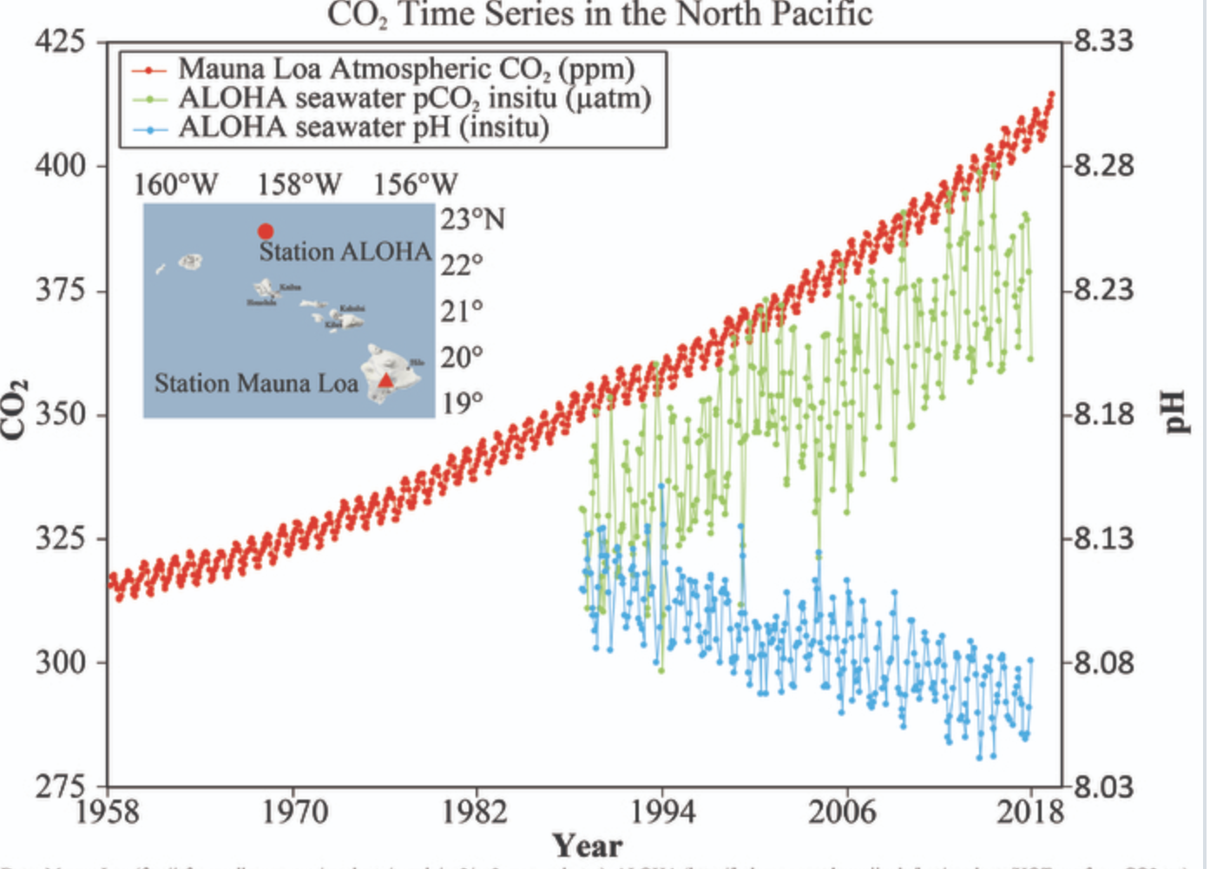

7B: Ocean acidification-A risky shell game?
Woods Hole Oceangraphic Institute conducted research for determining the effect of ocean acidification on marine organisms. The research depicts that by ocean acidification the amount of ocean’s PH is lowered that is due to the increase in the concentration of hydrogen ions. The rate of PH on the scale declines significantly (WHOI, 2019). The effects of acidic seawater were observed on sea urchin larvae. The findings depicts that the changes in the rate of PH affected the growth. Sea urchin’s growth was reduced.

Organism | PH | CO₂ PPM | Response
Sea Urchin | 7.25 | 350 PPM | Reduced growth

Lab 8 Slowing down an amplifying greenhouse effect
8A: Using technology to reduce CO₂ in the atmosphere
- The idea of father for the science project was to use show how carbon dioxide is absorbed from air.
- It was focused on proving that carbon dioxide is present in the air that can be utilized by the process of photosynthesis.
- The experiment started by keeping a potted healthy plant near the window in the room.
- The plant was kept in the dark for 3 days.
- A wide-mouthed bottle was taken that had a cork. The cork was split to half.
- 5-10 millimeters of hydroxide solution was added to the bottle. The amount of carbon dioxide present in the bottle was absorbed by this solution.
- One leaf was put inside the bottled by passing half part from cork. The remaining portion was outside. Grease was applied around the cork for ensuring no air entered the bottle.
- The plant was kept in sunlight for 4 hours and the leaf was then taken out of the bottle and put in iodine solution.
- The color of the leaf didn’t changed that was inside the bottle. This shows that without carbon the color of the leaf didn’t change.
8B: Evaluating CO₂ reducing technology
I still believe that “Green technology for construction” could be effective strategy for mitigating the risks of greenhouse gas emission and global warming. The concept of green building can focus on constructing by choosing sustainable features. Green technology can improve the buildings and cause fewer damages to the environment. The purpose is to utilize resources efficiently that will help in saving money. Emissions of toxic gases can be reduced that will help in mitigating the risks of global warming. By implementation of green technology and geothermal systems it is possible to control carbon dioxide emission.
There are some pros of green technology that include; minimization of degradation of environment, promotion of healthy environment, helps in conservation of energy and water resources. By controlling negative human activities such as increased reliance of fossil fuels and cutting of plants it will minimize emission of carbon dioxide. The effects of global warming are also slowed.
The potential disadvantages of sucking carbon from atmosphere will have “negative emissions”. Critics state that this technology will destabilize climate and is a source of serious distraction. There also implications of failing to attain the agenda further pose challenges for the environmentalists. The projects of green technology also involve high costs.

Lab 9 Food and climate change
9.1: Understanding global climate change and food systems

Optional Video Assignment: Understanding the Science of Global Climate Change

- Which video did you watch?
  - Climate Change: Lines of Evidence

- What did you learn from that video that was new information to you?
The video reveals the factors that are leading to climate changes such as increase in temperatures due to human activities such as increased use of fossil fuel and deforestation.

- What did you think was persuasive about the video?
The most persuasive about the video is use of effective graphics and reliable data. It has explained changes in weather at different seasons such as winter, summer and spring.

- Reorganize the items below into the correct timeline that considers both cause and effect as well as the sequential timing of events. Insert the letters for each item into the table below to organize the items into a logical order from left to right.
Millions of years ago
Present day
 | B | D | E | C | A

- Carbon dioxide is a heat trapping, greenhouse gas, so increasing concentrations of CO₂ in the atmosphere result in rising global temperatures.
- Ancient plants and animals die and are buried deep beneath the Earth’s surface trapping carbon.
- Increasing temperatures from increasing concentrations of carbon dioxide in the atmosphere can result in more extreme weather events, including droughts and flooding, rising sea level, and melting of ice caps and glaciers.
- Buried remains of ancient plants and animals are subjected to intense heat and pressure beneath the Earth’s surface that transform the remains into what we now call fossil fuels or hydrocarbons (large molecules made up of hydrogen and carbon atoms that contain large amounts of chemical energy).
- Population growth combined with industrialization results in increased burning of fossil fuels, which releases increasing amounts of carbon dioxide into the atmosphere.
- Humans begin mining and drilling for fossil fuels, including coal, oil and natural gas, to burn them and transform the stored chemical energy into useful heat and mechanical energy.

9.2: Food production in changing climate

Question: What are some of the challenges that farmers will face in a changing climate?
The challenges that farmers face include; increased temperatures that will affect yield of crop. Heat stress can damage cop production. Floods and droughts also pose challenges.
Questions
Inspect Figure 9.2.5 above. Which crops' yields have already been most affected by climate change, and which crops the least?

The yield of corn was reduced to amore larger extent compared to wheat in China and Brazil. Rice yield was not much affected.
What are some possible reasons for the difference in yield impact between corn, wheat, and rice that you see in Figure 9.2.5?
The most important factor that impacted yield include increased temperature due to global warming.
Summative assessments

Part 1: Exploring the National Climate Change Viewer

The parts of US that are expected to experience greater changes between 2050-2074 due to climate change are Boston, Miami, Washington and Ottawa.

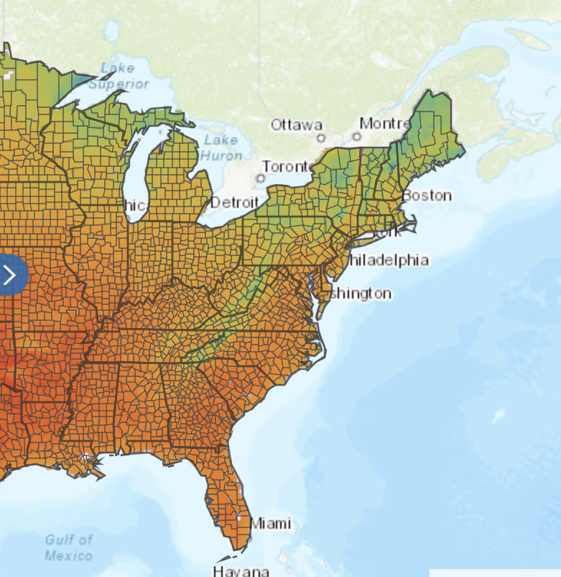

2) Which regions will dry?
The regions that are expected to dry the most include Chicago, Milwaukee, Kentucky and Indiana. This is because the color has changed to extreme dry.
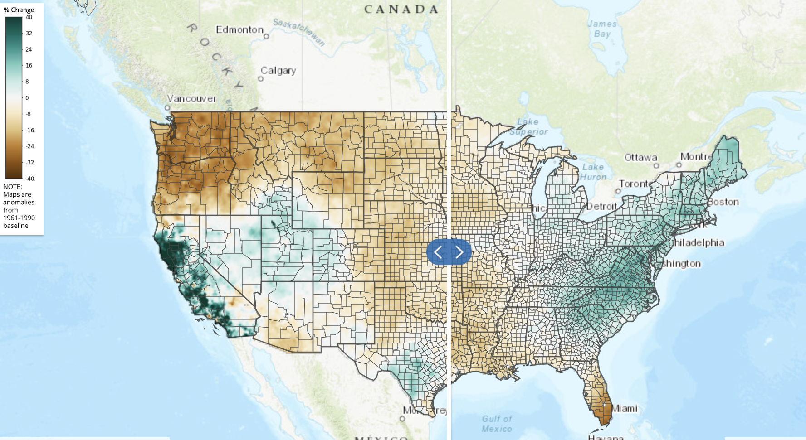
- In January Louisiana, Texas, Arkansas and Mississippi with experience less runoff. While the runoff will reduce in the preceding months.
4)By turning the variable to snow on the map it is determined that the areas that will fall in snowpack category include San Francisco, San Diego, North Pacific and Nebraska because temperature will fall to 0 degrees.

5) The map of climate shortage depicts that the states that will face this issue include Louisiana, Texas, Oklahoma, Kansas, parts of Missouri and Nebraska, Iowa and Minnesota. Climate variability is causing these changes.
6) Six variables that reveals greater changes in growing season include maximum temperature, precipitation, run-off, snowpack, soli shortage and evaporative deficit.

Part 2: Exploring climate predictions for your capstone region
- The key factors that will change the climate include variation in temperature, changes in soil storage and amount of water in snowpack. The USGC site has identified the variable that is temperature. US climate resilience toolkit depicts that the maximum temperature is 115⁰ Fahrenheit. Temperature changes have been viewed from 2019 to onwards. The changes in the earth’s temperature are threatening the climate sustainability.
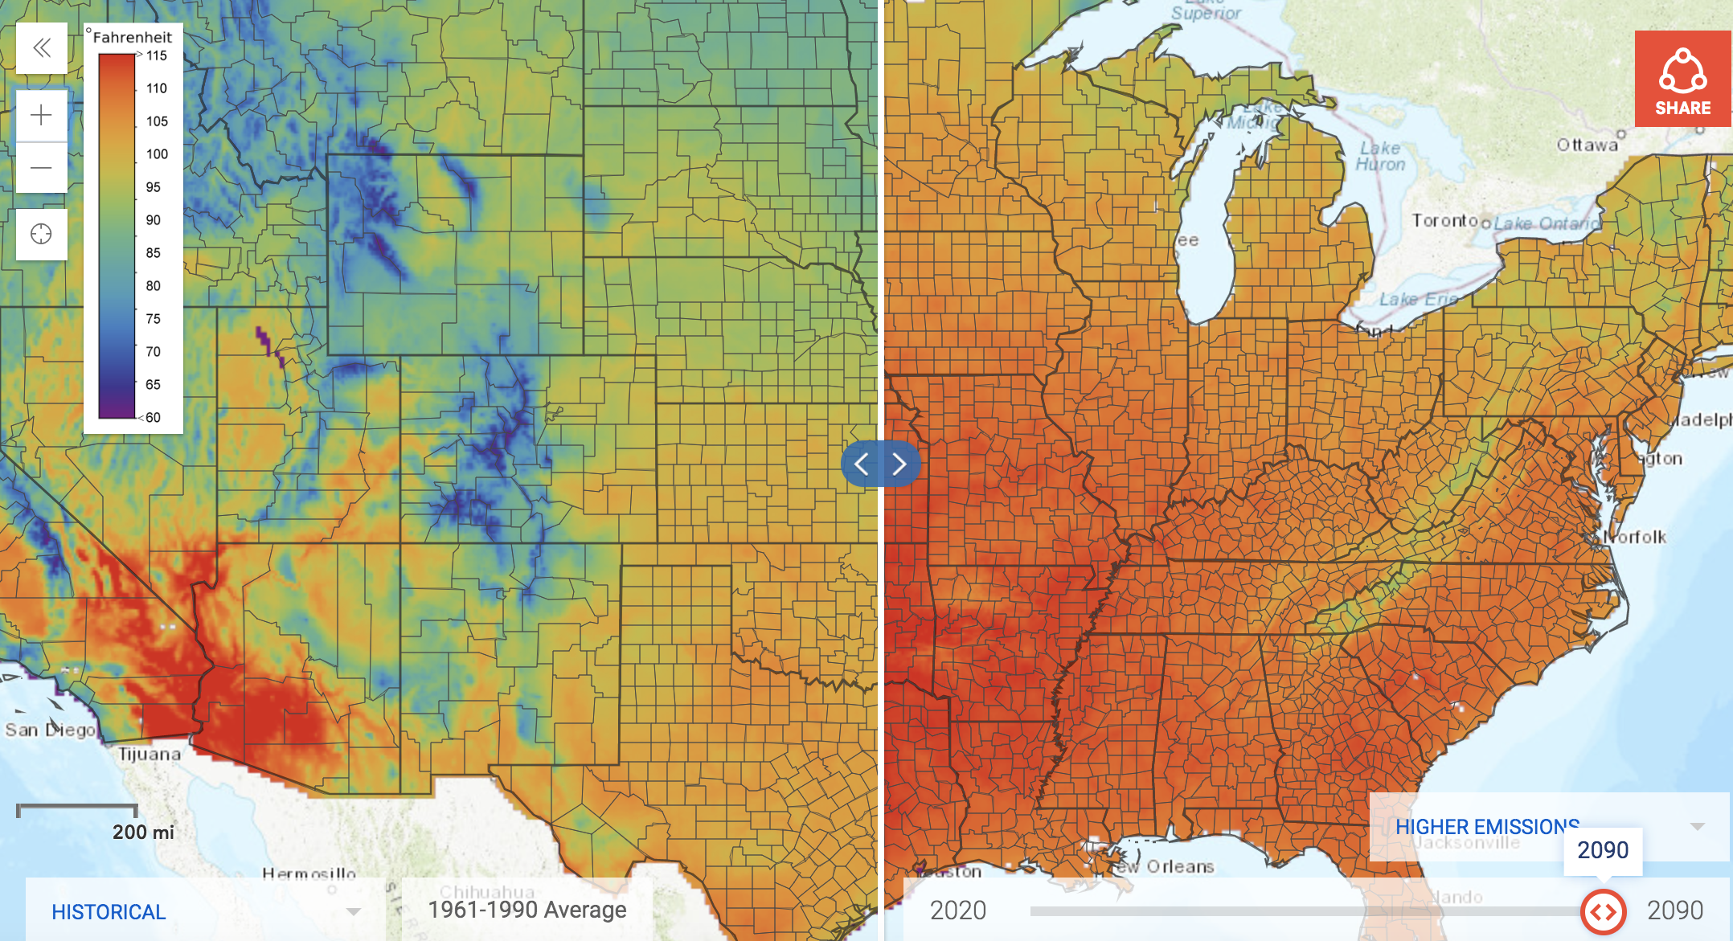

- The analysis also depicts that changes in the climate will also affect crop yield. Global warming has adversely impacted the agriculture. Yields of rice, maize and wheat are declined globally. Increase in temperatures increases risks of droughts, flooding and pest diseases that directly affect crop production. Due to melting of ice at rapid rates, resulting from global warming the precipitation has also increased. The changing dynamics of the climate also depicts future risks of drying lands.
- I have learned that farmers can adapt to climate change by diversification of crop rotation, integrating livestock by choosing efficient crop production system and enhancing the quality of soil. Adoption of effective irrigation techniques can be practical way of mitigating such risks. The video reveals that famers could succeed even in uncertain climates. I learned the benefits of misting systems and wind machines. Frost protection is also an appropriate method for dealing with climate uncertainties. Forage gives the opportunity of protecting resources in winter when they face high risks of extreme precipitation. By considering the varieties of crop that are more suitable and adaptable the farmers can minimize loss of weather changes.

References

BBC. (2019). Amazon fires: What's the latest in Brazil? . Retrieved 12 15, 2019, from https://www.bbc.com/news/world-latin-america-49971563
Boyd, C. E. (2000). pH, Carbon Dioxide, and Alkalinity . Water Quality , 105-122.
Cockburn, H. (2019). Amazon deforestation could be stopped by ‘miracle tree’ . Retrieved 12 16, 2019, from https://www.independent.co.uk/environment/amazon-burning-rainforest-inga-tree-climate-crisis-fires-deforestation-a9174566.html
Gibson, C. M., Estop-Aragonés, C., Flannigan, M., Thompson, D. K., & Olefeldt, D. (2019). Increased deep soil respiration detected despite reduced overall respiration in permafrost peat plateaus following wildfire. Environmental Research Letters , 14 (12).

WHOI. (2019). Ocean Acidification. Retrieved 12 16, 2019, from https://www.whoi.edu/know-your-ocean/ocean-topics/ocean-chemistry/ocean-acidification/faqs-about-ocean-acidification/
YouTube. (2011). Deforestation in the Amazon Rainforest . Retrieved 12 15, 2019, from https://www.youtube.com/watch?v=rm8TyJ2fOaw

