Title: Assignment 1: Planning your work
Student name: Luna
Professor name:
Course title: CIS210
Date:

Project I: Writing project
Duration: 1 week

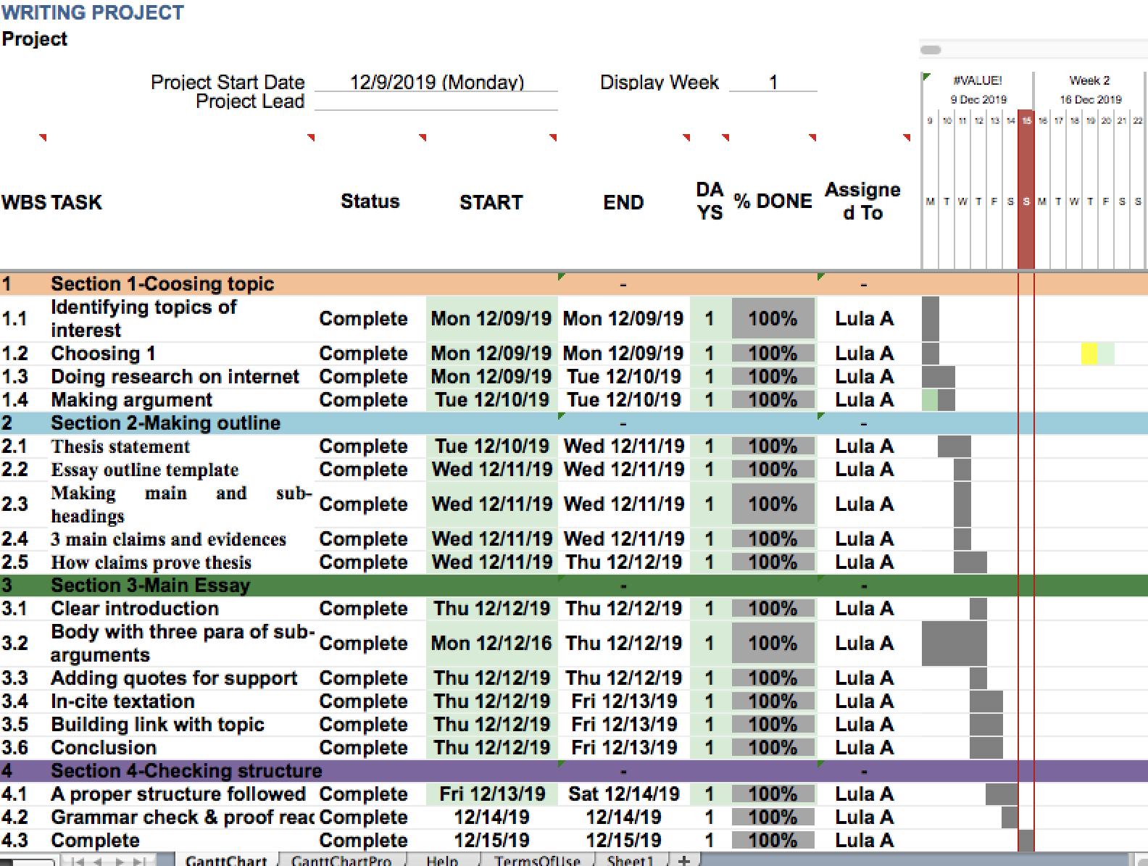

Project II: Winter shopping
Duration: 1 week
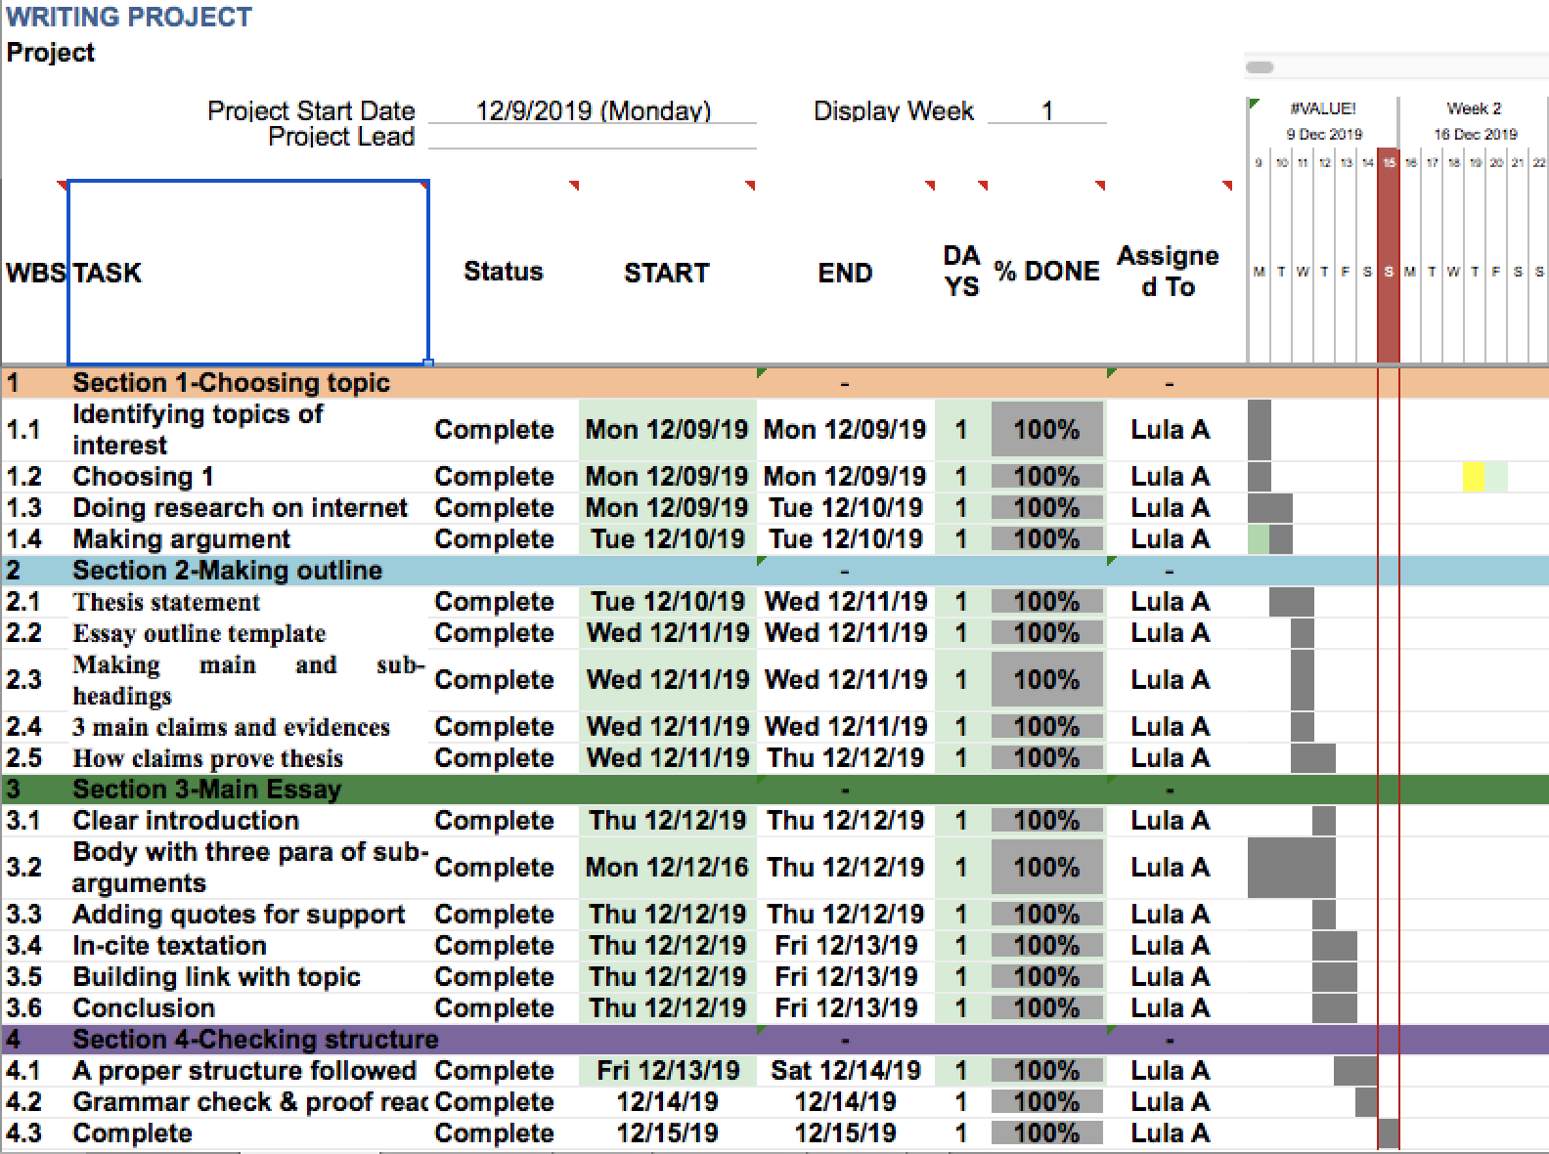

Project III: Communication course
Duration: 1 week

