Compensation Plan
Tracy (First M. Last)
School or Institution Name (University at Place or Town, State)

Compensation Pie Chart
The compensation plan shows how the compensation is distributed among different elements of the compensation plan. To illustrate the division of the total compensation plan, the circular graph pie chart is used, it is divided into different slices and illustrates a numerical portion to show the quality it represents. The compensation plan is divided into different sections each category has an intended purpose. The pie chart is made by giving priority to the different portions of the compensation plan elements for instance salary is the major portion, then benefits, then perquisites and then some other rewards based on the performance (“The_Most_Important_Compensation_Plan.pdf,” n.d.).
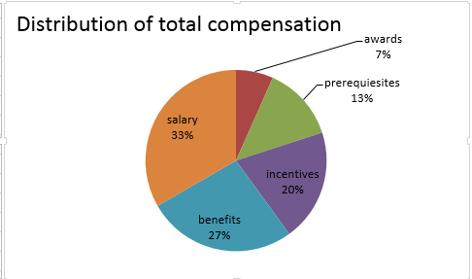

Implementation Plan

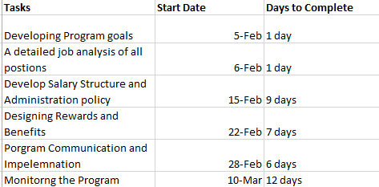

The successful implementation of the plan is an essential step in achieving the performance-based objectives from a total compensation plan. Failure to successfully implement the program negates all of the hard work that is put in crafting the best plan for employees. For this purpose, the compensation plan implementation can be divided in to certain steps such as developing program goals, doing a detailed job analysis, develop salary structure for all the employees, designing rewards and benefits for employees, implementation of program and monitoring and evaluation (“The Total Compensation Plan – Human Resources in the Food Service and Hospitality Industry,” n.d.). Along with all the steps the leadership must be informed about the strategic pay decisions. The final program must also be communicated to the employees and managers for any adjustments, approval, and review. The presentation can be made to managers and employees. The dates and deadlines set for the implementation of the program must be followed to achieve the desired results. In addition, several cultural, legal and other constraints must be accommodated before the implementation of the plan (Misra & Nair, 2011).
.
The benefits of total Compensation Plan
The total compensation management program identifies the desired behaviors and which are required to meet the specific business needs, and it drives employees towards those behaviors (Weldon, 2012). The total compensation plan assesses the business needs and set goals which an organization wants to achieve at the bottom line. The total compensation plans align the business goals with the performance, and it acts as a behavior-driven strategy. Unlike another simple compensation plan it is not an after-the-fact rewards strategy (Weldon, 2012). An effective total compensation plan supports all the levels of an organization, and at the end of the day it helps in retention of quality employees and stimulates results-oriented behaviors in an organization. Total compensation plan creates satisfaction which is then linked with the satisfaction which can be a factor for work motivation (Ghazanfar, Chuanmin, Khan, & Bashir, 2011). Studies reveal that work motivation is affected by the satisfaction employee gains from the compensation plans of an organization (Ghazanfar et al., 2011).
The success of the Compensation Plan
The factors that can reveal the success and effectiveness of a compensation plan involves finance data. Different financial elements such as payout vs. budget can be monitored to look if the plan is financially on track or not. In addition employee performance and retention is also an effective measure of the compensation plan as the plan is linked to employee satisfaction and good performance (Ghazanfar et al., 2011). Another way of looking at the effectiveness of the plan is looking at the targets if the plan has achievable targets and is employees are able to achieve those targets or not. An effective compensation plan also enforces the strategy, it motivates the right behavior among employees, and if the plan is contributing towards right behavior, then it is doing an effective job. Employee behavior and positive results can be evaluated by using survey and little research. Owners and companies must comprehend that there
is a straight link between reasonable total compensation and improved revenues (Phonsanam, 2010). The effective compensation plan leads to monetary and non-monetary rewards, if the plan is rewarding company then the plan can be declared as effective.

References
Ghazanfar, F., Chuanmin, S., Khan, M. M., & Bashir, M. (2011). A study of relationship between satisfaction with compensation and work motivation. International Journal of Business and Social Science, 2(1).
Ju, S., Kong, L., Hussin, Z. H., & Jusoff, K. (2009). The influence of employee benefits towards organizational commitment. Asian Social Science, 4(8), 147.
Misra, S., & Nair, H. S. (2011). A structural model of sales-force compensation dynamics: Estimation and field implementation. Quantitative Marketing and Economics, 9(3), 211–257.
Phonsanam, S. T. (2010). Total compensation practices and their relationship to hospitality employee retention.
The_Most_Important_Compensation_Plan.pdf. (n.d.). Retrieved from http://cdn2.hubspot.net/hub/436298/file-2343957472-pdf/The_Most_Important_Compensation_Plan.pdf?t=1423266810626
Weldon, D. (2012). Linking total compensation to performance. Compensation & Benefits Review, 44(3), 149–153.

