Project Paper

[Name of the Writer]
[Name of the Institution]

Project Paper

Introduction
Labor relations have always been challenging in most parts of the world as different countries impose different laws and regulations on labors. It is a field which discusses human relations with regard to the work they are doing, and the questions which arise in case of social inequality. These rules are determined while defining labor relations such as the type of physical work, number of hours required, amount of remuneration, degree of psychological strain, autonomy and freedom to work. If any of these things are disturbed, so would the relation with the subsequent country. This essay would discuss and provide an in-depth analysis of a current labor event in Mexico while comparing it with the labor relations in the United States. The context of this paper would also consist of Saint Leo’s University (SLU) core value of community. Providing an analysis of labor relations between both countries would help identify and evaluate the specific problem which exists for both countries, such as strikes formation.

Discussion
Workers strike at Mexico Plant
The labor relations in Mexico are governed by The Mexican Federal Labor Law and the Mexican Social Security Law according to the Article 123 Mexican Constitution (Teichman, 2018). Most countries in the world often face strikes formation accompanied by different factory workers or government workers. This type of situation where extreme conflicts arise due to social inequality is usually handled by the Federal Law that is governed by the state at the time. As for Mexico, it’s social inequality for labors has always stayed amongst the most impoverished countries which have the most labor issues in the world. Thus, the current happening within the Mexican border analysis a strike formation of over 40 percent of the total workers at San Luis Potosi, Mexico who also walked out. The company called the Goodyear’s that deal with tire manufacturing had workers stage a one day strike that was probably due to the average pay per day and the negotiation of a contract.
The average pay that is provided to employees working in San Luis Potosi is 210 pesos which makes a roughly amount of 2 U.S. dollars per day. Moreover, there are poor working conditions, and no average employee intends to stay at the plant for than three months. The contract with the company was made without any negotiation or vote from the employees. With a medium to large scale company consisting of 1,000 to 1,500 employees, Goodyear should not be making such inaccuracies. Instead what they should be doing is building strong relation and communication with the employees. To accommodate or solve such labor strike formation and issues, either the company or the Federal Law has to intervene (Zlolniski, 2018). One of the ways in which the company could resolve these issues is to provide a minimum wage of 9.62 dollars per day and an annual bonus of 1,650 dollars according to the bargaining committee made by the elected Union leaders.
As far as the health and working conditions are concerned, the company would have to provide a basic health plan to all of its employees and implement a safety inspection program once in a while after every few weeks so that no problems can be found. A company that huge which functions on over 1 million square feet of land and produces 6 million tires should be adequately managing employee appraisals and satisfactory issues. Either the company would resolve this issue, or the Federal Labor Law would have to intervene which would directly lead with the functions of labor unions and labor courts. In the Mexican labor market, a company requires a "just cause" to terminate an employee on the ground. Any unfair dismissal can be brought down to the country's labor court. The worker would either get reinstated or compensated for the position which they held.
SLU Core Value
Moreover, the labor laws in Mexico constitute a “just cause” of dismissal which is stated as either the death of a worker, worker disability, completion of a contract, company bankruptcy, etc. For this particular situation where a strike formation is being held, the company would have to negotiate bargaining terms as they are considered to be the most competitive in the Mexican market. The company or the Federal Law would have to provide a minimum wage, adequate working conditions, health insurances and plans for the employees. SLU also discusses and emphasizes the core value of community through developing a hospitable approach towards communities. They put more focus on belongingness, independence, and unity. Thus, mutual trust and respect is created amongst the social environment in which employees are working. This challenge brings a change within the workforce and allows them to learn, serve, and listen through clearing any inequalities found in the workplace.
Steel worker’s strike at Trump’s Steel Resurgence
As for the United States, all the major labor events and structures are handled by The Department of Labor's Office and the Labor-Management Reporting and Disclosure Act (LMRDA). These laws affect and manage all the labor across the United States and enact basic fiscal and democratic structures to control employees all over the private and government industries. The United States compared with that of Mexico's labor market consist of a "bill of rights" for workers, the disclosure of any labor practices, rules established for employees, and safeguarding their interests (Katz, Kochan, & Colvin, 2017). Some of these provisions are not recognized in Mexico and therefore represents a difference between the labor events occurring in the US and the events happening in Mexico. There are many different boards which manage labor markets all across the United States and also handle disputes over social inequalities.
This aforementioned labor relations criteria enlists all the rights and duties for employees, employers, and different labor unions across the U.S. The purpose of creating a labor relations department is to increase the bargaining power for employees in terms of getting better jobs, gaining equality in jobs, and most importantly organizing labor unions for a collective bargaining effort. Over 16,000 steelworkers went on strike concerning contracts disputes, and this could have hindered the “thriving” industry in the U.S. The workers on strike complained about the flexibility of their contracts and the money that is being generated by the company out of which they are paying an unrealistic amount to the labor. Due to the tariffs imposed on key allies such as Mexico, the imports for steel and aluminum have been hindered.
The difference between the labor relations in the U.S. with that of Mexico is not similar in terms of the wages and the extent of social inequality which happens with employees and workers in Mexico. To some extent, it is unfair to say that only the workers in the United States suffer because the workers in Mexico are deprived of all essential aspects such as health, working conditions, inequality, wages, etc. The labor relations in the U.S. shows a better bargaining power because of the various worker's laws such as the bills of rights, fair elections for union officers, etc. These laws are not found for Mexican workers. Americans are more manageable when it comes to unionized employment situations, and it involves different sorts of discipline such as law, economics, science, etc.
The United States handle labor relations in a different way. Mostly through federal agencies such as the National Labor Relations Board, National Mediation Board, and FLRA. All of these agencies safeguard the interests of labors in the U.S. labor market. The same attribute is hard to locate in Mexico as most of the private sector companies are not regulated and there is a difference between the government styles. Most communities in America offer labors with a spirit of belongingness, independence, and unity which is why their firm's productivity is double the percentage of that in any other continent. Workers find themselves in improbable situations where they deem to be treated unequal or biased in terms of wages as those are adequate (White, 2016). So to talk about a comparison between the labor relations between the U.S. and Mexico, there is a huge difference. The bargaining power of labors in America is more than that found in the alternate country.
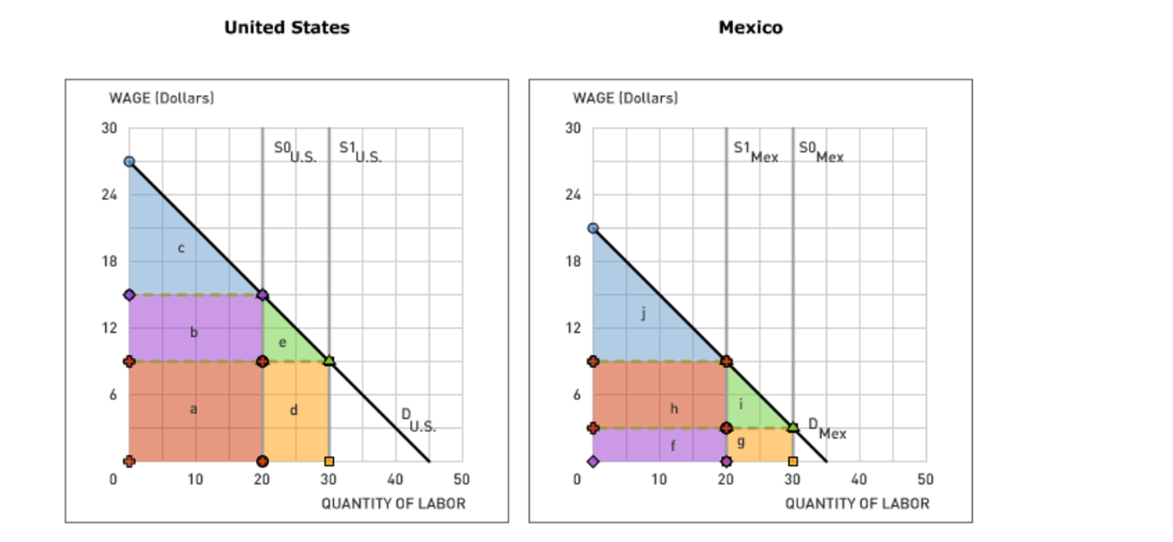
Conclusion
The aforementioned in-depth analysis based on the two countries labor relations and the disturbing events involving strike formations provides an overview of the countries labor research. The discussion shows that Mexico is more likely to have more labor strikes then that held in America due to the government structure and the social inequalities found within the private sector companies. Workers in Mexico struggle more while finding equality and decent wages. Moreover, the working conditions for workers in Mexico are also inadequate. Comparing these factors with the United States, labor relations here are more confronting then those seen in Mexico. There are many government and private agencies which often resolve labor disputes promptly and stop them from becoming a huge deal. Somewhat in Mexico, companies often leave labor disputes to the government to solve. Employees feel more secure and equal in America, and this is the meaningful comparison between both labor markets.

References

Katz, H. C., Kochan, T. A., & Colvin, A. J. (2017). An Introduction to US Collective Bargaining and Labor Relations. Cornell University Press.
Teichman, J. (2018). Economic restructuring, state-labor relations, and the transformation of Mexican corporatism. In Neoliberalism Revisited (pp. 149-166). Routledge.
White, A. (2016). The last great strike: Little Steel, the CIO, and the struggle for labor rights in New Deal America. Univ of California Press.
Zlolniski, C. (2018). Coping with precarity: subsistence, labor, and community politics among farmworkers in northern Mexico. Dialectical Anthropology, 1-16.

