Wee2_Mark
[Author Name(s), First M. Last, Omit Titles and Degrees]
[Institutional Affiliation(s)]

Author Note
[Include any grant/funding information and a complete correspondence address.]

Wee2_Mark
Dimensions of CSVs
There are seven different dimensions of CSVs which are listed below.
- Individualism | - Masculinity | - Power Distance | - Uncertainty Avoidance
- Long Term Orientation | - Indulgence | - Pragmatic Outlook

All of the above listed dimensions of CSVs have specific details and explanations. For example, in the Individualism, The high score is that the society expects an individual to take higher responsibility for oneself and family. While in the Low Score, one’s life is intertwined with a huge and large cohesive group (Barry, 2017). The description of each dimension is covered in the following graph.
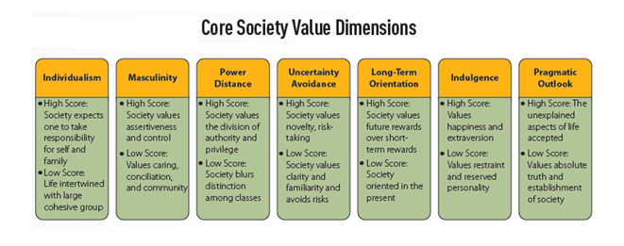
Nine Nations of America
The Nine Nations of America or The Nine Nations of North America is a book that is written by Joel Garreau. In this book, the author makes the suggestion that America or North America can be divided into nine nations that have different cultural and economic features. This work of the author is known as “a classic text on the current regionalization of North America”.
The New England
This nation differs from my nation in almost more than a single way. The very basic thing in which it differs is its location and region that is composed of six states while. While the other things or factors include the economic condition of New England and the economic condition of state I am a part of and living in. Furthermore, the social patterns also one of the crucial factors that differs from the state of New England from mine.

References
Barry, J. B., (2017). CB ISBN: 9781337469951. Retrieved 15 January 2020, from https://www.amazon.com/CB-Book-Only-Barry-Babin/dp/1305577140

