Last, First Name BIO 309,
Spring 2019
Project # 6 Neurotoxin
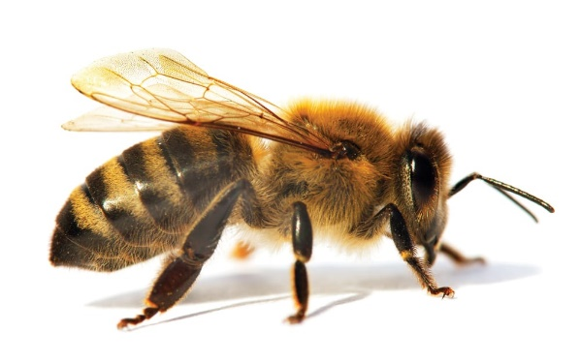
Apamin
General Information
- Apamin is a natural decapeptide of 18 amino acids collected from western honey bee venom (Apis mellifera).
- Apamin is widely known for its ability to block the ion type of channel that facilitates the selective streaming of K+ channels out of the nerves.
- Contains primarily alpha-helix and beta-turns
- Its extracted from the other components through chromatography and gel filtration.
Honey Bee facts
- The bee sting, which leads to infection with apamin has a burning pain with swelling and later leads to the area of bite turning red.
- Apamin infection has a high possibility of leading to throat and tongue swelling. Some levels of difficulty in breathing may follow.

Specific effects.

- Apamin blocks K+ channel through the allosteric mechanism when apamin binds away the channel pore resulting in a change in the channel shape, hence leading to a block.
- Neuronal excitability is experienced due to the K+ channel blockade affecting the brain and the spinal cord. The neurotoxic effects recorded leads to convulsion in rats.
- The K+ channel flow is selectively affected due to the permeability of the different membranes with smooth muscles being more vulnerable.
- Facilitates the transition of the hyperpolarizing membrane into a calcium-dependent depolarization by blocking the K+ channel and allowing Ca²⁺ ions channel through the membrane.
- There are peripheral dysfunctions of the nerves, especially in human beings.

References

- https://doi.org/10.1016/B978-0-12-804239-7.00049-4
- https://www.sciencedaily.com/releases/2010/07/100709130831.htm
- https://www.uniprot.org/citations/2013287
- https://www.ncbi.nlm.nih.gov/pmc/articles/PMC3630120/

