Folio task Report
[Author Name(s), First M. Last, Omit Titles and Degrees]
[Institutional Affiliation(s)]

Author Note

Folio task Report

Mathematical Investigation and Analysis (1)
Here ‘a’ is negative because the curve of the bridge is in the downward direction. The value of ‘c’ is 0 to maintain the structure of the bridge. Actually, point c represents the point of intersection between the curve and y-axis, i.e. between the road and the bridge. So it has to be zero in this case.
‘a’ is less than 1 because we want to draw the parabola in downward direction according to the requirement of bridge. As stated before, if its value is greater than 1 then the parabola will open in the upward direction, hence will disturb the construction of the bridge. After finding the equation of parabola by using either method, we can determine its roots by using the quadratic formula. The vertex is the point of the parabola, which is on maximum height, and it is given in the question. The axis of symmetry can be calculated by the value of 'x' in the vertex.

Mathematical Investigation and Analysis (2)
In order to find the equation of parabola using the trial and error method, we need multiple points on it. For the calculation of this point, we can use different techniques, including different kinds of interpolation. By doing all the maths, the final equation of the parabola is given by
y = -0.001$x^{2}$ + 2.7$x$ + 0
This equation is the true depiction of the required bridge and is verified by using Desmos.
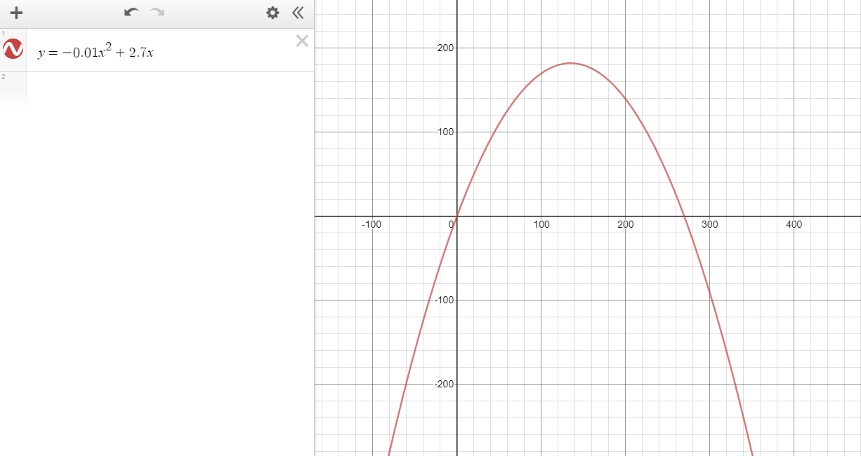Mathematical Investigation and Analysis (3)
Once we have calculated the equation of the parabola, we can find out other points of intersection between the line y=50 and the parabola by simultaneously solving the two equations. The two points of intersection are (20, 50) and (250, 50). Now to calculate the distance between the consecutive cables, we will divide the distance by 19. The distance between the consecutive cables is 12.105. Now, in order to calculate the coordinates of the cable with road, we will add 12.105 in all x- coordinates of the cables. Next, to find the coordinates of the cable with arch, we put the values of x-coordinates of all cables in parabolic equation. The length of the cable can be calculated in the following two ways.
- By subtracting the y-coordinates found in the previous step by 50.
- By using the distance formula in which the two points will be the points of intersection between the cables, roads and between the cables and the arc.

Mathematical Investigation and Analysis (4)

The reason the algebraic method is preferred over the trial and error method, in this case, is that in the former method, we need only two points in the parabola to determine its equation. However, the trial and error method demands multiple points to find the equation. To calculate the parabolic equation using algebraic, we use the following two points and the general equation.
y = a${(x-h)}^{2}$ + k
(135, 182.25) and (270,0)
Putting these two points in the equation, we will get
a = - 0.01
Hence the final equation of the parabola is
y= - 0.01 ${(x-135)}^{2}$ + 182.25

Conclusion
The similarity between the two results of both methods indicates that our analysis for the construction of bridge is true. Also, the Desmos graph approves our results.

