Jinyoung Kim
Assignment
Econ111

1a) the card is the most used payment instrument (non-cash) in number of transactions. In 2017, it accounted for more than 50% of non -cash means of payment. I quite agree with this statement, the cashless debit card when you are abroad does not allow all operations and if there is a problem with computers, we find ourselves without money. So even if banks try to dissuade their customers from using cash for their payments, they offer a lot of virtual means of payment (paypal, monéo, payment by smart phone, contactless payment cards) that we say: We must keep the possibility of paying in cash. Moreover, many merchants abroad do not have card payment terminals and only accept cash, including hotels. When possible, you should make withdrawals with your debit card. More than a prepaid debit card, this is the best way to access your money anywhere in the world.
1b) Life in Australia in 2019 is easy and at the same time difficult for the Australian people. If you have the appropriate education and experience, you can easily find a suitable job. High social security of the population, compulsory medical insurance, a decent pension, high quality food and much more - this is what attracts Russian people to this southern mainland. And therefore, those wishing to move to permanent residence in Australia in 2019 did not decrease, but, on the contrary, more and more of them appear every year. A high standard of living in Australia, without exaggeration, can be said to be the result of the development of the economy in an immaculate environment. The country has the least environmental disasters, polluted big cities and poisoned rivers. Proof of this is that the United States and many other developed countries buy milk and meat only in Australia. Thanks to this strategy, life expectancy in Australia only increases over the years.
2a) This includes the separation of social payments 80:20, while 20% go to the beneficiary's bank financial credit, and 80% to the withdrawal card, which can be used for acquires, as usual,. wherever there are outlets.
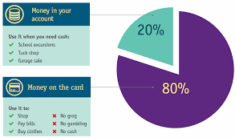
Fig,1, percentage of cashless debit card
The cash less debit card cannot be used for withdrawing cash or used in enterprises that mainly supply gaming or alcohol products. Australia has a very high level of education. Diplomas of Australian educational institutions are recognized throughout the world. Together with good conditions of study at universities, service departments are being created to help foreign students. Schools are mostly public, but there are those that are funded by various private foundations and religious organizations. There are Russian and Ukrainian schools that make life easier for Russians in Australia
.
Fig 2, The mounting human costs of the cash less debit card
2b) Yes, because delayed debiting does not present only advantages. Indeed, if you have more freedom in the management of your finances, be careful to have the necessary balance on your account at the date of deduction. Otherwise, you will have to pay a charge for payment incidents to your bank, until you have re-established the situation. Deferred debiting therefore imposes a certain rigor in the monitoring of your expenses, and a good anticipation of your cash flow.
More expensive but also more flexible, the deferred debit card allows to spread its expenses according to a debit date, usually monthly. This date can, for example, be set right after receipt of the salary, giving free rein to any purchase transaction during the month, regardless of the balance of the account. Dealer withdrawals and check payments remain debited immediately.
3) The customer cannot spend money that he is not yet have and, in this way, pay for expensive purchases without having to worry about the balance of his bank account. The deferred debit card is not a solution to the overdraft. This solution is only suitable for people who can replenish their account regularly and adequately. If the deferred debit card offers more freedoms, we can expect a severe backlash in case of impossibility of settlement at the time of maturity. If the owner does not have enough money, he or she will have to pay a fee for payment until the situation is reestablished (Donaldson, 2008).
4a) With this type of card, purchases are debited only once a month. When paying, the account is not debited immediately, but on a pre-defined date. This date can be fixed in agreement with the bank, so as to intervene only after reception of the salary for example. Given the cash facility it provides, the debit card offers credit-like operation. It allows you to spend money regardless of the balance of the account, taking advantage of a cash advance. The deferred debit card is suitable for employees receiving a regular salary, paid on a fixed date, or holders with sufficient income to periodically feed their account.
To summarize, the deferred debit card has three major advantages:
- It makes it possible to face an unforeseen expense without being immediately uncovered and forced to pay agios.
- The incumbent’s banking situation is transparent since the outstanding amount of the card, accessible via the Internet, is regularly updated.
- In case of tight cash, the holder can make a transfer from another account (eg a savings account) before being debited.
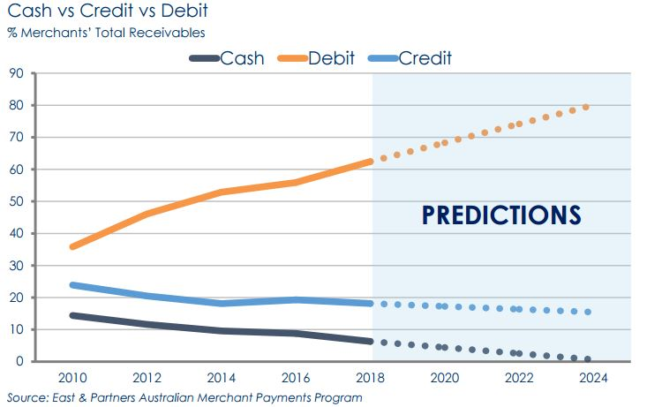
Disadvantages
The debit card is adapted to the expectations of those who wish to follow their expenses day by day. It allows having a constant visibility on the balance of a bank account; this stiffness is however a problem in case of unforeseen, and the regular use of the overdraft authorized can generate substantial costs. With this type of card, purchases are debited only once a month. When paying, the account is not debited immediately, but on a pre-defined date. This date can be fixed in agreement with the bank, so as to intervene only after reception of the salary for example.
Given the cash facility it provides, the debit card offers credit-like operation. It allows you to spend money regardless of the balance of the account, taking advantage of a cash advance (Donaldson,2008).
5a) Many criteria play on the way everyone wants to manage their cash flow. In order to meet the personal preferences of all their customers, most banks offer different types of payment cards. Thus, some cards open the possibility of an immediate debit of each expense on your statement of account when others allow a deferred debit at a fixed date every month. Finally, be aware that you can opt for a bank card with systematic authorization, which is the equivalent of the blocked package in telephony and allows you to spend without ever fearing the overdraft.
Ethical economy also believes that informational asymmetries play a significant role in the financial sector, and its participants, primarily non-professional investors and bank customers, are struggling to cope with it. The problem of discrepancies between self-interest and company’s interest is recognized as an ethical economy which is decisive, since it is this discrepancy in the functioning process that cannot be completely corrected by incentives, and it can only be weakened by special, uncorrupted incentives. It is doubtful that the use of sufficiently high economic incentives can lead to excessive motivation of market players, since financial motivation and intrinsic motivation are not the same thing. Ethical principles indicate the need to enhance the role of banks as socio-economic institutions that base their activities not only on the basis of professional enterprise, but also on ethical standards combining corporate and public interests (Wright, 2008). It seems that the principles of the Basel Accord, the economic norms recommended by it and the rules of behavior of banks should be supplemented by the norms of ethical behavior of monetary organizations. As part of reputational risks, the degree of participation of banks, in particular, in the implementation of social projects, the greening of production and regions, in the protection of consumers, should be taken into account more clearly. The unethical behavior of banks, one can bankruptcy of clients who experience problems with fulfilling their obligations to banks bordering on raiding; as well as the use by banks of informational awareness of client affairs, in particular, trade in insider information and trade secrets.
5b) In the case of a card with systematic (or prior) authorization, the debit is only possible (whether a withdrawal of cash or payment of a purchase) if the account is sufficiently stocked. This is a guarantee that can be useful if you tend to overheat the card or the card is for your child. It should be noted that this card does not necessarily prohibit overdraft facilities. In this case, the debit will be limited to the threshold stipulated by the agreement for the maximum overdraft authorized (Wright, 2008).
Mainly cashless transfer of funds allows the pensioner to save time on visiting institutions that make pension payments, and saves him from having to stand in queues to receive money. Receiving a money transfer to the card, the pensioner has the opportunity to use the full range of services provided to bank card holders. With the help of the SEC, you can perform the following actions: independently withdraw (deposit) cash at an ATM or contact a bank operator for this; transfer all funds (or part of them) from one card to another; pay for purchases directly with a card through bank terminals installed in stores and pay utility bills.
If it shouldn’t it be practical to all beneficiaries of government expenditure because the deferred debit card is not recommended for the most expensive profiles, and even on the contrary! It imposes in fact to keep rigorous accounts to ensure that the necessary amount will be available on the account at day J. Otherwise, the overdraft charges and payment incident arrive quickly and cascading. Delayed debiting is of particular interest, for someone who knows how to manage his budget but whom needs a cash advance on an exceptional basis. A bank card "with systematic authorization" or "anti-overtaking" differs from other cards on an essential criterion. It verifies, before the validation of each transaction or withdrawal, that its holder has the necessary funds on the account. Otherwise, the payment is simply rejected! The operation differs from that of a conventional card, with which the sum would have been written in overdraft and would have given rise to fees and penalties.
References
Donaldson, D (2008). Difficult to conclude’: impact of cashless debit card trial. Online available at: https://www.themandarin.com.au/95938-difficult-to-conclude-impact-of-cashless-debit-card-trial/
Families and Children. Online available at: https://www.dss.gov.au/families-and-children/programmes-services/welfare-conditionality/cashless-debit-card-overview
Wright, J., 2008. Do authoritarian institutions constrain? How legislatures affect economic growth and investment. American Journal of Political Science, 52(2), pp.322-343.

