[Name of the Writer]
[Name of Instructor]
[Subject]
[Date]
Assignment
There is a strong correlation between the inflation level and employment. Any country with high inflation faces different problems. It is because inflation has adverse impact over the growth of the economy. It affects the exchange rate, cost of borrowing, prices, and overall economy of the country. Besides, inflation has negative over the growth of the economy however it leaves a positive impact on the employment level. In the article, the conditions of the employment level and the impact of inflation are being discussed. Whenever inflation increases in the country, the unemployment rate decreases and more people get opportunities to get new jobs.
In the article, a report has been discussed regarding the employment rate fluctuation. It shows that opportunities for new jobs are increasing and the unemployment level is low up to 3.7%. The proportion of the total population in America looking for a job and has increased to 0.2% (Irwin). The author discussed the different factors that can lead to this employment ratio. Various economics terms like interest rate, inflation, recession, the great depression, investment, and Philips curve are being discussed to figure out the actual reason for significant increase in employment level. The author argued that inflation is the reason that is a disturbing investment, interest rate, and somehow employment level by increasing the supply of money in the economy.
In the article, the primary concept that has been discussed is the relationship between the inflation and employment level with the help of the Philips curve. Inflation leads to change in various economic factors that result in lowering the unemployment level. Philips curve is the curve that indicates the negative correlation between inflation and unemployment level (Irwin). For instance, whenever inflation increases it leads to decrease in unemployment level and vice versa. Economist and government always try to maintain or decrease the inflation rate because it has a negative impact on the economy. When inflation rate increases it results in an excessive amount of money in the hand of consumers. When consumers get more money to spend, they demand more goods and services. To control the high demand for goods and services producers , stakeholders either increase the price of the existing supply of goods or services or increase the production. With an increase in production, demand for more labor increases. In other words, producers get the opportunity to expand their production and provide more jobs. This is how inflation leads to an increase in the employment level.
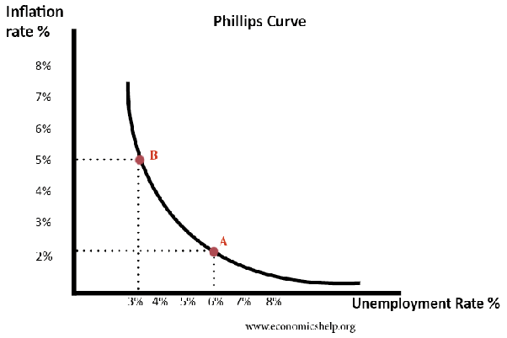
The above graph indicates the relationship between unemployment and inflation with the help of the Phillips curve. At the point, The unemployment rate is 6% with only 2% of inflation. When inflation rises to five percent at point B, the unemployment rate decreased to only 3%. However, the author discussed that the Phillips curve does not seem to be operated in the real world but somehow it is working in the US economy as it had been developed. The reason behind the unrealistic framework of the Philips curve is that inflation not always hit the unemployment level; there are various factors that eliminate the impact of inflation from the unemployment level. For instance, when inflation leads to the increase in aggregate demand it results in an increase in real GDP. Therefore, the producer hires more labor to meet the aggregate demand by providing sufficient supply of the goods and services (“Phillips Curve - Economics Help”). However, at a particular point, the economy reaches the full capacity, where no labor can be hire any more. At this stage, producers increase the wages of the labor which results in wage inflation. In addition, they increase the prices of goods and services which lead to a constant rate of unemployment. Economists believe this phenomenon more realistic as producers prefer to increase prices first then increasing the number of labor. However, the report shared in the article indicates that the Philips curve is working in the economy to lower the unemployment rate. Government is trying to maintain the inflation rate by increasing the interest rate.
The article is important to understand the pattern of economic growth especially the fluctuation in the unemployment level. However, authors have ignored the one important aspect which shows that inflation is not the only element which impacts the employment level. The element is the investment level. The author is right on the point that inflation is the risk and it is affecting interest rate, wages rate, and employment rate. However, producer or behavior of investors also has a crucial role. For instance, investment increases when investors do not see any risk related to the future value but a number of investors do not take risks. They decrease or limit their investment whenever notice that inflation can be higher in the future. Therefore, it leads to lowering the risk of inflation (Jayaraman and Singh). In addition, when investors believe that inflation rate is going to be stable in future, they increase their investment it sometimes leads to the inflation before the estimated period because of the supply of money increases in the economy. The increase in investment leads to more opportunities to produce goods and services by providing a number of new jobs.
Therefore, it is concluded that employment level is higher in America and the author thinks that its inflation that playing its role. The author discussed other economic factors like great recession, interest rate, investment, and wage rate. However, he focused on the inflation rate and discussed the Phillips curve that is resulting in lowering the unemployment level. The author created a strong argument where inflation rate affects the number of economic indicators including employment level. There is an inverse relationship between inflation and unemployment. However, the author did not highlight the importance of investment level which also provides opportunities to develop new job. Also, it stabilizes the inflation rate and economic growth becomes sustainable.

Work Cited
Irwin, Neil. “Three Key Factors That Will Determine How Long the Hot Job Market Lasts.” The New York Times, 3 Nov. 2018. NYTimes.com, https://www.nytimes.com/2018/11/02/upshot/the-job-market-is-firing-on-all-cylinders-three-questions-will-determine-how-long-it-can-last.html.
Jayaraman, T. K., and Baljeet Singh. Foreign Direct Investment and Employment Creation in Pacific Island Countries: An Empirical Study of Fiji. p. 18.
“Phillips Curve - Economics Help.” Economics Help, https://www.economicshelp.org/blog/1364/economics/phillips-curve-explained/. Accessed 10 Apr. 2019.

