The World Automotive Market

[Name of the Writer]

[Name of the Institution]

The World Automotive Market

Application of Market
The automotive market at global level comprised of a wide range of companies and organizations. These corporate organizations are established as the main stakeholders of the overall functioning of the industry of automotive at the international market level. A huge range of automobile companies at the country level involves the global perspective of the market of automotive. Exploration of potential buyers and sellers in case of the automotive market is essential to assess the overall potential of this particular market. When it comes to consideration of buyers and sellers of the market of automotive than it works in two forms. Some automotive markets work in the business-to-business in which cars are sold by the manufacturing companies to the dealership whereas there is the approach of business-to-consumer where there is a direct business connection between car sellers and consumers in the form of public business dealing. Exploration of the basic product of the automotive market is essential to identify the potential business perspective of this market ¹. The items of the car are established as the basic product of the global automotive market. The global business of automobile market involves manufacturing and selling of car vehicles around the world.
It is important to mention that changes in the global business scenario eventually influence the automotive market specifically considering the practical implications of demand and supply. It is interesting to explore the features that influence the economic domains of demand and supply for the basic product of car in case of international automotive market. It is observed that the market structure of the automotive sector is changing due to different factors relevant to the broad ideas of demands and supply. When it comes to exploration of demand factors than different financing options is the key parameter to observe changes in case of the automotive market. Car loans are recognized as the major driving force that influences the demands of cars in different markets linked with the global perspective of the automotive market. It is crucial to indicate that the growing trend of advertisement and marketing also impact the demand for the main product of the market of the automobile. Price of the car also plays a critical role in the entire phenomenon of demand for the product of cars at the global business level. Price of the commodity plays a critical role to bring any form of change in the demand of the product for the market of automobile products. It is also vital to explore specific aspects that become the reason for a change in case of the supply side of the automotive market. Increasing range of efficiency of operation is a major indicator of offering a business change in the form of the supply side of the product of cars. Another major reason for changing trend in the market of automotive is established as the increasing role of technology advancement. Growing access to business technology eventually increases the potential of production of cars at a global level.

Analysis
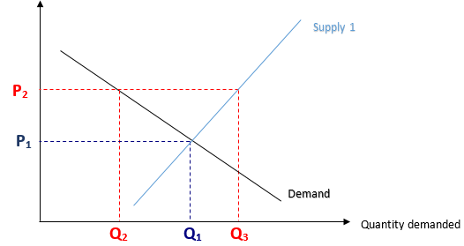
The changes in the form of demand and supply eventually impact the overall business of the product of automotive at both the local and global level. Demand and supply are determining as the basic economic indicators to evaluate the changing perspective of the market of the automotive industry. Various contributing factors functioning in the market eventually reflects the demand and supply of the basic product of the market of the automobile at an international level.
Consideration of the changing marketing trends helps to determine the significant implications in the form of demand and supply. Evolution of different contributing factors is essential to determine the changing aspects of relevant to the broad idea of operations of the market of the automotive industry. The domains of changes in prices and quantities in case of cars links with different factors that influence the demand and supply of the product of the automobile market ². The diagram about the quantities and price of the product of cars indicate the approaches of demand and supply. It is revealed that change in the form of price and quantity impacts both forms of demand and supply of the product at the international business level.

Conclusion
To conclude the discussion about the economic approach of the international market of automotive, it is essential to indicate the demand and supply are two main economic aspects to assess the business approach of the market at the global business level. The automotive market is established as one important market operating at the global level that influences the economy of countries and the overall domain of the global economy. The perspective of change is greatly linked with the market of automotive at the international business level. There are many different factors that contribute to the overall paradigm of economic changes specifically in the case of automotive sector working at the global business level. The broad idea of changes can observe in many different forms considering the approaches of both demand and supply side of the business. The changing business features eventually influence the buying and selling prospects of the products of cars. The growing trend of technology advancement ultimately increases the supply of the product of cars. On the other side, the factor of technology advancement also impacts the demand side as customers are more attracted to buy high-tech automobile product. Government involvement is another major domain relevant to the global business operations linked with the broad perspective of the automobile market.

End Notes
1. Dijk M, Yarime M. The emergence of hybrid-electric cars: Innovation path creation through co-evolution of supply and demand. Technol Forecast Soc Change. 2010;77(8):1371-1390.
2. Estampe D, Lamouri S, Paris J-L, Brahim-Djelloul S. A framework for analysing supply chain performance evaluation models. Int J Prod Econ. 2013;142(2):247-258.

