Analytical Essay
Name
[Institutional Affiliation(s)]

Author Note

Introduction
The occurrence of obesity has amplified internationally in the previous few decades. World health organization has declared obesity as the major health problem among countries. According to an estimate, obesity has been associated with other health disorders such as hypertension, cardiovascular disorders, diabetes, and stroke. The quality of life has been decreased significantly in recent years (Blüher, 2019). The predominant causes of obesity are observed to be physical inactivity and sedentary lifestyles (Blüher, 2019). Certain genetic and biological factors are also associated and has become the cause of obesity in the communities. It has been observed that societies have adopted a sedentary lifestyle that has created several health issues among them (Blüher, 2019). The exact cause and pathophysiology of obesity are still unknown, however, several related factors such as a sedentary lifestyle, inadequate food and physical inactivity are strongly linked with the physiological processes that cause obesity (Blüher, 2019). Certain evidence-based healthcare researches have shown that there is an association between cortisol and weight gain (Blüher, 2019). The studies have shown that an increase in cortisol level can significantly resist insulin and in turn, blood sugar level rises (Ells, Demaio, & Farpour-Lambert, 2018). This paper will analyze certain causes of obesity through evidence-based researches and its association with the development of obesity-related health problems.

Causes of Obesity
Overeating Behaviors
Overeating has been associated with the upsurge in the cases of obesity. It is associated with socio-cultural behaviors of the communities, peer pressure among societies, uncontrolled eating habits, and inappropriate diet management particularly hunger, an increase in snaking behaviors and appropriate sleep hours among individuals (Ells et al., 2018). Obesity is increasing in recent years due to these factors as all of these are linked with the changes in the physiological systems of the body that cause certain hormonal changes in the body (Blüher, 2019). Physiological changes in the body cause fat storage in the cells and tissues (Ells et al., 2018). Medications and lack of awareness for the diet and sleep management along with a sedentary lifestyle collectively become the cause of obesity (Ells et al., 2018). Various evidence-based health researches on children have been conducted that have evaluated the adapting sedentary lifestyle, snaking and inappropriate sleep hours are linked with obesity upsurge in children (Blüher, 2019). It has been reported that lack of appropriate sleep and inadequate diet such as consumption of snacks have significantly increasing obesity and obesity-related diseases among communities.

Lack of Health Education
It was assumed in previous studies that only low socio-economic status was associated with the increase in obesity among communities however, high-income countries are equally facing the same issue (Ells et al., 2018). This issue is linked to a lack of education and health promotion among communities. Low and middle-income countries have been observed with a significant rise in the deformities associated with obesity (Ells et al., 2018). However, high-income countries have adopted a sedentary lifestyle that has allowed the development of certain heart-related problems and obesity in the communities (Ells et al., 2018). Increasing education and promotion of particular health-related education can significantly decrease the occurrence of obesity.

Socio-Economic Conditions
Certain socio-economic factors such as unemployment reduced productivity and social disadvantages have been observed to be associated with the underprivileged health status among communities (Ells et al., 2018). Certain factors such as economic disadvantages also lead to the development of certain issues among families that raise obesity. For example, lack of availability of resources and unavailability of healthcare professionals and if available families are not able to seek help regarding health issues can create certain issues in individuals (Blüher, 2019). The economic burden in communities leads to the development of obesity and related health issues.

Low Energy Expenditure
Factors that influence strongly body changes that cause obesity include aging, medications, genetic factors and microbiota are associated with the low energy expenditure (Blüher, 2019). These factors cause the body to expend energy less than the energy consumed by the body (Ells et al., 2018). Gender is also linked with the upsurge in obesity as it has been observed that women have more obesity-related issues as compared to men (Ells et al., 2018). Certain ethnic groups such as Asian Americans and African Americans also have more cases of obesity in the population as compared to other ethnic groups (Blüher, 2019). Fat usually takes longer time to be dissolved and therefore it has been observed that consuming more fats will be stored in tissues leading to obesity.
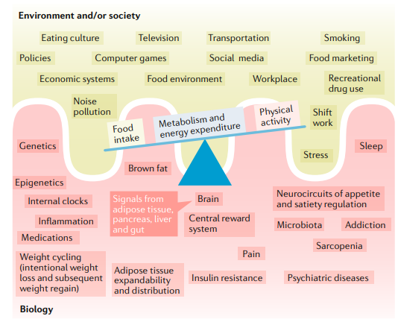
Figure 1 Complex Biological and Environmental elements contributing to Obesity
Studies have shown that consuming inappropriate diets such as junk and fast food, consuming lower amounts of water and intake of less fiber can cause obesity (Ells et al., 2018). Various studies have reported that in recent years, eating habits of the communities are significantly changed (Blüher, 2019). These changes have been observed essentially in consuming higher quantities of fatty food and snacks. This has caused the communities to develop obesity and related health issues in individuals. Children have adopted this habit significantly. Men and women are equally facing this issue in these years.

The attitude of Physical Inactivity in Communities
Adaptation of a sedentary lifestyle has bade various health disorders in the communities. Physical inactivity has been observed as the most important and significant cause of obesity in societies (Blüher, 2019). As various studies have shown that lack of physical activity can cause metabolic changes in the people that lead to the development of obesity (Blüher, 2019). Chronic fatigue and joint pain are the associated illnesses that are linked with the increasing obesity cases in the communities. Socio-cultural behaviors such as families have a culture of lack of physical activity and they often discourage healthy lifestyles that can lead to obesity.
Lack of education and awareness among communities is also linked with physical challenges such as the sedentary lifestyles of individuals (Ells et al., 2018). Certain studies have evaluated that workplaces are strongly linked with an increase in obesity such as the working environment has raised the concept of sitting and spending time in front of laptops and computers (Blüher, 2019). These changes have been essentially linked with the adaptation of sedentary lifestyles.

Emotional Barriers and Sedentary Lifestyles
Emotional barriers such as women are often discouraged because of dominant male cultures among families. Adaptation of sedentary lifestyles and physical inactivity has promoted arthritis and cardiovascular disease among communities (van Strien, 2018). Major noncommunicable diseases have been observed to be linked with obesity. Such as lack of appropriate diet can cause changes in the physiological and metabolic functions of the body (Ells et al., 2018). These metabolic changes can cause certain hormones to rise in the body which can lead to an increase in the storage of fat in tissues (Blüher, 2019). Fat storage will ultimately lead to heart and related cardiovascular diseases and bone-related disorders or sometimes complete disabilities (Ells et al., 2018). Therefore, obesity is the major root cause of almost all kinds of non-communicable diseases.

Conclusion
Pandemic dimensions have been changed in recent years due to the increase in obesity and related diseases. Preventive measures have failed their results in many cases, for example, certain prevention-related programs were initiated that aimed to introduce the behavioral interventions among communities but later it was identified that it would take years to change behaviors of the communities (Ells et al., 2018). The study has successfully identified various causes of obesity from evidence-based researches and has suggested that certain health-related issues such as obesity can be prevented with behavioral interventions (Ells et al., 2018). However, it would take years to develop certain changes that can significantly reduce the burden of non-communicable disease including obesity-related health disorders.
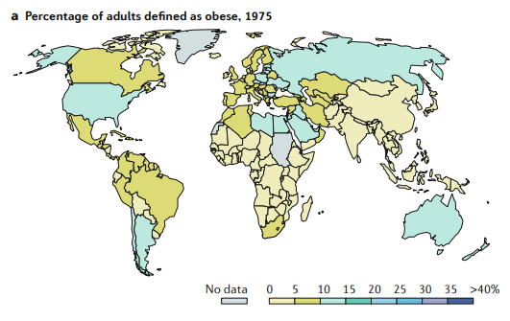
Figure 2 Trends of Obesity in the year 1975
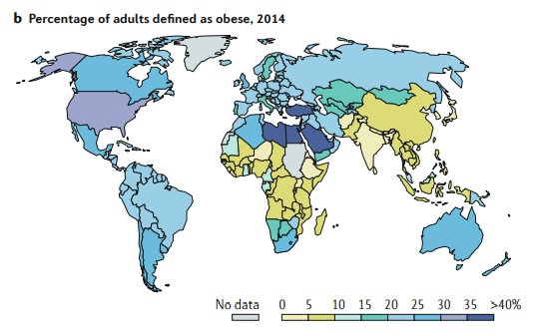
Figure 3 Trends of Obesity in the year 2014

References
Blüher, M. (2019). Obesity: Global epidemiology and pathogenesis. Nature Reviews Endocrinology, 1.
Ells, L. J., Demaio, A., & Farpour-Lambert, N. (2018). Diet, genes, and obesity. British Medical Journal Publishing Group.
van Strien, T. (2018). Causes of emotional eating and matched treatment of obesity. Current Diabetes Reports, 18(6), 35.

