Neha Kakkar
EIA Process Audit (Impact Prediction)
Report

1. Introduction
EIA is a set of measures carried out in order to identify the degree of danger of the impact of financial action on the environment and public health. The Government of Japan launched the idea of ​​environmental impact assessment in 1972. That year, the Cabinet adopted guidelines on environmental conservation measures affecting public works. These guidelines, however, did not describe any procedure for environmental impact assessment (Harashina, 2001). The Environmental Agency, created in 1971, has prepared a standard legislative procedure beginning in 1975.
Best Practice
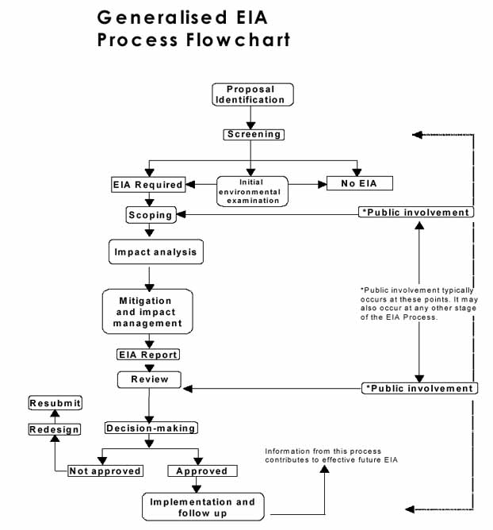
Figure1, flowchart
According to Barrett and Therivel, (1989), On March 28, 1997, the government introduced a draft law on EIA. This bill provides for an enrollment method based on the scope of projects to designate those that should be the subject of an environmental impact study. The supporter of a project that exceeds a certain size established by ordinance under the law (category 1 projects) must prepare an environmental impact study without prior review. A project smaller than the Category 1 Threshold, but larger than a Prescribed Scope (Category 2 Projects), must be screened to allow the Competent Authorities to determine environmental impact is needed. In addition, the bill establishes a process (with public participation) to determine the significance of the issues to be addressed. The proponent of a project will be required to write a document that describes how they intend to conduct the study, projections or assessment of environmental effects. It must also make this document public in order to receive the advice of local governments and those interested in environmental conservation. The proponent must also make the preliminary environmental impact study public. The Environmental Agency may comment to the competent authorities on the impact study. If necessary, the competent authorities may require the proponent to amend its final environmental impact study (Barret and Therivel, 2019).
Practice issues
According to Imura and Schreurs, (2005), The Commission for the Study of Environmental Impact Assessment Systems has identified a number of problems that need to be tackles by the nationwide administration. Here are the main points:
- the late stage of environmental impact assessment (the need to take environmental issues into account in the early stages of project development),
- the limited opportunities for participation available to the public (only residents of a designated area can express their views),
- the weakness of the review process (the Environmental Agency can not express an opinion unless the competent authorities ask it).
The 1997 Environmental Impact Assessment Bill is expected to improve, in many ways, Japan's assessment system, including:
- establishing public processes to determine the importance of the issues and priorities that will be the focus of the evaluation,
- Establishing screenings for designated medium sized projects
- by ensuring the simplicity of the evaluation method
- by integrating a controlled monitoring system
Strength and weaknesses
It is a specific tool focused on a specific project and context. At the same time, the EIA has the properties of both an integral (all conceivable types of environmental impact) and a selective (only concerns solutions and projects of crucial importance) tool. It also ensures that environmental interests are respected before exposure (Wiedmann et al., 2007).
The weaknesses of the EIA process in Japan relate to such problems: using a linear approach to the decision-making process, which, in essence, is cyclical; difficulties in reviewing alternatives and effects resulting in unproductive information overload; the duration of the EIA process and project planning; limited usefulness of using EIA for decision making.
Expectations
Several debates on EIA systems have led Japan to recognize the need for strategic environmental assessments or planning. It is the responsibility of the proponent of a project to initiate the process. When deciding to do so, the proponent's internal decision-making process is already completed, although the content of the decision will be reviewed as part of the environmental impact assessment process.
Conclusion
“The Environmental Impact Assessment” Act of 1997 allows us to believe that the environment will be more accountable when making decisions in Japan (more than is currently the case with existing procedures).

References
Harashina, S. (2001). A new stage of EIA in Japan: towards strategic environmental assessment. Built Environment (1978-), 8-15.
Barrett, B. F., & Therivel, R. (1989). EIA in Japan: environmental protection v economic growth. Land Use Policy, 6(3), 217-231.
Barrett, B. F., & Therivel, R. (2019). Environmental policy and impact assessment in Japan (Vol. 2). Routledge.
Imura, H., & Schreurs, M. A. (Eds.). (2005). Environmental policy in Japan. Edward Elgar Publishing.
Wiedmann, T., Lenzen, M., Turner, K., & Barrett, J. (2007). Examining the global environmental impact of regional consumption activities—Part 2: Review of input–output models for the assessment of environmental impacts embodied in trade. Ecological economics, 61(1), 15-26.
Canter, L. W., & Wood, C. (1996). Environmental impact assessment.
Wood, C. (2003). Environmental impact assessment: a comparative review. Pearson Education.
Jay, S., Jones, C., Slinn, P., & Wood, C. (2007). Environmental impact assessment: Retrospect and prospect. Environmental impact assessment review, 27(4), 287-300.
Ramanathan, R. (2001). A note on the use of the analytic hierarchy process for environmental impact assessment. Journal of environmental management, 63(1), 27-35.
Wathern, P. (Ed.). (2013). Environmental impact assessment: theory and practice. Routledge.
Morris, P., & Therivel, R. (Eds.). (2001). Methods of environmental impact assessment (Vol. 2). Taylor & Francis.
Wang, Y. M., Yang, J. B., & Xu, D. L. (2006). Environmental impact assessment using the evidential reasoning approach. European Journal of Operational Research, 174(3), 1885-1913.

