Neha Kakkar
EIA Process Audit (Impact Prediction)
Report

Introduction
Environmental Impact Assessment (EIA) is a comprehensive interactive process aimed at identifying the effects of the planned to implement economic or other activities on human health and the environment. The basis of the Australian system of environmental assessment of economic activities is EIA and environmental impact assessment. Thus, in the Australia, a real mechanism was developed to prevent negative impacts on the OPS, as well as the manifestations of social tensions caused by them. The experience of using the EIA procedure in the Australia has entailed favorable consequences for the protection of the environment, reducing the negative impacts from the implementation of insufficiently thought-out and informed decisions in economic activities (Thomas, 1998). In general, it is necessary to note the crucial role of the application of the EIA procedure in the Australia, as the clear and simple methodology for its implementation has gained recognition and quickly spread in almost all developed countries Glasson and Therivel, 2013).
2. Best practice ideas
The Act provides for various types of environmental assessment:
- evaluation without preparation of a public report on the environment or an environmental impact study;
- evaluation following the preparation and public review of a public environmental report or an environmental impact study;
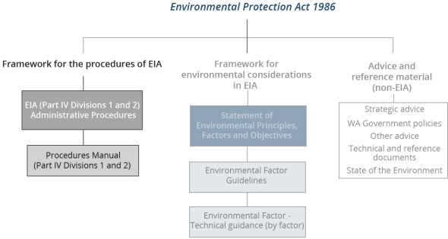Figure.1 EIA
According to figure 1,the first consideration of best practices is fully provided for in the EIA system of Western Australia in that anyone can comment on the proposals and their materials will be considered as the initiator. This ensures that minimum expectations for natural justice are ensured by this process (Ahammed and Nixon 2006). In addition, the assessment provides for the analysis of not only new (developed and coming into force), but also existing legislation. It can be probable that citizens with weak education or who only speak English as a next verbal communication may not contribute in EIA as a consequence The “environmental bureaucracy” represented by state authorities in the field of environmental protection, with the support of the demagogic-minded part of the population, erected this barrier to economic development, with the aim of - creation of additional costly "ritual" of environmental fees. Both that and another creates obstacles to a steady progressive economic development, being a brake at a substantiation of economic projects (Arts and Morrison-Saunders, 2012). .
The second best practice is only partially in the sense that the EPA itself is not directed or explicit stakeholder engagement is expected (Canter and Wood, 1996). Overall, based on the considerations covered in my two criteria for participative EIA, the process in Western Australia meets minimum expectations for natural justice but falls short of what represents ‘best practice participative EIA’ in advanced democracies.

3. Disadvantages / Practice issues
The practice of environmental assessment in both industrialized and developing countries is subject to a number of difficulties and restrictions whose existence is widely recognized. The Symposium explored a wide range of issues and challenges.
Three points of discussion had been defined before the Symposium:
- understand and communicate the added value of environmental impact assessment
- apply the EIA in times of limited resources
- Situate environmental impact assessment in the context of international development
Advantages
The effectiveness of the EIA system is most fully manifested when it is used for large-scale projects with significant environmental impact and affecting a wide range of stakeholders. For such projects, the impact assessment, which is produced according to the methods regulated by the applicable standards, norms and rules that separately consider the impact on the atmosphere, the hydrosphere, without informing a wide circle of interested parties, turns out to be particularly inadequate to its real value.

Conclusion

The national environmental impact assessment, conducted more than twenty years ago, is a well-established practice in support of Australia's environmental policy. However, as in other countries, EIA is under pressure in government and society at large. These include the micro-economic reform of the Australian economy, the evolution of Commonwealth-State relations, and the need to reconcile the demands of economic development with those of environmental protection.
In recent years, environmental policy has undergone some notable changes across the Common wealth. These changes have had and will continue to have significant effects on the way EIAs are administered in Australia.

References
Thomas, I. (1998). Environmental impact assessment in Australia. Sydney: Federation Press.
Glasson, J., & Therivel, R. (2013). Introduction to environmental impact assessment. Routledge.
Gilpin, A. (1995). Environmental impact assessment: cutting edge for the 21st century. Cambridge University Press.
Ahammed, A. R., & Nixon, B. M. (2006). Environmental impact monitoring in the EIA process of South Australia. Environmental Impact Assessment Review, 26(5), 426-447.
Arts, J., & Morrison-Saunders, A. (Eds.). (2012). Assessing impact: handbook of EIA and SEA follow-up. Routledge.
Canter, L. W., & Wood, C. (1996). Environmental impact assessment.
Wood, C. (2003). Environmental impact assessment: a comparative review. Pearson Education.
Jay, S., Jones, C., Slinn, P., & Wood, C. (2007). Environmental impact assessment: Retrospect and prospect. Environmental impact assessment review, 27(4), 287-300.
Ramanathan, R. (2001). A note on the use of the analytic hierarchy process for environmental impact assessment. Journal of environmental management, 63(1), 27-35.
Wathern, P. (Ed.). (2013). Environmental impact assessment: theory and practice. Routledge.
Morris, P., & Therivel, R. (Eds.). (2001). Methods of environmental impact assessment (Vol. 2). Taylor & Francis.
Wang, Y. M., Yang, J. B., & Xu, D. L. (2006). Environmental impact assessment using the evidential reasoning approach. European Journal of Operational Research, 174(3), 1885-1913.

