Your Name
Instructor Name
Course Number
Date

Mobile and Embedded Device Security
Security has always been a major concern in mobile computing. Not only in mobile computing but in everything online is not safe until proper security measures are not taken. To ensure the security of mobile computing several mobile device management tools are available that help facilitates users in securing their devices and data (Johnson).
SOTI MobiControl facilitates companies to securely manage and maintain any device or any operating system after it has been deployed. It also helps in controlling business mobility, while also tracking physical assets and handling contents and applications (MobiControlv14ConsoleTransitionGuide.Pdf). While discussing several features of SOTI MobiCloud tool some of the main features are listed below:
On-boarding and off-boarding
Enrollment is done through a barcode scan. The scan of the barcode can automatically configure a device with the help of account information, proxies, applications, and virtual private network (VPN) settings.
App management
Admins have the authority to upgrade, manage and distribute secure applications on devices that are shared, personal or corporate.
Device management
The software tool provides toolkit contains several advanced features to manage access to corporate resources while also configure lockdown and detect rooted devices.
Security features
This tool can integrate with Office 365 and active directory. Further, it has built-in root detection features well. Moreover, it also has a malware detection system that facilitates minimizing the risk of any security issue to the android devices. In case of any security issue, the end-users can locate their device and then reset the password. By doing this they will be able to remove the data from their devices and can shop for administration sanctioned profiles.
Deployment options
SOTI MobiCloud can support both cloud and on-premises deployment. Whatever the medium the user may choose SOTI MobiCloud online site can help with the deployment process. Typically, the installation method contains two main steps that are: a console that communicates with the deployment server and exchange information from online support to the device. The next step is the deployment server that sends the information of the devices to the database.
Screenshots of the tool
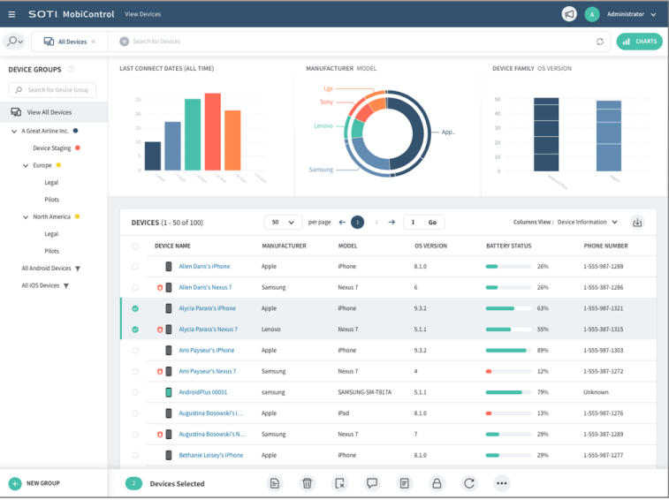
Fig:1 SOTI MobiCloud console
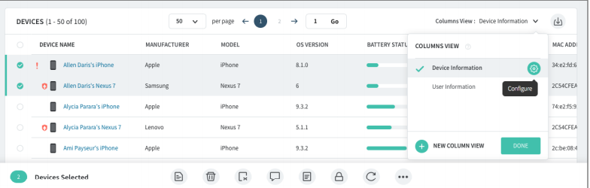
Fig:2 Device list that SOTI MobiCloud can support synonymously
Views/Opinions
This tool facilitates a lot in managing the device security. It also aids in managing multiple devices and can support both android and IOS.

Works Cited
Johnson, David B., and D. Maltz. "Mobile computing." (1996): 153-181.
MobiControlv14ConsoleTransitionGuide.Pdf. https://www.soti.net/files/shared/MobiControl/MobiControlv14ConsoleTransitionGuide.pdf. Accessed 9 Oct. 2019.

