Camillo Golgi
[Name of the Writer]
[Name of the Institution]

Title: Camillo Golgi
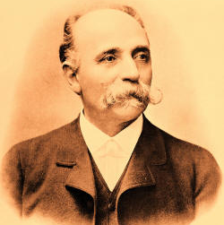
Fig. 1 Camillo Golgi
(https://corrosion-doctors.org/Biographies/GolgiBio.htm)
History
Camilo Ponzi was born on July 17, 1843 in a village Corteno near Bresica in Italy. He received the degree of medicine at the University of Pavia. In 1869, he began his scientific career by working on theories of psychiatry but soon abandoned it because he believed theories must be supported by facts. He started concentrating on experimental research on nervous system. He shared Nobel Prize with Santiago Cajal in Physiology or Medicine in 1906. He died on January 21, 1926.
Accomplishments
- Discovery of ‘black reaction’, a staining technique with silver nitrate in 1873.
- In 1875, he published first drawings of neural structures. He gave the description of olfactory bulb and protoplasmic processes in olfactory glomeruli (Da Fano, 1926).
- He described morphological features of glial cells and two types of nerve cells; Golgi type I and Golgi type II neurons (“Camillo Golgi,” n.d.-b).
- In 1878, he described tendinous sensory corpuscles; Golgi tendon organs.
- In 1885, he published a monograph on anatomy of central nervous organs (Bentivoglio, n.d.).
- He determined three forms of malarial parasites and three types of fever and photographed characteristic phases in 1890.
- In 1897, he noticed the internal reticular apparatus and officially reported it in 1898. Later, it was named after him as Golgi apparatus (Dröscher, 1998).
- He established and headed the Istituto Sieroterapico- Vaccinogeno in the province of Pavia.
- He worked as the rector of University of Pavia.
He was made the Kingdom of Italy’s senator.
- During World War I, he founded a neuro-pathological and mechano-therapeutic center for the treatment of patients with peripheral nervous lesions and recuperation of the injured.

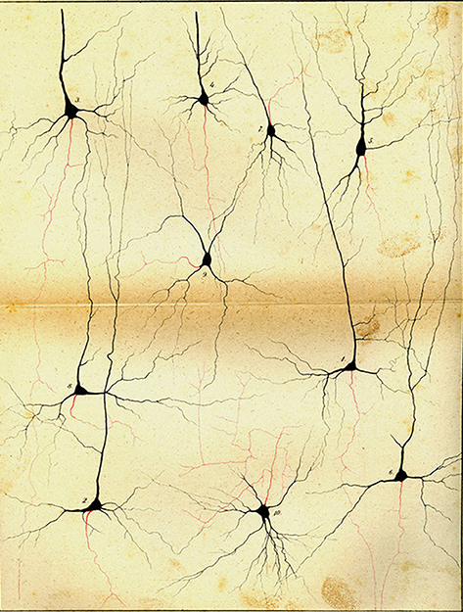
Fig 2. Drawing of Golgi impregnated neurons of cerebral cortex (Bentivoglio et al., 2019)
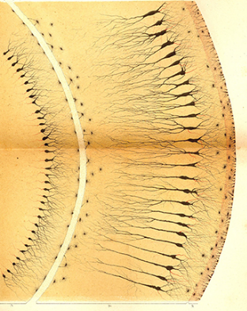
Fig 3. Hippocampus impregnated by Golgi’s stain (Bentivoglio et al., 2019)
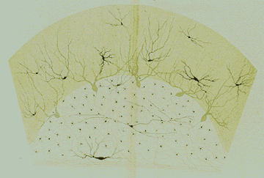
Fig 4. Golgi’s drawing of human cerebellar cortex (Bentivoglio, n.d.)

References
Bentivoglio, M. (n.d.). Camillo Golgi. Retrieved September 3, 2019, from NobelPrize.org website: https://www.nobelprize.org/prizes/medicine/1906/golgi/article/
Bentivoglio, M., Cotrufo, T., Ferrari, S., Tesoriero, C., Mariotto, S., Bertini, G., … Mazzarello, P. (2019). The original histological slides of Camillo Golgi and his discoveries on neuronal structure. Frontiers in Neuroanatomy, 13, 3.
Camillo Golgi. (n.d.-a). Retrieved September 3, 2019, from https://corrosion-doctors.org/Biographies/GolgiBio.htm
Camillo Golgi. (n.d.-b). Retrieved September 3, 2019, from Palomar website: https://www2.palomar.edu/users/ccarpenter/camillo_golgi.htm
Da Fano, C. (1926). Camillo Golgi. 1843–1926. The Journal of Pathology and Bacteriology, 29(4), 500–514.
Dröscher, A. (1998). Camillo Golgi and the discovery of the Golgi apparatus. Histochemistry and Cell Biology, 109(5–6), 425–430.

