Alipay: Challenges Posed by E-Commerce & E-Business
[Name of the Writer]
[Name of the Institution]

Alipay: Challenges Posed by E-Commerce & E-Business

Introduction
Alipay is the world’s largest mobile payment platform based in China. It was established in 2004 and within 9 years it overtook Paypal in 2013. Today, its mobile app is used for online shopping by about 400 million users, who are attracted by the ease of online shopping. Chinese consumers are increasingly using alternative electronic payment methods such as credit and debit cards and mobile payment (Alipay, 2018). Alipay offers many benefits over traditional payment methods. However, there are also a number of problems associated with it.

Discussion
Services
Alipay provides payment services both domestically and internationally by collaborating with nearly 200 financial institutions such as banks and MasterCard as well as Visa. In smartphones, Alipay is used via Alipay mobile app known as Wallet app. For local transactions at the spot such as instore transactions, QR codes are used. Credit card bills payment, purchasing of food, phone top-up, P2P transfer, purchasing of tickets can also be done through Alipay app. It also facilitates payment during international travel.
Security
In today's digital world of interconnectedness, security threats and risks are constantly evolving. In order to successfully operate, special measures need to be taken. Alipay employs several security mechanisms to keep user accounts safe. Separate login and payment passwords as used. Both of them need to be different. Upon 5 wrong entries of login password and 3 wrong entries of payment password, the account is locked. Information encryption over the network has also been implemented to prevent hackers from knowing passwords.
Comparison with other payment systems
The traditional card payment methods make Alipay similar to PayPal, WeChat Pay and Apple Pay. The time taken by fund transfer varies for chosen payment method. So, unlike the instant payment system, such as Zelle and Venmo, Alipay also offers a method in which funds are not instantly transferred (European Central Bank, 2019).
Benefits
- Extensive coverage and availability in places such as malls, subway stations, etc.
- International payment channels
- Variety of financial and investment products such as funds, stock and deposits. Yue’Bao by default invests the money deposited in the account, thereby increasing value.
- Integration of a wide range of services e.g. Cinema ticket, mobile top-ups, discounts on shopping, making an appointment for hospitals, etc.
- Availability of offline payments.
- Powerful credit system
Problems
Generally, mobile payment methods are vulnerable to cyber-attacks (United Nations, 2012). Some of the factors which make mobile vulnerable to cyber-attacks are shown in the following figure.
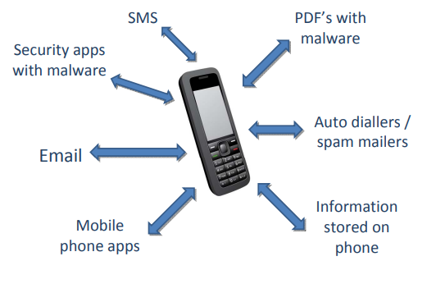
Figure 1
- Alipay cannot be used everywhere.
- There exists a threat of its use for terror financing.
- Alipay allows for tax evasion (Jing Travel, 2018). For example, in Vietnam Alipay was used extensively in 2018 to evade tax Vietnam. Its use had resulted in zero-dollar tour problem in which tours at low prices are offered to Chinese, requiring forced shopping from partnering stores in foreign countries. Therefore local tourism of Vietnam received little to no benefit from incoming Chinese tourists (Jing Travel, 2018). The process bypassed the companies partnering Alibaba, and Chinese tourists would process their payments in Renminbi through Chinese POS terminals. Hence Vietnam lost its ability to collect taxes.
- Overseas online transactions further complicate the problem of collecting sales and income tax. Income tax and sales tax policies vary from place to place. Complications are created when a person is physically present somewhere else and conducts transactions somewhere else i.e. in a place where tax policies are different. Moreover, State regulations in online payment also result in unexpected losses. For instance, it was reported in 2018 that Alipay and Tencent were poised to lose more than $1bn due to the central bank new policy that all funds of third parties should be kept reserve (Wildau, 2018).

References

Alipay. (2018). Alipay Digital Wallet. Retrieved from Global Alipay: https://www.cybersource.com/content/dam/cybersource/Alipay_Partner_DS.pdf
European Central Bank. (2019). Instant payments. Retrieved from www.ecb.europa.eu: https://www.ecb.europa.eu/paym/retpaym/instant/html/index.en.html
Jing Travel. (2018). Chinese Mobile Payments Being Used for Tax Evasion in Vietnam. Retrieved from Jing Travel: https://jingtravel.com/chinese-mobile-payments-being-used-for-tax-evasion-in-vietnam/
United Nations. (2012). Mobile Technology: Threats and Opportunities for Taxation and Government Payments. Retrieved from United Nations: https://www.un.org/esa/ffd/wp-content/uploads/2014/09/8STM_PPT_MobileTechnology.pdf
Wildau, G. (2018). Tencent and Alipay set to lose $1bn in revenue from payment rules. Retrieved from Financial Times: https://www.ft.com/content/b472f73c-859e-11e8-96dd-fa565ec55929

