Rich Picture and CATWOE Analysis
[Name of the Writer]
[Name of the Institution]

Rich Picture and CATWOE Analysis
When one talks about the development of the healthcare policy, it is very important to make sure that the underlying complexity of the whole system has to be understood. There are many stakeholders involved if one talks about the provision of the healthcare and thus there is a need to ensure that the multi-faceted approach is needed to be adopted towards the resolution of the healthcare problems. What it means is that the problems that are witnessed at the healthcare level are needed to be looked at clearly and effort has to be made to make sure that the clear course of action must be developed with regards to how these problems are going to be resolved. In this paper, it is going to be discussed that how the resolution of the problem that is being faced in the healthcare domain is being carried out and what are some of the prospective solutions for the given problem. The methodology that is going to be looked at the resolution of this problem would be the Rich picture and the CATWOE analysis. These tools are important in terms of how it can be made sure that the multi-faceted approach can be developed with regards to the resolution of this problem. This application demonstrates the power of SSM in providing a rigorous and logical approach to determining the attributes, criteria and cost elements of the system that can then be fed into a more formal model to yield information as to cost effectiveness.

Rich Picture
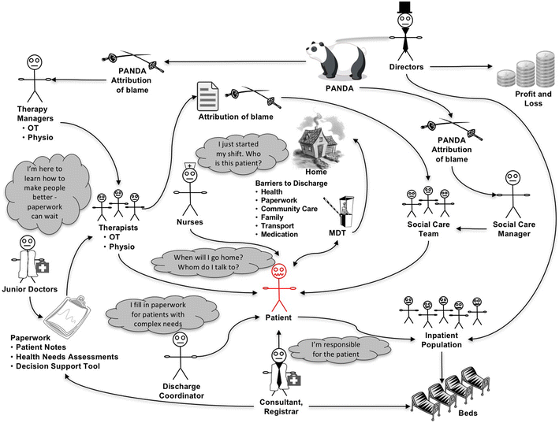
One of the most basic problems that is being faced during the course of the implementation of the healthcare system is that how it does not add enough value to the life of the stakeholder. The idea is to ensure that the processes must be simpler and there has to be no complications in this regard. Looking at this picture, the key thing that has to be kept in mind is that how the organization of the workflow is one of the most important elements of how the healthcare organization is supposed to be run. This picture talks about the fact that for an organization to be efficient at any level, it is crucial that they carry out the value chain analysis. What it means is that there has to be effort on their part to make sure that they keep in mind the perspective of all the stakeholders and how the decision making is going to affect them at the given point of time. There has to be clarity of purpose with regards. Now, here it can be seen that the documentation that the patient is being asked for is quite extensive to say the least. This extensive documentation would lead towards the distorted customer experience. So, the information collection mechanism needs to be better when things are being done at the level of the organization. The next thing that has to be done is that it needs to be ensure that efficient allocation of the inpatient population has to be carried out.

CATWOE Analysis
In the next corresponding section, the CATWOE analysis is going to be carried out. The idea behind this analysis is sot make sure that the stakeholders and the key players that are going to be involved in the function and the operations of the operations of the organization must be made the part of the whole value addition process.

Customer
These are the patients who are getting enrolled into the hospital for their treatment. The key process and rationale of any healthcare institute must be to make sure that the relief is being provided to the stakeholders. What it means is that there is a need to ensure that the broader stakeholders who are involved in the decision making are the customers and patients. The whole process must be patient centric rather than adding things that are inefficient and distort their experience.

Actors
Now, this is where the hospital administrators and the people who are responsible for the operation of the facility have to step in. The key thing that is needed to be taken into account this time around is that the involvement of all the players have to be made out in terms of how the direction is needed to be given to the project. The key stakeholders have to determine what are some of the rationales through which the process of easing out the patient process is going to be done As the whole facility is needed to be made patient centric, effort is needed to be made to ensure that the people who are involved must decide what must be the mitigation strategy.

Transformation
The management, and that includes the medical as well as the non-medical staff has to work in the manner that the at first, the process that are taking too much time must be done away with. Effort is needed to be made to make sure that all the broader stakeholders who are involved must put their perspective. During this process, all the operational processes such Medicare officers, nurses and the physicians must come up with the strategy that would allow the integration of the overall operating processes. That would in turn ensure that the overall benefit that is being provided to the stakeholders should be managed appropriately at the given point of time in term of how stakeholder agreement is done.

Worldview
The other important thing that is needed to be checked here is that what is the world view with respect to these implementations. What it implies is that special effort has to be put in terms of the public relations aspect of the whole thing and what are the general public outcomes of the whole equation.

Owner
The management such as the medical and non-medical personnel would be the one that would be owner of the whole process.

Environment
The environment concerns are going to be managed in the manner that the quality and time criticality during the course of the project is going to be managed in the right manner in the pursuit of the corporate goals

Conclusion
What it means is that the healthcare premises should forecast the number of patients that they are going to be handling at a given point of time and based on that forecast, facility has to be developed. Not only that there is also a major need to rehaul the process and bring about the staff that is able to integrate evidence-based practices during the course of their healthcare services. What it means is that the effort is needed to be made to make sure that all the prospective stakeholders who are involved in the thing that required that much expertise as the healthcare. Not only that, there is a need to ensure that the process optimization has to be carried out. What it means by process optimization is that the processes that are causing the delay in the healthcare intervention are needed to be filtered out. Developing and implementing policy at governmental level implies dealing with complexity and hence understanding the multi-faceted nature of the domain in question. This paper offers a candidate framework for such policy analysis and implementation. A key feature of the framework is the adoption of soft systems methodology (SSM).

References

Armstrong, H. (2016, August). Managing Information Security in Healthcare—an Action Research Experience. In IFIP International Information Security Conference (pp. 19-28). Springer, Boston, MA.
Crowe, S., Brown, K., Tregay, J., Wray, J., Knowles, R., Ridout, D. A., ... & Utley, M. (2017). Combining qualitative and quantitative operational research methods to inform quality improvement in pathways that span multiple settings. BMJ Qual Saf, 26(8), 641-652.
Fennessy, G. (2016). Knowledge management in evidence-based healthcare: issues raised when specialist information services search for the evidence. Health Informatics Journal, 7(1), 4-7.
Gillies, A. C., & Howard, J. (2017). Information as change agent or barrier in health care reform?. International Journal of Healthcare Information Systems and Informatics (IJHISI), 6(1), 19-35.
Kalim, K., Carson, E., & Cramp, D. (2014, October). The role of soft systems methodology in healthcare policy provision and decision support. In 2004 IEEE International Conference on Systems, Man and Cybernetics (IEEE Cat. No. 04CH37583) (Vol. 6, pp. 5025-5030). IEEE.
Kotiadis, K., & Robinson, S. (2018, December). Conceptual modelling: knowledge acquisition and model abstraction. In Proceedings of the 40th Conference on Winter Simulation (pp. 951-958). Winter Simulation Conference.
Lehaney, B., & Paul, R. J. (2016). The use of soft systems methodology in the development of a simulation of out-patient services at Watford General Hospital. Journal of the Operational Research Society, 47(7), 864-870.
Petkov, D., Petkova, O., Andrew, T., & Nepal, T. (2017). Mixing multiple criteria decision making with soft systems thinking techniques for decision support in complex situations. Decision Support Systems, 43(4), 1615-1629.
Sylvester, A., Tate, M., & Johnstone, D. (2017). Re-presenting the literature review: a rich picture of service quality research in information systems. PACIS 2007 proceedings, 113.
Tako, A. A., Kotiadis, K., & Vasilakis, C. (2017, December). A participative modelling framework for developing conceptual models in healthcare simulation studies. In Proceedings of the Winter Simulation Conference (pp. 500-512). Winter Simulation Conference.

