Australia and New Zealand Group Group Gained Cultural Diversity
[Name of the Writer]
[Name of the Institution]

Executive Summary

One of the most important things that the organizations have to ensure these days is that how they are going to be managing diversity at their level. In the past, there was not much awareness among different societal stakeholders that how the diversity is supposed to work out but with the passage of time, people have started to develop this realization that workplace needs to be more inclusive to ensure that differentiation is being needed to be managed at the broader level at the given point of time. As a matter of fact, the organizations in Australia have started to realize some of the implicit benefits of value diversity is going to be adding at their workplace. There have been many recent studies that have showed that if there is greater cultural diversity at the workplace, then it translates into the greater profits for the organization.

Contents
Introduction 3
Importance of Handling Diversity at the Workplace 4
Australia and New Zealand Banking Group 5
Value System of the Organization 6
Reconciliation Action Plans 6
Integrating Maori and Pasifika People into the Fold 7
Given the Chance 8
Integration of the LGBT Community in the Organizational Fold 9
Celebrating of the Diversity Week 10
Conclusion 11
References 13

Australia and New Zealand Group Group Gained Cultural Diversity

Introduction
Diversity is one of the major issues that is being faced by the organizations these days. The businesses have to be very clear with regards to their policies and perspectives. Specially in the countries like Australia where the ethnic and racial demographic is quite diverse and thus effort is needed to be made to ensure that all the stakeholders. Not only that, the representation in the social demograhics is needed to be there in terms of how the diversity concerns are going to be managed. Especially due to the fact that how the dynamics of the businesses have changed these days and not only they have to ensure that they take care of their services and operations, but public relations have become quite an important part of the whole debate (Stevens et al, 2018). Specially for the organizations that are in public service spheres, it becomes imperative that they take care of the diversity management. In this paper, it is going to be seen that how Australia and New Zealand Group, also known as the ANZ Group takes care of the diversity, what is the extent the diversity as a problem is being faced in Australia and what sort of decision making methodologies are needed to be used to bring a level of control in this regard (Fine et al, 2018).

Decision Making Framework
There was a survey that was carried out in 2013 and it showed that how about 50 % of the organizations that are part of the Australian workforce can take. Not only that, as the organizations are expanding their scope of services at the global level, it has become rather important for them to make sure that they take into account of the whole level (Abbasi & Hollman, 2017). With the multitap cultural workforces being witnessed all around the world, it has become important for all the stakeholders to make sure that they realize some of the intrinsic benefits of having diversified workplace. Not only that, it also leads towards employee satisfaction and lower employee turnover which in turn is good for the long-term goodwill of the organization. Not only that, it also allows the businesses to make sure that they have better understanding about how the marketplace is operating and what are some of the things and changes that they can bring in their organization to make sure that the customer base is being catered (Rubaii & Beck, 2016). Now some insight is developed about the importance of how the diversity management is supposed to benefit the organization, in the next section, it is going to be seen that what are some of the broader steps that are taken by ANZ Group to ensure that they work towards more diversified workforce (Thomas & Plaut, 2016).

Australia and New Zealand Banking Group
The organization that is going to be discussed during the course of this paper is Australia and New Zealand Banking Group, also known as the ANZ Banking Group. It is the third largest bank in the region in terms of the market capitalization and is one of the largest banks in the Australia in terms of the market penetration with regards to its customer base (Prasad et al, 2018). The other advantage that the entity enjoys is that they are one of the biggest banks that is operating in the New Zealand as well (Wentling & Palma, 2017). The bank is operating in other countries as well such as United States and United Kingdom thus making it one of the few organizations in Australia that is operating at such a multinational level (Mor Barak et al, 2018). The bank has gained fame for its sustainability policies and how they have managed diversity among their ranks. In this paper, it would be seen that how ANZ Banking Group was able to make sure that they were able to sustain diversity among their workplace in terms of the cultural relevance and what where some of the things that were done by them in this regard (Rivas et al, 2017). Below mentioned is how diverse the workforce in Australia is at the moment.
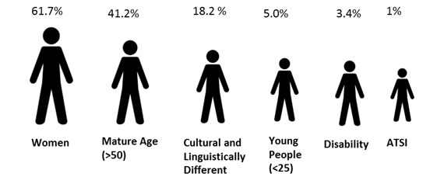

Source: (Rivas et al, 2017)

Method of Introducing Diversity in the Organization
One of the most important things for the organization is to make sure that they are operating at the level that is allowing them to be culturally relevant at the given point of time and it is one of the core values of the ANZ Banking Group (Prasad et al, 2018). At the same time, they have leveraged internal strength as well as developed the culturally diverse workforce that is allowing them to make sure that they are creating value for their customers and shareholders as well at the given point of time (Hearns et al, 2017). Not only that, the celebration of the diversity is one of the key aspects of their overall culture (Mor Barak et al, 2018). The other thing that they have attempted to inculcate in their culture is to ensure that they are supporting the employees all around the world in the pursuit of the value system. This value system is going to allow them to make sure that they are performing their duties to the best of their abilities at the given point of time and the diversity is prevailing in the organization (Wentling & Palma, 2017). So, one of the basic things that the organization can do is that they can look at their value system and make diversity the major part of the way these values are going to be playing their part in their business operations (Prasad et al, 2018). This was an important step keeping in mind the below mentioned matrices.
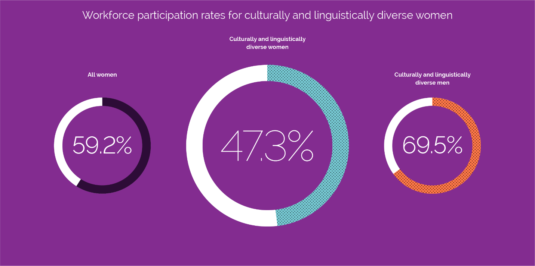
Source: (Prasad et al, 2018)

Reconciliation Action Plans
It is very important for the organization that is operating at such a massive level to make sure that they are allowing the different stakeholders that are working at the level of the organization to understand what are some of the cultural constraints. Specially in country like New Zealand where there are lot of the things that can be done in this regard to make sure that the social and economic participation of the people is going to be made possible (Leveson et al, 2018). One area that has always been neglected when it comes to the broader policy making and integration is the Aboriginal and Torres Strait Islander Australia (Prasad et al, 2018). What this reconciliation action plan is intending to is that it is trying to make sure that enough diversity tools are being prepared that are going to eventually make sure that the Division of the Diversity across the board in Australia is going to be managed in the appropriate manner and the prior commitments that are witnessed in this regard are taken care off. They have specially worked with the Reconciliation Australia to identify the talent pool that belongs to these regions to make sure that the cultural diversity module is being developed and the people from the Aboriginal and Torres Strait Island are being integrated at the broader level in Australia (Hartenian & Gudmundson, 2017). Not only that, the policy and its blue print is readily available on the open sources which means some of the other organizations that are the part of the system are going to be able to take the cue and they can work on the same set of ideals to make sure these things are achieved (Ang & Van , 2015).

Integrating Maori and Pasifika People into the Fold
Now, despite the fact that Maori people are an important demographic in the region, not much of an effort is being made to make sure that they are being integrated into the job market fold (Konrad et al, 2018). One of the reasons that they are not being allowed that much at the workplace is that their culture is quite different as compared to the one that is being seen in the normal workplaces around the world (Triandis et al, 2015). They form an integral part of the demographic of the region and thus there is a need to make sure that an effort is being made that these unique set of people are integrated somewhat into the job market (Devine et al, 2016). What ANZ Banking Group has done is that it has made sure that the people of this region are brought into the fold with the help of the specialized cultural exchange programs (Ang & Van , 2015). With that, effort was being made to not only customized products being made for this market segment, but effort was also being made to ensure that how specific promotional offerings were created for these people (Watson et al, 2016). The idea behind the whole thing was to make sure that the engagement level of these people have to be increased. One of the ways through which it could have been done was to allow greater representation of these people of every demographic (Watson et al, 2016). The continuation of this whole effort was to make sure that the staff training programs were also carried out as well as making sure that how the language and the culture of these people is being showed during the course of the cultural campaign (Ang & Van , 2015). The idea was to make sure that all the communities that are involved in the decision-making process of these people have to be involved. It resonated well with the set of values that were set by Australian and New Zealand Banking and group and went a long way towards making sure that how these people were allowed the recognition and some sort of celebration of the culture of these people was carried out at the given point of time.

Given the Chance
Even though the Australia as a nation does not face the same issue in terms of the refugee population, but they are still considerable people that are coming into the country (Patrick & Kumar, 2016). Thus, it is very important to make sure that the contribution of these people in the economy is being realized and effort is being made to make sure that they are integrated into the economy at some level (Ang & Van , 2015). One of the ways through which it can be done is to make sure that the people who have refugee background and are migrants are brought into the workplace fold (Watson et al, 2016). Not only that, the ANZ Banking Group is one of the few organizations that have made a conscious attempt towards making sure that people who are seeking asylum in Australia are also being involved in the way decision making has been done for the good of the country (Devine et al, 2017). One of the key thing that ANZ has done in this regard is that how they have partnered with the Brotherhood of the St Laurence. The idea is to ensure that considerable job opportunities are provided to the people who are looking to work this way and thus allowing greater opportunity to these people to integrate into the job market (Watson et al, 2016). The idea behind this initiative was to ensure that people who do not have the best of opportunity to enter into the Australian job market are also given a chance (Watson et al, 2016).

Integration of the LGBT Community in the Organizational Fold
The problem at the moment is that it has become increasingly hard for the LGBT community to make sure that they integrate into the job market (Prasad & Mills. 2017). The problem for them is that how they are going to be making sure that even in the times when the community is gaining relevance among different stakeholders in terms of diversity, it has become extremely hard for these people to make sure that they are well represented (Prasad & Mills. 2017). And it goes way beyond the conventions of the job market due to the fact that even in the normal societal routine, they have a hard time making sure that they become the part of the way things are being done (Watson et al, 2016). The idea by ANZ Banking Group was to make sure that the sense of inclusion is being provided to the people that belonged to this group and thus allowing them various avenues through which they would find it easier to interact with one another (Prasad & Mills. 2017). The campaign was carried out and during the course of the campaign, effort was being made to make sure that the simple things such as homosexual couples holding hands and raising awareness about the issue that how the support system must be developed. The crucial things that is needed to be done during the course of the organizational cultural policies are needed to be amended as well (Prasad & Mills. 2017). The research showed that the movement and the campaign had a positive impact in terms of the way homosexuals were feeling at the workplace and it allowed them an environment through which they are going to be able to make sure that they are among the select group of people who are secure when it comes to showing their sexual inclination in public (Devine et al, 2017). The campaign generated lot of positive goodwill for the Australian New Zealand Bank and it was one of the prime reasons that the they were able to land diversity award for three consecutive years (Ely & Thomas, 2016).

Celebrating of the Diversity Week
The ANZ Banking Group is one of the few organizations that regularly celebrates the diversity week for its employees. The idea behind the program is to make sure that the diverse and vibrant workforce was carried out (Lewis & Geroy, 2016). Each day of the diversity week focused on the premises that how it can be made sure that the different aspects of the organizational diversity can be managed (Ely & Thomas, 2016). For instance, there was a whole day that is dedicated to the Maori community, and then there was a day that is dedicated towards the refugee and indigenous communities (Robinson & Dechant, 2017). The idea behind the whole week was to make sure that the understanding and realization has to be there are among different stakeholders that what is the composition of the people that are working in the Australian New Zealand Banking Group and how effort is needed to be made to make sure that the individuals are able to understand the overall banking system and make an effort to innovate in an appropriate manner (Ely & Thomas, 2016). Not only that, the other thing that is needed to be done during the course of the whole process was to make sure that the people tend to understand how the process regarding the diversity is needed to be managed (Robinson & Dechant, 2017). It was a celebrated event and one of the major corporate events in the Australia where effort was being made to make sure that the more inclusive of the region was being showed (Christian et al, 2016). In the hindsight, it can be said that the ANZ Banking Group is a major contributor towards how the diversity management is being done and stands out as a great example of what are some of the perceived benefits of diversity (Lewis et al, 2017). Being one of the top organizations, below mentioned is their performance with respect to the management towards change.

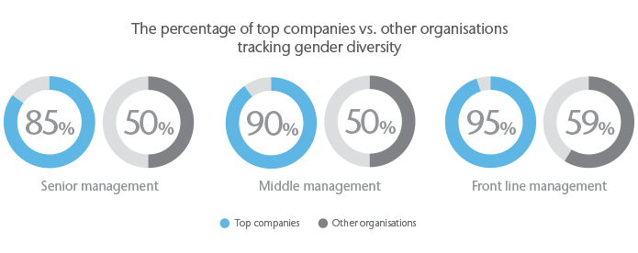
Source: (Lewis et al, 2017)

Conclusion
Diversity has become an important aspect of the organizational management in this day and age. It is very important for all the stakeholders to have an understanding about how the diversity in the organizational culture is needed to be looked at and what are some of the key concerns in this regard (Ely & Thomas, 2016). ANZ Banking Group has stood out as somewhat an industry leader when it comes to the way management of the diversity in the organization is supposed to be carried out (Lewis et al, 2017). They have showed different stakeholders what are some of the broader things that can be done at the level of the organization to ensure that the diversity is being managed. Not only they have integrated people from different cultures in their organization, but even the other communities such as LGBT and refugees are also given due consideration during the course of the whole process (Ely & Thomas, 2016).

References

Abbasi, S. M., & Hollman, K. W. (2017). Managing cultural diversity: The challenge of the'90s. Information Management, 25(3), 24.
Ang, S., & Van Dyne, L. (2015). Handbook of cultural intelligence. Routledge.
Christian, J., Porter, L. W., & Moffitt, G. (2016). Workplace diversity and group relations: An overview. Group Processes & Intergroup Relations, 9(4), 459-466.
Davidson, M., & Fielden, S. L. (2016). Individual, diversity and psychology in organisations. John Wiley and Sons.
Devine, F., Baum, T., Hearns, N., & Devine, A. (2016). Managing cultural diversity: opportunities and challenges for Northern Ireland hoteliers. International Journal of Contemporary Hospitality Management, 19(2), 120-132.
Devine, F., Baum, T., Hearns, N., & Devine, A. (2017). Cultural diversity in hospitality work: the Northern Ireland experience. The International Journal of Human Resource Management, 18(2), 333-349.
Ely, R. J., & Thomas, D. A. (2016). Cultural diversity at work: The effects of diversity perspectives on work group processes and outcomes. Administrative science quarterly, 46(2), 229-273.
Fine, M. G., Johnson, F. L., & Ryan, M. S. (2018). Cultural diversity in the workplace. Personnel Administration, 19(3), 305-320.
Hartenian, L. S., & Gudmundson, D. E. (2017). Cultural diversity in small business: Implications for firm performance. Journal of Developmental Entrepreneurship, 5(3), 209.
Hearns, N., Devine, F., & Baum, T. (2017). The implications of contemporary cultural diversity for the hospitality curriculum. Education+ Training, 49(5), 350-363.
Konrad, A. M., Prasad, P., & Pringle, J. (Eds.). (2018). Handbook of workplace diversity. Sage.
Leveson, L., Joiner, T. A., & Bakalis, S. (2018). Managing cultural diversity and perceived organizational support: Evidence from Australia. International Journal of Manpower, 30(4), 377-392.
Lewis, D., French, E., & Phetmany, T. (2017). Cross-cultural diversity, leadership and workplace relations in Australia. Asia Pacific Business Review, 7(1), 105-124.
Lewis, J. S., & Geroy, G. D. (2016). Employee spirituality in the workplace: A cross-cultural view for the management of spiritual employees. Journal of Management Education, 24(5), 682-694.
Mor Barak, M. E., Findler, L., & Wind, L. H. (2018). Cross-cultural aspects of diversity and well-being in the workplace: An international perspective. Journal of Social Work Research and Evaluation.
Patrick, H. A., & Kumar, V. R. (2016). Managing workplace diversity: Issues and challenges. Sage Open, 2(2), 2158244012444615.
Prasad, P., & Mills, A. (2017). Understanding the dilemmas of managing workplace diversity. Managing the organizational melting pot: Dilemmas of workplace diversity, 1.
Prasad, P., Mills, A. J., Elmes, M. B., & Prasad, A. (2018). Managing the organizational melting pot: Dilemmas of workplace diversity. Sage.
Robinson, G., & Dechant, K. (2017). Building a business case for diversity. Academy of Management Perspectives, 11(3), 21-31.
Rubaii-Barrett, N., & Beck, A. C. (2016). Minorities in the majority: Implications for managing cultural diversity. Public Personnel Management, 22(4), 503-521.
Stevens, F. G., Plaut, V. C., & Sanchez-Burks, J. (2018). Unlocking the benefits of diversity: All-inclusive multiculturalism and positive organizational change. The Journal of Applied Behavioral Science, 44(1), 116-133.
Thomas, K. M., & Plaut, V. C. (2016). The many faces of diversity resistance in the workplace. Diversity resistance in organizations, 1-22.
Triandis, H. C., Kurowski, L. L., & Gelfand, M. J. (2015). Workplace diversity.
Watson, W. E., Kumar, K., & Michaelsen, L. K. (2016). Cultural diversity's impact on interaction process and performance: Comparing homogeneous and diverse task groups. Academy of management journal, 36(3), 590-602.
Wentling, R. M., & Palma‐Rivas, N. (2017). Current status and future trends of diversity initiatives in the workplace: Diversity experts' perspective. Human Resource Development Quarterly, 9(3), 235-253.

