[Name of the Writer]
[Name of Instructor]
[Subject]
[Date]
Work Image Analysis

“Work is about a search, too, for daily meaning as well as daily bread, for recognition as well as cash, for astonishment rather than torpor; in short, for a sort of life rather than a Monday through Friday sort of dying.”
The quote mentioned above was written by famous American author, actor, historian and broadcaster, Studs Terkel, in his classic book, Working. With these words, the author wants to highlight the significance of work an why it should be important for any individual.
To elaborate the words of Terkel in a more appropriate way, two images have been selected.

Image 1:
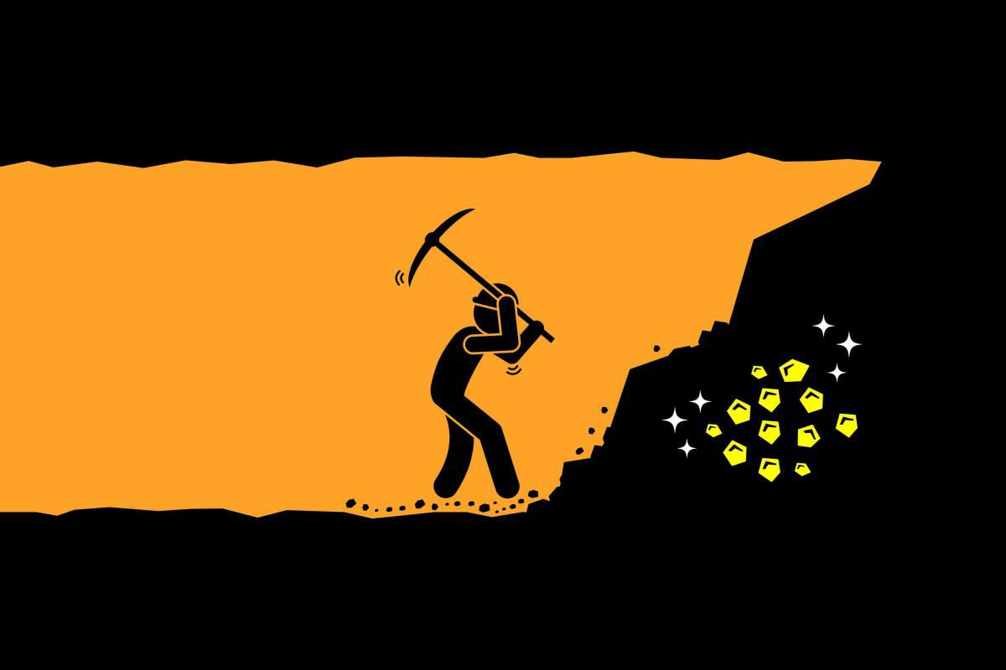

The above image depicts the benefits of working, especially working hard. In the picture, a man, most probably a laborer is shown working in a mine of coal. The laborer is digging on the stones, and it is an established fact that how hard working and digging in the pits is. The artist has tried to portray that if you work hard, you will get something good in the end, which implies that work is nothing but meaningful.

Image 2:

This image shows the workspace of an office. This image is more related to teamwork at workplace and the importance of working in groups. There are some laptops and notes over the table, and the workers are shown to first-five with each other to show unity and teamwork for some upcoming project. This implies that if the work is done happily and by keeping yourself united, it can prove to be more productive and increase your motivation.

