Business Report
[Author Name(s), First M. Last, Omit Titles and Degrees]
[Institutional Affiliation(s)]

Executive Summary
Total Quality Management is an approach that uses tools and techniques to implement TQM in the operations of a company. It remained as an area of excellence of Toyota. Toyota gave a practical outlook on the implementation of TQM in operations and management. In order to respond the increasing demands of quality, the company came up with the implementation techniques of Total Quality Management. The first step initiated by the company was to stop switching workers between machines and expanded those practices to other operational divisions. The company has its own version of the TQM which is usually referred to as TPS or Toyota production system. At Toyota, Kaizen is a way of life that is the principle of continuous improvement. The production system at Toyota is characterized by Just in Time manufacturing, manufacturing according to needs, and Kanban and Jidoko or autonomation. In 2001, the company also established “The Toyota Way” that sums up its goals and objectives of quality. The company has adhered to the core principal of manufacturing high-quality products since its founding. Eventually, this has become the source of competitive advantage for the company.

Introduction
The total quality management is a sustainability approach which centers at customer satisfaction by providing them with the optimum level of quality in products and services. It is the customer-centered approach and uses tools and techniques to implement TQM in the operations of a company. This report seeks to discuss the excellence and successful employment of TQM at Toyota, which is its area of excellence of the company (Dahlgaard & Mi Dahlgaard-Park, 2006). Firstly, the report will discuss the background and the need for total quality management in the company and then it will make an analysis of how the company successfully applied TQM principles in its manufacturing and services. Toyota gave an outlook to the TQM practices and it is said that TQM today is due to the quality improvement practices at Toyota Motors Co., Ltd. The company has received several awards for its TQM practices counting the Deming Application Prize in 1965 and the Japan Quality Control Award in 1970.

Background
Toyota is one of the leading Japanese companies in the automobile industry and its products are marketed and sold worldwide. The company was established in the year 1937, on August 7, it is known for manufacturing vehicles and financing in other industries as well. The primary market of the company in Japan, Europe, North America, and Asia as well. The manufacturing of automobiles in Toyota involves numerous steps such as design, production, and assembling of parts. The automotive division also involves marketing and selling of products. The company owns subsidiary companies as well named as Daihatsu focused on manufacturing mini vehicles and cars and Hino that manufactures trucks and buses.
The parent company, Toyota manufactures components and parts of the vehicles, and currently, three types of cars are sold at Toyota comprising conventional, hybrid and full cell vehicles. The company's product line ranges from mini-vehicles, compact cars, buses, and sports cars to pickup trucks. At Toyota, the automobile segments were facing several issues such as defects in products due to the wear and tear of machinery. Owing to this fact the productivity lessened in the operating division. The systematic defects, that can be defined as worker's confusion in working from one machinery to other required the solution to the issue. In order to increase productivity and overcome the issue of ascending defects, and respond to the increasing demands of quality, the company came up with the implementation techniques of Total Quality Management.

Analysis and Discussion
Toyota faced huge challenges as part of the implementing strategy of TQM in its operations. The challenge was to implement TQM on the various problems that the company experienced and those glitches were related to the operational design of the production of its products. In addition, it was also linked with employee behavior and the way employees were treated. It is evident that the challenge was on the management on how well they work with the operations of the company to produce optimum output for the company. The first step initiated by the company was to stop switching workers between machines and assigned individual responsibility of employees on machines. In a way, the principle of training and development was implemented in the operational unit as part of bringing total quality management practices in Human Resource of the company (Miranda Silva, J. Gomes, Filipe Lages, & Lopes Pereira, 2014). After this Toyota expanded its TQM practices in other departments and operational divisions.
The customer-focused approach of the company provides it with the principles that have been imitated by a number of companies around the world. The company has its own version of the TQM which is usually referred to as TPS or Toyota production system. The primary challenge of TPS was to produce the desired results of high-quality service to Toyota customers, equal and fair treatment to workers, providing them with job security and flexibility and reduction in cost (Amasaka, 2008). For this purpose, Toyota integrated the principle of Kaizen or continuous improvement. At Toyota, Kaizen is a way of life. It enabled all the employees at the company to follow the standardized guidelines that replicate the mission, goals, and vision of the company. In addition, it supports the culture which the company tries to maintain in process development and employee relations. Kaizen at Toyota enabled the company to develop and maintain a healthy relationship with the clients (Amasaka, 2008). Kaizen implemented total quality management in the operational management of the company and it became a valuable element in the TPS and promoted training and customer-focused management responsibility that reflects TQM’s philosophies.
The production system at Toyota is characterized by Just in Time manufacturing, manufacturing according to needs, and Kanban and Jidoko or autonomation. Toyota implemented just-in-time production in order to meet customers’ demands efficiently and promptly and this production technique linked the production activity to the real demand in the market place. Just-in-time production heavily depends on precise processes based on the number of items needed in a specific time. It was a planning challenge but the Toyota Production System has reacted to this issue by adopting an approach that meets this challenge in a cost-effective and efficient manner. Just-in-time is itself, grounded on four crucial principles that work collaboratively to aid this unique concept at a basic level: Heijunka, Elimination of waste, Takt time and Kanban.
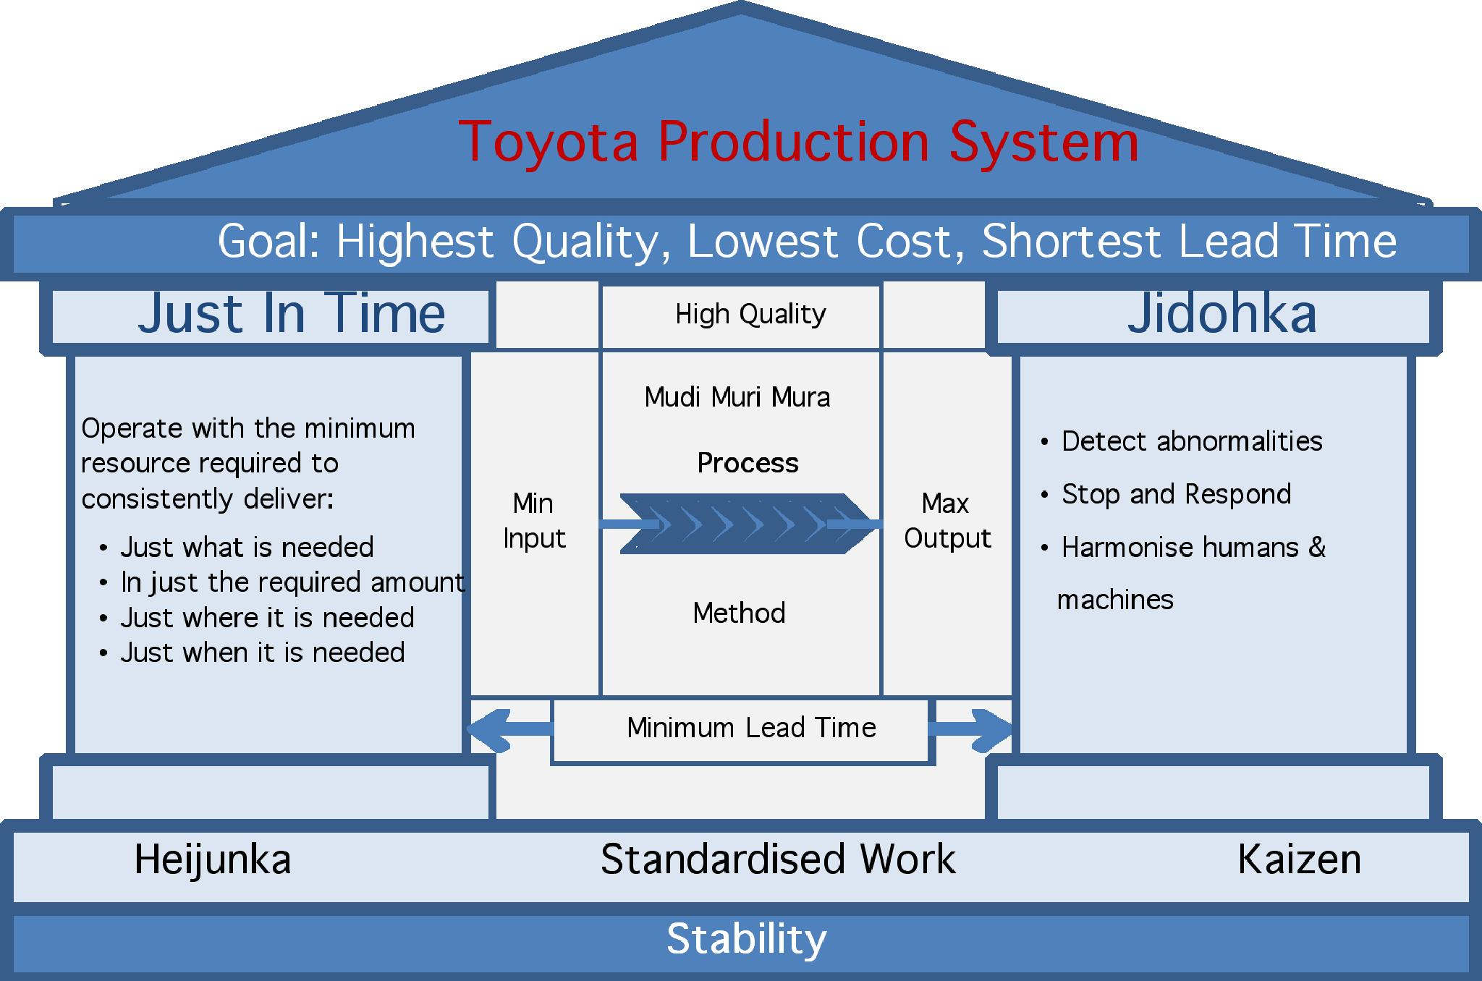
Figure 1Toyota Production System
At the TPS, there is no room for compromise when it comes to quality. Jidoka or autonomation integrates quality appraisals into each stage of the manufacturing process. The origin of Jidoka or autonomation can be traced back to Sakichi Toyoda, Toyota’s founder. He made the Toyoda power loom, which was the first one in the world with a non-stop shuttle change motion and automatic stopping device. Jidoka ensures that any abnormalities in the process are resolved promptly by guaranteeing that all processes are noticeable. Quality is throughout checked and every team member is accountable for quality evaluation before the products are transferred to the subsequent production line. Any error identified is dealt in no time. The Kanban System manages the just-in-time process, it is a scheduling system, different from the TPS and exists to manage and control the quantities in each process of just-in-time process and lean manufacturing. Toyota implemented this system in 1953. The mandatory amount and units are written on the card that is communicated to the people involved in the proceeding process in the Toyota plant. Toyota established rules and principles to implement Kanban. Three distinctive steps are involved in kanban which leads to the process completion.
In 2001, the company established "The Toyota Way", as part of its global expansion and in this, it sums up its goals and objectives of quality. It comprises of two main pillars "Respect for People" and “Continuous Improvement”. The company declares that it felt the need for presenting the latest values, goals, and guidelines to the employees belonging to different cultures and backgrounds and work for the company. It is a system intended to offer tools for people to allow them to continuously improve. It is the culture of the process improvement methods which is dependent on employees for waste elimination, identifying issues and fixing them. It is a system intended to provide techniques to people to constantly hone their work. The Toyota Way means high dependency on people.

Conclusion
An analysis of the implementation techniques of TQM at Toyota reveals that how Toyota achieved success in the areas of creating job satisfaction for its workers and enabled them to take responsibility of reducing defects and enhancing quality in its manufacturing and operations division. The production system at Toyota pops out from the real experiences and the system is enriched with real-world effects and implications. The system plays a vital role in evolving the operational quality of companies all over the world. Hundreds of companies are following the TQM methods implemented by Toyota even to this date that clearly indicates the success of the company. The company has adhered to the core principal of manufacturing high-quality products and serving to society, since its founding. Eventually, this has become the source of competitive advantage for the company.

References
Amasaka, K. (2008). Science TQM, a new quality management principle: The quality management strategy of Toyota. Journal of Management & Engineering Integration, 1(1), 7.
Dahlgaard, J. J., & Mi Dahlgaard-Park, S. (2006). Lean production, six sigma quality, TQM and company culture. The TQM Magazine, 18(3), 263–281.
Miranda Silva, G., J. Gomes, P., Filipe Lages, L., & Lopes Pereira, Z. (2014). The role of TQM in strategic product innovation: an empirical assessment. International Journal of Operations & Production Management, 34(10), 1307–1337.

