[Name of the Writer]
[Name of Instructor]
[Subject]
[Date]

TD Bank Assignment
Banking in the United States started during the late 1800 and with the passage of time it has become one of the most sought industry in the United States (Grosse and Goldberg, 2018). The financial market in the United States is one of the most divers in the world and the strength of the financial market is such that it has allowed the banking industry to develop one of the most diverse banking setups in the world (Grosse and Goldberg, 2018). Even though there has been numerous financial crisis, it is the diversity in the banking industry that has allowed United States to make sure that they stay competitive around the world (Grosse and Goldberg, 2018). Some of the major banks in the United States are JP Morgan Bank, Bank of America and Wells Fargo (Perrault and Williams, 2016). There are certain estimates that point out that the overall size of the banking industry of the United States is about 58 % of its total economy (Grosse and Goldberg, 2018).

Size and the Scale of the Banking System
The first thing that is needed to be looked at when one talks about the industry analysis is that what is the size and the scale of the banking industry (Grosse and Goldberg, 2018). The key point that must be kept in mind is that what are the number of institutes and the overall size of the banking industry in United States (Grosse and Goldberg, 2018). It must be noted that it is quite complicated to estimate the actual size of the banking sector in the United States due to the fact that there is considerable diversity in the market as there are semi government as well as the government banks that are working at the given point of time (Grosse and Goldberg, 2018). Following mentioned is the landscape of the banking system in the United States now (Grosse and Goldberg, 2018).

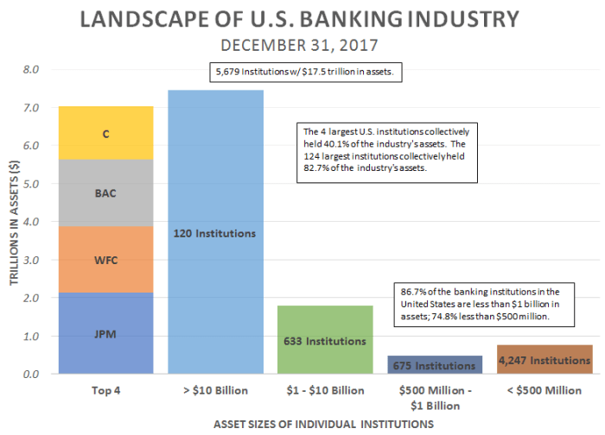
Looking closely at the salient features of the banking industry, the other thing that tends to stand out are the statistics about the banking industry (Grosse and Goldberg, 2018). Now, there are about 633 banks that are working in United States with the estimated asset size of about $ 1 to $ 10 billion (Perrault and Williams, 2016). As per the estimates, the United States banking sector is one of the largest banking sectors in the world (Grosse and Goldberg, 2018).

Industry Trends and Challenges for the Banking
One of the major trends that is witnessed in the banking industry of the United States is that fact that how well spread out the overall system is now (Grosse and Goldberg, 2018). There are 87 % of the banking system that have charters that are less than $ 1 billion now (Grosse and Goldberg, 2018). In the aftermath of the recession of 2008, it was seen that how there are $ 500 million to $ 1 billion in assets at the moments (Grosse and Goldberg, 2018). The number of institutes that are operating now in the United States are set to be around 4500 (Grosse and Goldberg, 2018). The interesting thing is that as the economy is expanding, the banking system of the United States is shrinking further and further (Grosse and Goldberg, 2018). What can be seen from the banking system of the United States is that more and more banks are coming together in a bid to create a consortium and the banking system at the moment in United States is consolidating in a sense that mergers and acquisitions are being carried out at an extensive level meaning that the spread of the overall banking system is going to decline (Grosse and Goldberg, 2018).

TD Bank Profile
TD Bank is a United States national bank and the subsidiary of the Canadian multinational bank (Adrian and Shin, 2019). The bank now is primary operating in the Eastern Coast in about 15 states in the United States (Grosse and Goldberg, 2018). It is one of the few banks that has its presence in the Washington DC. With the passage of time, it has become one of the largest banks in the United States in terms of the deposits as they are at number 7 in terms of the amount of deposited that they have at their disposal (Adrian and Shin, 2019). The asset mix of the bank is also impressive due to the range of mergers and acquisitions that are carried out TD Bank across its history (Grosse and Goldberg, 2018). The bank has its headquarters in Cherry Hill, New Jersey (Adrian and Shin, 2019).

Challenges and Issues Faced by TD Bank
One of the majors challenged that is being faced gee TD Bank now is that how they are supposed to manage the deposit spread at the given point of time (Grosse and Goldberg, 2018). The bank has been struggling for quite some time now when it comes to how they are going to be taking care of its deposits and thus they must make sure that they are not facing liquidity constraints and issues at the given point of time (Adrian and Shin, 2019). At the same time, the other major issue for the bank is that how they have not been successful when it comes to making sure that they advance ahead with their retail banking (Grosse and Goldberg, 2018). Currently, it is very important for the banks to make sure that they are integrating technology in terms of the way they operate at the given point of time (Adrian and Shin, 2019). One of the biggest issues that is faced by TD Bank is that they are not applying technology in an appropriate manner in terms of the way they are operating and thus they must ensure that they bring on board major technological challenges in terms of the way they are supposed to be operating. Thus the major change in the technologies and the reluctance on the part of the TD Bank when it comes to adopting these changes is one of the major issues that is faced by TD Bank (Adrian and Shin, 2019). At the same time, the other major challenge that is faced by TD Bank is that how they are supposed to be managing the ever-changing customer expectations (Adrian and Shin, 2019). Now, as the technology has become a more dominant part of the way banking systems are needed to be operating, it is very important for TD Bank to make sure that they are providing their client base mobile banking options (Reinhart et al, 2017). That is not happening now as the mobile banking options that the banks need to provide are needed to be diverse. As per the surveys that are carried out by PwC, about 50 % of the client base these days is relying on internet banking when it comes to the way major decision making is supposed to be carried out. On the other hand, bank like TD Bank is reluctant when it comes to using the technology which is one of the major challenges that is faced by them (Adrian and Shin, 2019). The large number of branches that are opened by them is another issue in terms of the way they operate (Grosse and Goldberg, 2018). The problem is that they are still relying on the premise that the customers tend to prefer banking with the help of the manual interface and the manual banking is the way forward (Grosse and Goldberg, 2018). The increased number of branches means that not only they are facing challenges in terms of the way cost management is supposed to be carried out (Grosse and Goldberg, 2018). It has led to considerable strain on their resources. So, this is another area that they need to work upon more closely to make sure that better results are obtained in terms of the banking performance at the given point of time (Grosse and Goldberg, 2018). In the next section, SWOT analysis of the banking industry is going to be carried out (Grosse and Goldberg, 2018).

SWOT Analysis
Strength
- The huge branching networks
- Brand equity as well as extensive global outreach
- Major range of diversified banking services (Saba et al. 2018)
- Offering CASA and insurance to the customers as a matter of fact, TD Bank is one of the few banks in the United States that is following this practice (Perrault and Williams, 2016)
- TD Bank has gone a long way towards making sure that they are working as a mere saving and loan faciliatory to making sure that it plays a much more active role in banking operations (Hasan and Marton, 2016).

Weakness
- One of the major issues for the TD Bank is that there is lack of coordination on their part when it comes to the way development of the services are supposed to be carried out (Hasan and Marton, 2016).
- The huge branches of the network mean that the asset utilization is far from ideal and as the resources are scattered, the bank is carrying a huge risk in terms of the way they operate (Hasan and Marton, 2016).
- There are some structural weaknesses that are faced by the banks since how there are contrasting ideologies at the global and local level (Hasan and Marton, 2016)

Opportunities
- With the increased diversity in the United States financial market, there is scope for them to make sure that they can further work on to ensure that they can increase their deposit base (Hasan and Marton, 2016)
- Implementation of the technology can go a long way towards bringing about new avenues for the banking for TD Bank (Hasan and Marton, 2016)
- Economic recovery is quite visible, and the banking industry has revived its fortune and it provides them an opportunity to make the most of it (Hasan and Marton, 2016).

Threats
- The mergers and the acquisitions of the banks and the consolidation means that the new competition is always evident in the banking industry (Perrault and Williams, 2016)
- With some of the other prospective markets becoming more attractive, they carry a risk of liquidity constraints in the future (Perrault and Williams, 2016).

Conclusion and Recommendations
There are many things that are needed to be done by TD Bank to make sure that they stay competitive in the highly diversified market in the banking world. One of the major challenges that is faced by them now is that how they are going to make sure that they integrate technology in terms of the way they operate (Perrault and Williams, 2016). Thus, the integration of the technology must be the key agenda in terms of the way they operate (Hasan and Marton, 2016). The other major thing that the bank must do is to make sure that the bring about efficiency in terms of the way they operate and must focus more towards online banking (Hasan and Marton, 2016).

Works Cited

Adrian, Tobias, and Hyun Song Shin. "The shadow banking system: implications for financial regulation." FRB of New York Staff Report 382 (2019).
Grosse, Robert, and Lawrence G. Goldberg. "Foreign bank activity in the United States: An analysis by country of origin." Journal of Banking & Finance 15.6 (2018): 1093-1112.
Hasan, Iftekhar, and Katherin Marton. "Development and efficiency of the banking sector in a transitional economy: United States experience." Journal of Banking & Finance 27.12 (2016): 2249-2271.
Perrault Crawford, Elise, and Cynthia Clark Williams. "Should corporate social reporting be voluntary or mandatory? Evidence from the banking sector in France and the United States." Corporate Governance: The international journal of business in society 10.4 (2016): 512-526.
Reinhart, Carmen M., and Kenneth S. Rogoff. "Banking crises: an equal opportunity menace." Journal of Banking & Finance37.11 (2017): 4557-4573.
Saba, Irum, Rehana Kouser, and Muhammad Azeem. "Determinants of Non Performing Loans: Case of US Banking Sector." The Romanian Economic Journal 44.6 (2018): 125-136.

