Program Development in Recreation & Sports
[Name of the Writer]
[Name of the Institution]

Program Development in Recreation & Sports

Name of the Agency
In this day and age, it is very important that there are youth sports programs that are needed to be setup to make sure that young people have an outlet where not only they can train and make the best of their abilities, but they are also able to make sure that they can channel their creative prowess and energy. The name of the youth Program is YMCA of the Triangle

Mission Statement
The purpose behind the formation of the YMCA of the Triangle is to make sure that the facility and a place can be provided to the young people where they are in the position to make sure that they can channel their positive energy. Also, the idea behind the formation of the program is that in this day and age, where physical activities are rather limited, an opportunity and place is provided to the people where they can let it out all out.

Vision
To create a state-of-the-art youth program that not only provides greater sporting opportunities and facilities to the people in the community, but to also make sure that such facilities are able to create class level athletes that can move forward in their respective career.

Values
Following are some of the values.
- Commitment towards fitness
- Promoting the fitness culture among the young generation
- Allowing them to make sure that they indulge in positive physical activities
- Providing them with the venue from where they are able to create and channel their physical activities.
- Coming up with appropriate sporting events that provide representation of the community at the broader level.

Strategies
One of the key things that the YMCA of the Triangle intend to achieve is that it wants to make sure that the appropriate facilities and avenues are provided to the people at the given point of time. The idea is to make sure that by channelizing and using the funding in an appropriate manner, a facility is created that allows people a relaxing environment where not only they are able to interact, but they are also able to make sure that they spend time in positive sporting activities.

Organizing Authority
It has to be noted that when such a facility is being setup, it requires lot of funding and getting the community to engage for the funds is a possible option, the support from the government is always going to be needed to make sure that the appropriate decision making could be done in terms of how the funding options are going to be looked at. As the YMCA of the Triangle intends to provide state of the art facilities, it means that the funding requirement are going to be on the higher side. The idea is to make sure that the partial funding for the initiative is being done by collecting and mobilizing the local community for the funds. The equipment though and some of the major start-up cost has to come from the side of the government. The initial costs are always going to be on the higher side due to the fact that there are lot of things that are needed to setup the facility of such a magnitude first time around, and without any intervention or support from the government, it is going to be very hard to ensure such a venture is setup. The role of government also becomes important due to the fact that it is one of the few instances where regulatory compliances are needed to be taken care off in terms of creating a high performance centre

Organizational Structure of the Facility
The organizational structure of the facility is going to be modelled on these grounds.

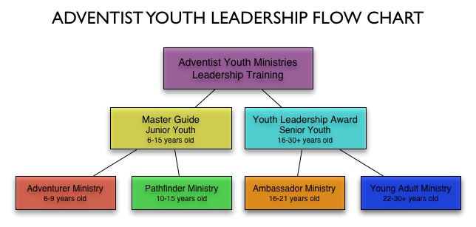
Now some of the initial requirements and the idea is being developed as far as the way the whole thing is going to work. The next section is going to look at the roles and the responsibilities of the people who are involved in the whole process.

Job Descriptions

Job Description of the Incumbent
Following are some of the tasks and the duties that incumbent has to perform as far as the major roles and duties are concerned.
- Making sure that the oral and written communication at both the ends is being carried out in an appropriate manner.
- Ensuring that the connection is setup between the youth and the training centre and understanding some of the expectations of the people that are involved with the initiative.
- Planning and organizing activities that the club intends to organize.
- Establishment and monitoring the effective working relationship with all the participants of the program as well as making sure that the volunteers and the public stakeholders are also asked to be involved during the course of the whole process.
- Making sure that the innovative program development capabilities are being showed at the broader level at the given point of time.
- Coordinating the physical activities that are needed to be organized across the board as well as making sure that the positioning of the activities is being done at an appropriate level.

Supervisor Job Description
- Creation of the program and the activities that are going to be carried out at the youth centre are going to be the responsibility of the supervisor.
- They also have to make sure that they are creating and arranging various activities that are needed to be setup for the children at the community centre as well as the adolescents so that they are able to serve the whole narrative in a much more appropriate manner.
- Effort must be on the part of the supervisor that the coordination is supposed to happen among all the stakeholders of the program.
- Effort must be made to make sure that the ways are being found to ensure that the community children are brought together, and a conclusive and fair environment is being provided to them.
- Training and the supervision of the staff at the youth centre is also the responsibility of the supervisor.
- Creation of the budgets, as well as making sure that all the costs and the expenses that are incurring at the centre are also needed to be placed to make sure that the appropriate decision is being made with regards to the overall direction of the program.

Job Description of the Employee
- Management and taking care of the paperwork is one of the most important requirements that is needed to be done at the part of the employee.
- The repair and maintenance as well as the management of the day to day operations of the entity is another thing that is needed to be looked by the employee.
- Effort must also be made on their part to make sure that they are taking signed permission from the parents with regards to the activities that they are supposedly going to be performing in the program in case someone younger than 18 is enrolling in the program,
- Planning of the day to day activities as well as the management of the calendar is something that is needed to be done by the employee.
- Hiring and talent management as well as taking care of the scheduling and time management of the people who are enrolled in the institute.
- The other thing that the employees have to take care is to make sure that they are evaluating and implementing controls in terms of the way performance centre is supposed to work.

Areas and the Facilities Used by the Program
Now some of the particulars of the way program is going to work are being planned out, the next thing that is very important that is needed to be taken care off is to make sure that the areas and the facilities that are supposedly going to be used by the incumbent are needed to be managed in the appropriate manner. Effort must be made to make sure that the degree of independence is needed to be provided to the people who have enrolled into the program. Following are some of the snaps of the areas and program vicinity.

Youth Activities Area
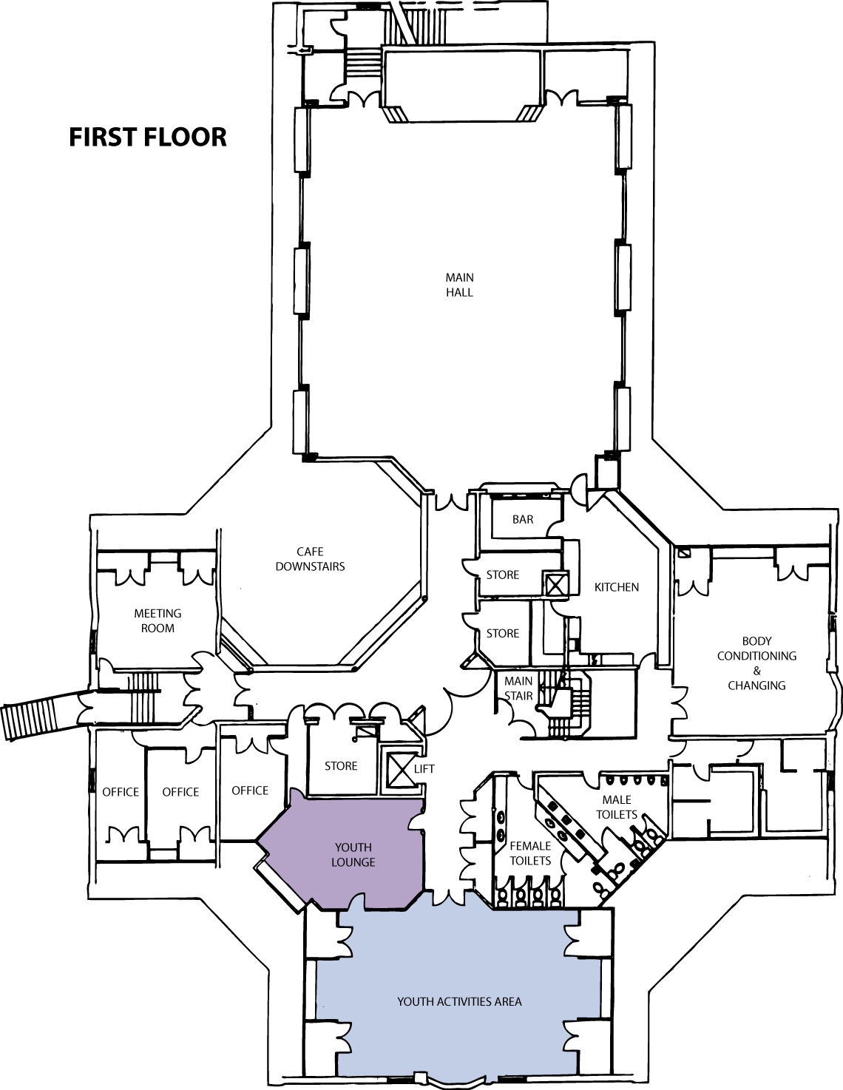

Floor Plan
