Table of Contents
Health care system and economic 1
Summary: 1
Cost effect and cost benefits: 2
References: 4

Health care system and economic

Summary:

This report is based on health care systems and economics in the United Kingdom. We can say that health is the most important factors in human’s life. So, firstly we describe the analysis of UK’s health care systems and also understanding about interdependent relationship between publish health and economics. Many organizations promote this type of work which relates to social health care centers. Organization and public health system funded money for the welfare of society. Here we discuss UK state so, UK state considers a specific country which involves in this work. After researching that results are this country in with a population of about 62.262.000 peoples. The GDP of this country has been $2.260 trillion GBP.so, approximately 8.4% of the UK’s GDP is spent on health care furthermore many institutions held be opened in the UK for the purpose of health care. If we summaries that this progress groom and grow above 10% in the UK state. So, we can say that health is the most important factor. Government of the UK play a vital role in these fields through medical services, prescription and lastly hospital treatment as a public patient.
Wellbeing financial aspects are a part of financial matters worried related to health care. After analysis GDP proportion, health expenditure has grown from around 8.7% in previous 2006-2016 in Australia and other US countries. Money plays a vital role in funding the system NHS within England is mostly funded by there own taxation and national contributions. Another word smaller part is also collected by patient charges like prescriptions dentistry etc involved in this system. A fundamental 1963 article by Kenneth Arrow, regularly attributed with offering to ascend to wellbeing financial aspects as a control, drew calculated qualifications among wellbeing and other goods. Health system enhances workforce abilities.
The United Kingdom spends much money on public health services. In 2000 the UK spend 50 billion pounds and 2008 spend 100 billion pounds. With the passage of time, the UK spends more money around 151.9 billion pounds in 2019. Publish sectors or private sectors mixed provision is not significant in England. After research majority publish provision is focussed rather than other private provision. Edler, J.et al, (2016).
Factors that recognize wellbeing financial matters from different territories incorporate broad government intercession, a recalcitrant vulnerability in a few measurements, deviated data, boundaries to the passage, externalities and the nearness of an outsider agent. In medicinal services, the outsider operator is the doctor, who settles on obtaining choices (e.g., regardless of whether to arrange a lab test, endorse a drug, play out a medical procedure, and so forth.) while being protected from the cost of the item or administration.
Wellbeing market analysts assess various kinds of budgetary data: costs, charges, and uses. Vulnerability is natural for wellbeing, both inpatient results and budgetary concerns. The learning hole that exists between a doctor and a patient makes a circumstance of particular preferred standpoint for the doctors of the UK.

Cost-effectiveness and cost benefits:
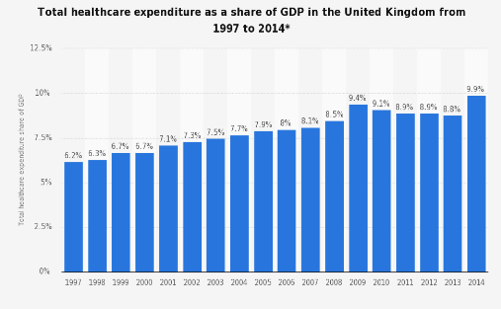
Cost-effect investigation (CEA) is a type of monetary examination that thinks about the relative expenses and results (impacts) of various game-plans.
- cost spoke to on one pivot and the viability on the other axis. Cost-viability investigation centers around boosting the normal dimension of a result, distributional cost-adequacy investigation broadens the center strategies for CEA to fuse worries for the conveyance of results just like their normal dimension and make exchange offs among value and effectiveness, these progressively refined techniques are exceptionally compelling while breaking down mediations to handle wellbeing imbalance. NHS provides well economical supports to the public from the consequences of ill health. This healthcare organization has the lowest proportions of UK’s civilian who can avoid medicines as well as healthcare’s treatments due to costs such as 2.3% in the year 2016 (Kingsfund.org.uk, 2018). The UK has one of the largest shares of the generic prescribing of several comparator countries at 84% in the year 2015 with the comparison of an average of 50%.
The development assistance in health is mostly linked with cost and finance. Because without cost and finance running health care systems not possible. This represents about 1.10% of the national GDP. Also that in 2010, this rate contribution with increasing has been enhanced as the GDP share. The overall innovative financing and cost effect involved funding in response to a global program for health. In this respect, the ideas for innovative funding have been related to cost and benefit effects.
- With the increase in numbers of older people and other age group, aids in inevitable enhance of healthcare expenditure/year.
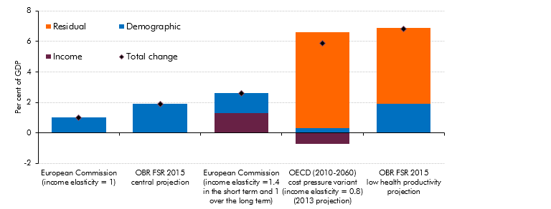
- However, this expenditure of healthcare is not purely determined by the demographic factors, other variables that are non-demographics in nature such as economic, technological and institutional characteristics, modification in health care treatment helps in explaining or impact on expenditure.
- It has been observed that from the aging report of commission in 2015, within the industrialized country, this rate has been increased due to this technological change (obr.uk, 2015).
- This advancement has also impacts on demand of patient too and has reduced labor input (Edler & Yeow, 2016).
- Any consensus has not been observed over the contribution of the demographic income as well as residual factors within health care spending drivers in long term (obr.uk, 2015).
Arraigning training programs for every healthcare professional so that they can adopt those advanced technologies in order to understand data from machinery.UK government needs to invest in the research and development section so that advanced machinery can recognize diseases. Based on those data records, necessary treatment facilities can be provided at the lowest amount of price.
From the above-mentioned analysis, it can be concluded and summarized that within the health care and cost effect and benefits part, analysis of the UK’s health care system has been carried out. This has been for facilitating the understanding of the interdependent relationship among economies, public health, and health care. Health institution play a vital role in UK state and also that all over the worldwide state which related to social benefits and cost-effectiveness.

References:
Cook, J. E., Purdie-Vaughns, V., Meyer, I. H., & Busch, J. T. (2014). Intervening within and across levels: A multilevel approach to stigma and public health. Social Science & Medicine, 103, 101-109. Retrieved from http://personal.psu.edu/jec44/pubs/Cook%20et%20al.,%20SSM%20(2014).pdf

Edler, J., & Yeow, J. (2016). Connecting demand and supply: The role of intermediation in public procurement of innovation. Research Policy, 45(2), 414-426. Retrieved from https://www.sciencedirect.com/science/article/pii/S0048733315001638

