Table of Contents
Introduction 1
Evaluation of IPO amount 2
IPO is a costly way for listing 3
Equity raised from IPO change cost of Capital 4
(d) 6
IPO analysis during period 2007 to 2017 6
XERO on ASX 6
References 8

Introduction
Initial public offer is a way in which an organization (Private organization) make their shares available to the general public to purchase. After the issuance of their shares the statues from private organization change into public or listed company. The process of selling shares can proceed through the general public of financial institutions. As the share is available in the market the general public can buy and sell shares openly which is known as “Trading”. In Australia, the body is known as “Australian Stock Exchange”, ASX. Investing in initial public issue is sometimes very advantageous, as most of the time companies share price increase after IPO, investing a few dollars in some good name companies return back a handsome amount, (Ritter, 2002).
It is not obvious that every IPO will perform good, it depends on the company policies and management behavior towards the buying of shares, some companies outperform in first-day trading and their share price increase which is known as “Underpricing “.
I have selected three companies to form three different sectors, which have to raise capital more than $100million, and their IPO occurs from 2007-2013. The companies are,
Company | Industry | Date of IPO | Amount Raised | Offer price | Closing price on the first day of trading | Return on the first day of trading
Virtus Health | Healthcare Equipment | Jun-13 | $346.5m | $5.68 | $6.20 | 9.15%
GDI Property | Real Estate | Dec-13 | $567.7m | $0.95 | $0.89 | -6.31%
Dick Smith | Retail Store | Dec-13 | $345 | $2.2 | $2.16 | -1.6%

Virtus Health
Virtus Health went into IPO in June-2013 and raised capital of $345.5m. The offer price of shares on the first day was $5.68 which close at $6.20 with an increase of 9.15% on the first day. Pharmaceutical is an attractive market all over the world due to the good growth in their financials. This could be the reason of public interest towards the buying of shares.
GDI Property
GDI property is dealing in real estate, and the company has an initial public offer in Dec-2013, which brings capital for the company $567.7m. The opening price of the share at day first of trading was $0.95 which close at $0.89 with a decreasing effect of 6.31%. Its look like the public is not that much attractive towards the buying of shares.
Dick Smith
Dick Smith was a retails store, which was initially started and found by Mr. Dick Smith as a radio selling shop. After different strategies and better result in company growth, Dick Smith went into IPO in Dec-2013 with the opening price of $2.2 and close at 2.16 with an increasing effect of 1.8%. The company raises $345m from IPO. Baker, M., & Wurgler, J.

Evaluation of IPO amount
Virtus health raises capital of $346.5m and they spend this amount into a different investment such as,
SR | Investment | Amount | Purpose
1 | Sims Clinics Limited | $23.726million | 70% of ownership.
2 | Hari Clinic | €6 million | Ownership
3 | Sunshine Coast | $1.2million | Ownership
4 | Tasmania | $16.0million | Ownership
5 | Capital Expenditure | $12.6million | Expansion
6 | Geographic Expansion | $8.007m | Expansion
7 | Payment of loan | $13.4m | Loan payment
8 | IPO transaction cost | $10.651m | Expenses
9 | Cash reserved | $140m | Assets

GDI Property collect $567.7m in their first IPO, these funds they used to acquire different properties to add the value in their fix assets. The investment of company properties is mentioned below,
SR | Investment | Amount | Purpose
1 | Mill Green Complex | $332.0m | Property Expansion
2 | 233 Castlereagh St | $121.0m | Property Expansion
3 | 25 Grenfell St | $109.0m | Property Expansion
4 | 307 Queen St | $120.8m | Property Expansion

Dick Smith operates in Retail store and company raise the capital of $345.
The company use this amount in three purposes, investment to open new branches that the motive and intention of management on that time, payment to supplier to boost their confidence and mid-year dividend to attract more investors, actually these decision was the major reason of liquidation, management was unable to keep the balance of loan providers and future investments just forget dramatic increase in their sales.
b)

IPO is a costly way for listing
Companies went into IPO for the collection of capital from the general public, as long as IPO has benefits there might be some drawback such as ownership is dilute into the general public, cost of equity increase. Companies collect cash by selling their shares (Ordinary) to meet their long term and short term objectives. Shareholder invests for long term with the intention of good return in the shape of the dividend, as they are sagacious and want to increase their wealth, (Oesterle, 2006).
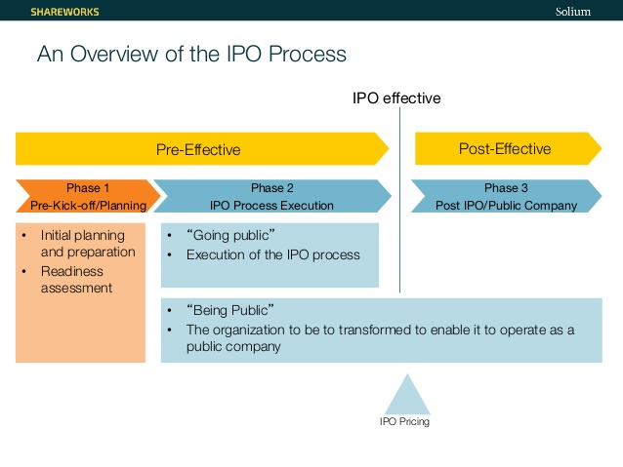
IPO is a process, which involves different steps. A details pre-planning is required and documentation for IPO, which will consume human force as well as huge legal and processing cost. Once the IPO is completed then shareholder demands are very hard to fulfill such as their objectives and management goals should be inline by the following stewardship.
Debt is a cheaper source of finance than equity as it is for the limited period of time and loan providers does not have any post loan approval concerns with the company performance, the organization is doing well or not, they don’t have any concern as there loan as secured against the covenant, (Minton, 1999).

Equity raised from IPO change cost of Capital
Equity finance is an expensive to source of finance that debt because debt is secured against the fixed assets of the company but the Equity is not secured against any assets, if the company goes into liquidation first debt finance holder receive their investment as they are secured. Equity holders will get the residual amount at the end.
Companies cost of capital consists of two factors, debt finance, and equity finance. Which calculate the weighted average cost of capital. But changing the one side of the cost of capital will affect the other side of the cost of capital, (Carpenter, 2002).
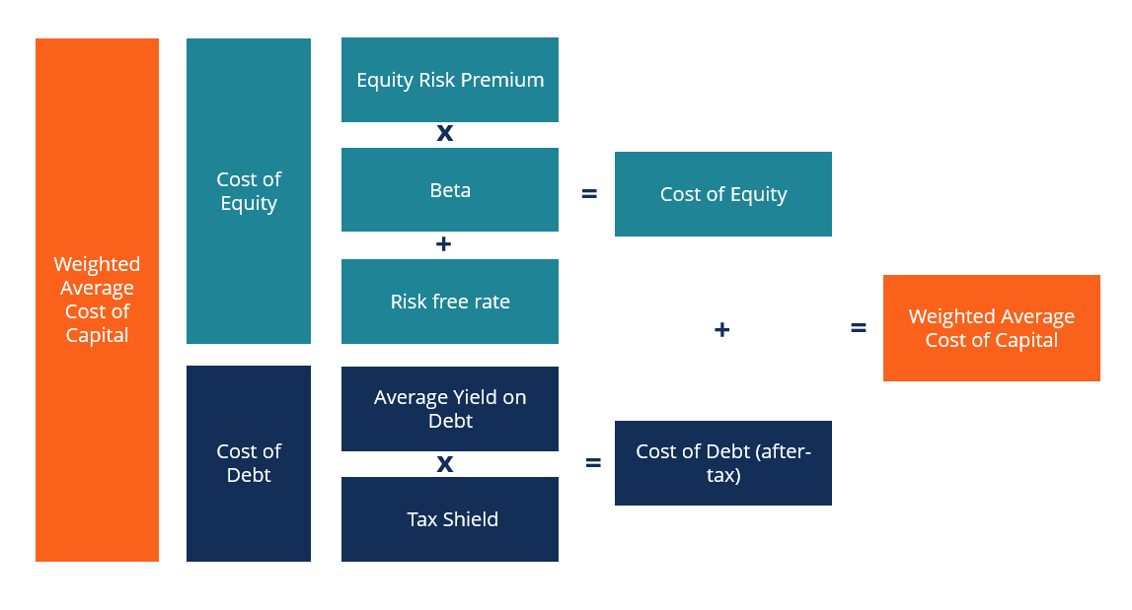
c)
Underpricing is method in which companies offer their shares price less than the value of the company which they have actually, for example, a company has a total worth of its shares $850,000 and they offer the price $5 for 150,000 shares. With this price, the company has a total worth $100,000. So the company follows the policy to attract the customer on the day of IPO. As long as the companies are older they will perform outclass after the IPO as they know how to operate or if they have already experienced in other companies which is already listed on the stock exchange.
It is assessed that the ASX market IPO are underprice 25.47%. Similarly it is also observed some IPO are overpriced which are 1.55%. These assessment are concluded on the basis of market adjusted abnormal return and primary market assessment. (Loughran, 2004).
Empirical studies provide the issues which are relevant to the company performance during IPO, the size of the organization, offer size, subscription rate and the age of the firm. As long as the company is old and well expert they have the good knowledge and skills to perform. Asymmetry and signaling these two theories explain the pricing of IPO. It describes the timing of the IPO which is very important for the success of the company. For example, if the company is going into IPO before the election, the political situation definitely effects the success because in these days investors are little hesitant to invest.
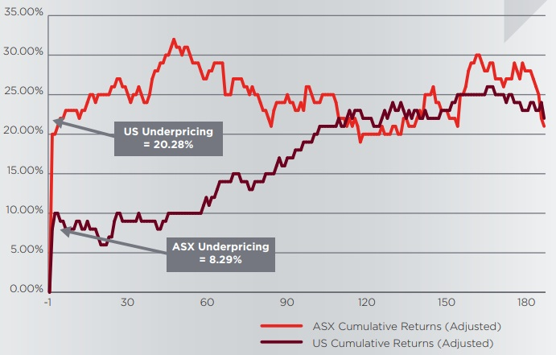

(d)

IPO analysis during period 2007 to 2017
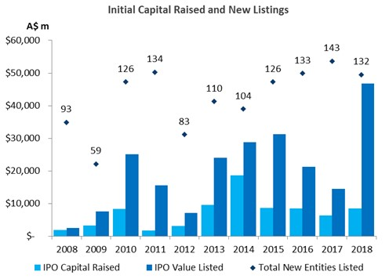
The performance of the Australian Stock Exchange was outperformed during the year 2016 and 2017. The worth of the ASX in 2016 was about to $1.8 trillion in March. Trading volume has increased by about 23% with respect to the previous year. This was the domestic equity market of ASX. The global decision has also affect the ASX such as Trump is elected and the separation of the United Kingdom from European Union affect the stock exchange. So investors manage their risk through geo-political effects and bring their investment to ASX, (Baker, 2007).
2017 was also a good year with respect to the whole decades, two companies were on the stock exchange “supermarket chain Coles and Unibail Rodamco”. In this year almost 132 companies list of the stock exchange and increase the ranking of the ASX on the 18th level. A successful example of Listing is VIVA energies during this year.

XERO on ASX
In February ASX got another milestone, Xero’s Consolidation as a sole listing. This attract the international investors to invest into ASX. Xero has good name in accounting software, the company is also listed in new zeland stock exchange in 2007. The company fall into 100 index as a sole listing. Xero is a multibillion dollar software company, after the consolidation company show their satisfaction in ASX as a listing and investors interest.
Growth of pre-IPO funding is very popular nowadays, cross boarding companies follow this policy for the success of the IPO. Where Revasum, which completed a $10-million pre-IPO round in August, and New Zealand Company Straker Translations are the best example of pre-IPO funding.
Year | IPO activity
2007 | 85
2008 | 93
2009 | 59
2010 | 126
2011 | 134
2012 | 83
2013 | 110
2014 | 104
2015 | 126
2016 | 133
2017 | 143
e)
The Primary purpose of listing is to collect money, the value of the private equity holder is convert into public listing. Companies has different growth during the time period such as some companies outperform after listing due to of their experience and some has bad experience, it depend on many factors. Most of the companies did not perform well straight after the IPO, they need minimum3-5 years to make their position in the market. The investment they collect through IPO they invested in different projects which will take time in return. Once all the investment start maturing the return will arise which add the value in shareholder wealth. It is also difficult for the management to tackle the new rules and regulations of listing and lot of corporate governance issues. So all these things matters for the success of the companies.
In current companies scenario, virtues health perform outclass after the IPO as they issue 14% of dividend in the very next year, similarly Dick Smith distribute mid-year dividend although the company went into liquidation in span of two years due to of the imbalance of investment and loan. The calculations are performed below in the table form the day of IPO to 2018 financial year.

GDI PROPERTY
Year | Opening Price |  |  | Closing Price |  | Growth
2014-2015 | 0.95 |  |  | 0.91 |  | -13%
2015-2016 | 0.91 |  |  | 0.875 |  | -17%
2016-2017 | 0.875 |  |  | 0.885 |  | -10%
2017-2018 | 0.885 |  |  | 1.015 |  | 14%
2018-2019 | 1.015 |  |  | 1.29 |  | 50%
Dick Smith
Year |  | Opening Price | Closing Price |  | Growth
2014-2015 |  | 2.2 | 2 |  | -9%
2015-2016 |  | 2 | 0.35 |  | -83%
2016-2017 |  | Discontinue Operations
2017-2018 |  | due to of Liquidation
2018-2019
 | Virtus Health
Year | Opening Price | Closing Price | Growth
2014-2015 | 7.85 | 5.37 | -32%
2015-2016 | 5.37 | 6.87 | 28%
2016-2017 | 6.87 | 5.38 | -22%
2017-2018 | 5.38 | 5.75 | 7%
2018-2019 | 5.72 | 3.94 | -31%

f)
companies decision will change if the shareholders will demand more dividend in the current period as the share price of all three companies is already is not outclass during the period.

References
Baker, M. &. (2007). Investor sentiment in the stock market. Journal of economic perspectives, . 21(2), 129-152.
Carpenter, R. E. (2002). Capital market imperfections, high‐tech investment, and new equity financing. The Economic Journal, . 112(477), F54-F72.
Loughran, T. &. (2004). Why has IPO underpricing changed over time?. Financial management, . 5-37.
Minton, B. A. (1999). The impact of cash flow volatility on discretionary investment and the costs of debt and equity financing. Journal of Financial Economics, . 54(3), 423-460.
Oesterle, D. A. (2006). The high cost of IPOs depresses venture capital in the United States. Entrepreneurial Bus. LJ,. 1, 369.
Ritter, J. R. (2002). A review of IPO activity, pricing, and allocations. The journal of Finance, . 57(4), 1795-1828.

