Export Plan for D.A.P Exports
[Author Name(s), First M. Last, Omit Titles and Degrees]
[Institutional Affiliation(s)]

Author Note
[Include any grant/funding information and a complete correspondence address.]

Export Plan for D.A.P Exports
D.A.P Exports is the business company that exports the parts of the automobile as well as auto-lubricants to various countries. The main objective of D.A.P Exports is to acquire a handsome amount of sales revenue in its first operational year in Jamaica region. Our target is to gain 100 customer based taxi organizations and also to enhance sales modestly in the second year.
Why This Company Should Export?
D.A.P Exports developed a huge customer contact network in Jamaica. It has the experience of 20 years of selling products both in the Caribbean and Latin America. This company has made a contract with the taxi companies of Jamaica region for providing auto lubricants and auto parts on wholesale rates(Software, n.d.). Now taxi companies will either use parts in repairing vehicles or would sell parts to the consumers. Our company will sell auto parts in the region of Jamaica.
Export plan
D.A.P Exports possess a total of 8,000 sq.ft. area in Florida. Our organization keeps the prices in control and also has fast access to related businesses(“DAP terms, easily explained,” n.d.). Our company startup expenses are more focused on repackaging and inventory equipment.
Product/Service for Export
Our company exports transmission parts, electrical parts, engine parts and lubricants.
Operations
Recently, the market is unable to attract competitors. The shops of auto vehicles are not fulfilling the demand for the older car parts(“DAP EXPORTS PRIVATE LIMITED - Company, registration details, products, directors, charges and contact details | Connect2India,” n.d.). Our strategy is to utilize taxi services in the form of a distribution network and targeting the main customer who can acquire segment market share which is ignored currently from the big players.
Personnel and Export Organization
D.A.P sell products developed from older cars
Resources Inside the Company
Our main resources are skilled workers, our products and parts of cars.
Resources Outside the Company
This company outside resources include vendors and contractors
Industry Structure, Competition, and Demand
Through analysis, it is found that in Jamaica there are more than 25,000 vehicles who use taxi services, also this number is growing rapidly. For D.A.P Exports, the target consumers are taxi firms as they do not have any established channel for purchasing the car parts. When the taxi companies buy products directly from D.A.P Exports the cost will be reduced and they will acquire the desired product immediately.
Products/Services to Be Exported
Automobile and auto-lubricants
Background Facts
Our company's marketing strategy is that in the initial months we will provide 15% off on our all products which are more than 1000 dollars. The target customers are auto parts stores and taxi companies.
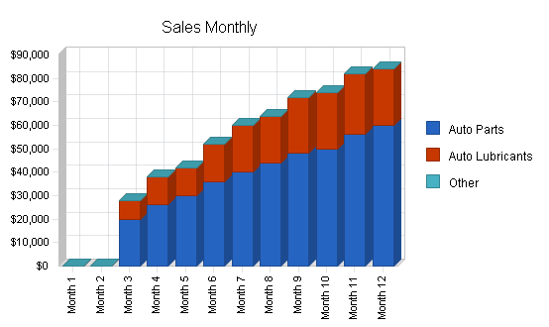

References
DAP EXPORTS PRIVATE LIMITED - Company, registration details, products, directors, charges and contact details | Connect2India. (n.d.). Retrieved November 21, 2019, from https://connect2india.com/DAP-EXPORTS-PRIVATE-LIMITED/1396193
DAP terms, easily explained. (n.d.). Retrieved November 21, 2019, from https://howtoexportimport.com/DAP-terms-easily-explained-515.aspx
Software, P. A. (n.d.). Export Automobile Parts Business Plan Sample—Executive Summary | Bplans. Retrieved November 21, 2019, from https://www.bplans.com/export_automobile_parts_business_plan/executive_summary_fc.php

