Exhibition of world art
Student’s Name
Institution affiliated

Exhibition of world art
- India
- Pilichamundi with an extended tongue
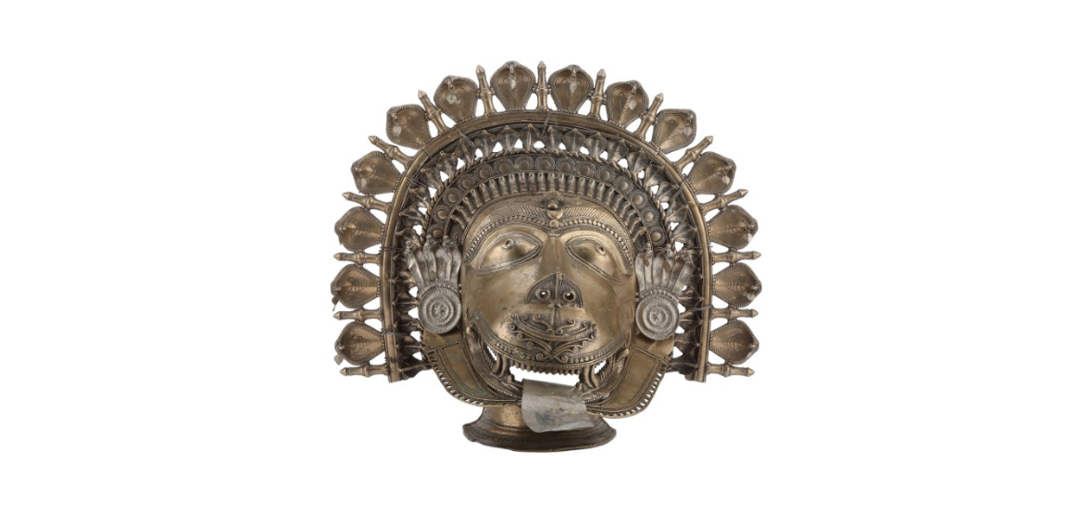
Pilichamundi is a totemic spirit of ancient tiger as practiced by pre-Hindus societies in the Tulu Nundu Region in Karnataka. The artist is unknown and the title of work is believed to Bhuta worship. The art dates 19th century. It was made from brass, but its tongue was made of silver. It is currently located in India’s national museum.
Pilichamundi was a repsentative of Bhutan cultic ceremonies. People worshiped spirit called bhuta in a ceremony called Bhuta-Kola where a priest or oracle invokes the spirits which then appears and interacts with locals by answering their questions and solving their problems. Bhuta worship was intimate practice where families curve out niche in their houses where worshipping was made.

- Karnataka Breastplate
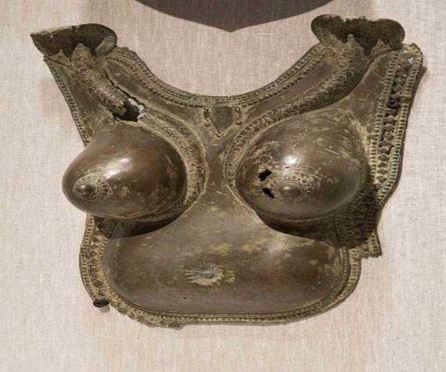
Karnataka breastplate was a 18th -19th century art work created by communities in south India. The ancient communities develop this artwork as a representation of women protection during the ancient tribal wars. Karnataka breastplate was entirely made using bronze. It is currently located in New Orleans Museum Art.
Anthropologists have documented different ways in which breast plate was used especially in Kanara region in southern coast of India where Karnataka Bhutan worship thrived. Apart from acting as protective gear, women adorned Karnataka to show beauty and worship of bhuta. Adorned together with jewelry and beautifully painted consumes, Karnataka served purpose of bringing out beauty of cultural dances.

Chinese artwork
- Painting of Chinese Qingming Festival in 13TH century
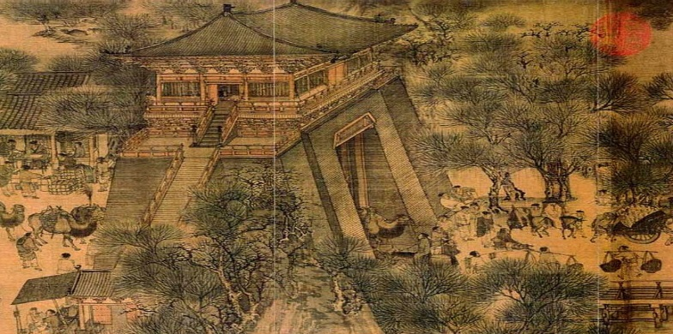
This art was painted by Zhang Zeduan in around 13th century. It is located in Beijing Museum. It is panoramic handscroll
This art represented a painted of Qingming Festival performed in China to celebrate festive spirits and wordly possessions. The festival contained rich art factual elements and cultural meanings in Chinese culture.

- Night Shining White
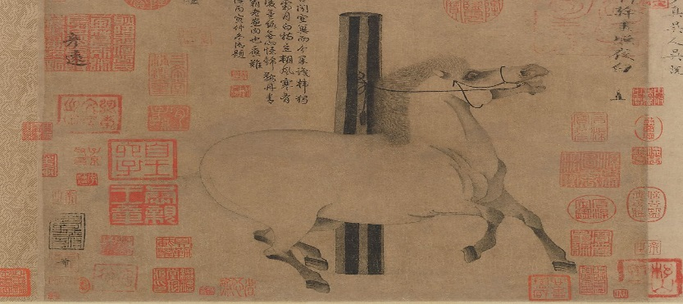
This is a painted art work created by artist Han Can in around 13th century. The painting is located in Metropolitan Museum in New York. It is painted on Handscroll using ink.
The painted shows cavalry horse belonging to emperor Xuanzong during the Tang Dynasty. It represented life during the ancient times especially the reign of Tan dynasty. The horse depicted the mythological high tempered horse, which represented dragon.

- Japan
- The great wave of Kanagawa

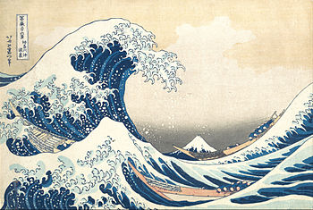
The art was painted by Katsushika Hokusai in around 1829 – 1833. It was painted in color woodblock. It is located in Mentropolitan Museum Art.
The painting depicted the lives of ancient Japanese fishermen especially in the coastal town of Kanagawa. Although many assumed the painting as a representative of tsunami which rocked ancient town, study of the painting showed that it was representation of rogue wave. The painting also represented ancient Japanese landscape during the 19th century

- Landscapes of Autumn and winter
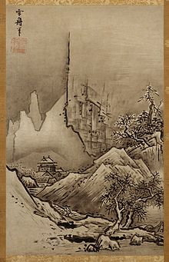
This painted was made by Sesshu Toyo in 15th century during the Muromachi period . It is located in Kyoto National Museum. It was painted in color wood block
This painting depicted the winter and autumn period in ancient Japan. It shows the changing seasons and the beauty of region during the 15th century. It represents ideal understanding of the area.

- African
- Ndop of King Mishe
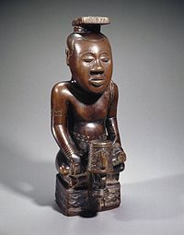
The Ndop of King Mish was made by Mishyaang Mambul in around 1760 – 1780. It is currently found in Brooklyn Museum. It is sculptured out of wooden material.
The ndops are royal portraits representing leaders of Kuba people in Central Africa. These portraits were not only intended to represent naturalist portraits of leader but also kings/leaders spirit. Ndops represented kingship style of leaderships and indicated people believe on immortal of kings.

- Ashanti Trophy head
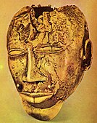
The ashanti trophy head was made in 1870s in the then powerful Asante Kingdom. Though the creators was unknown, it is believed to be created by ancient chiefs who were often leaders in wars. The art was made of pure gold and it is found in Wallace Collection in London.
The trophy head represented head of enemy killed by chief in the battle. It depicted socio-political lives of ancient Ashanti people characterized by tribal wars. It also showed structure of political leadership and role of each leader within the leadership structure.

- Oceania
- Gable figure (Dilukai)
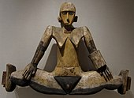
This was 19th century painted wood made by Belauan people. It is found in Metropolitan Museum ART in New York. It was made by Belauan people
The painted art represented a figure of young women carved over doors of chiefs. The art shows a young woman seated and hands placed on thighs. It is believed by Belauan people that the women protected the community from evil spirits.

- Dinonga eidu
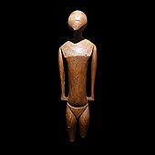
This wooden sculpture made in 1800 in Caroline Islands. It is found in Auckland Museum. it was made of wood.
Dinonga Aidu was important idol worshiped in pre-Christian times in Nakuoro Atoll in eastern Caroline Islands. It was regarded as a representation of community and individual deity. It was highly adorn by people as master guider and protector. It was offered sacrifices.

Overview of “World exhibition art”
The exhibition generated above shows art from different parts of the world including Africa, china, Japan, Oceania and India. These art work has similarities and differences. Some of these arts were made from similar materials, for example, there are made of wood, while others made of metal. Some similar in terms of shape and size of the objects. There are also significant differences. Each artifact had own specific meaning which was relevant to the community owning it. Besides, there was also big difference in where the art were displayed. Some were displayed in leader’s houses while others were carried by people in their daily lives. Generally, arts from different parts of the world showed different meaning and carried specific significance

References
Saffronart (2016) Pilichamundi with extended tongue. Retrieved from https://www.saffronart.com/customauctions/PostWork.aspx?l=20945
NOMA. 2017. NOMA unveils dance ritual objects in new Indian art gallery. Retrieved from https://noma.org/indian-art-gallery-ritual-dance/.
China Online Museum. 2019. Night-Shining White. Retrieved from http://www.chinaonlinemuseum.com/painting-han-gan-night-shining-white.php
The British Museum (2019) Kanagawa-oki nami-ura 神奈川沖浪裏 (Under the Wave off Kanagawa) / Fugaku sanjūrokke. Retrieved from https://web.archive.org/web/20141211122356/http://www.britishmuseum.org/research/collection_online/collection_object_details.aspx?objectId=3097579&partId=1
Tokyo National Museum (2019)Landscapes of autumn and winter. Retrieved from https://www.tnm.jp/modules/r_collection/index.php?controller=dtl&colid=A1398
Wallace collection (2012) trophy head (Asante) Ghana. Retrieved from https://www.wallacecollection.org/collection/trophy-head/
Khan Academy (2018) Portrait of King Mishe miShyaang maMbul (Kuba peoples). https://www.khanacademy.org/humanities/ap-art-history/africa-ap/a/ndop-portrait-of-king-mishe-mishyaang-mambul

Metropolitan Museum Art, 2017, Dilukai from the Caroline Islands, Belau (Palau). Retrieved from https://www.metmuseum.org/toah/ho/10/oci/hob_1978.412.1558a-d.htm
Journal of Polynesian society (1968) A Wooden Image from Nukuoro in the Auckland Museum. retrieved from http://www.jps.auckland.ac.nz/document//Volume_77_1968/Volume_77%2C_No._1/A_wooden_image_from_Nukuoro_in_the_Auckland_Museum%2C_by__Janet_M._Davidson%2C_p_77_-_79/p1

