Economic Trade
Student’s Name
Institution
Date

Q1. Explain the difference between absolute advantage and comparative advantage
The concept of absolute advantage is the natural ability of the nation to produce specific goods in an effective and efficient manner at a very lower marginal cost. However, comparative advantage is the capability of a country to produce specific products at a lower opportunity and marginal cost. Absolute advantage addresses the lower marginal cost of production of specific products compared to competitors in the market. However, the concept of comparative advantage is suitable for international trade because both nations in trade are mutually benefiting because of the comparative advantage of each other.
Q2.
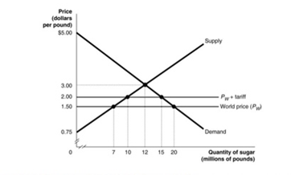
The equilibrium price is $3 per pound and the quantity is 12 million per pound. Therefore, the consumer surplus is 7 million pound of sugar. The producer surplus is 15 million and the government revenue would be $ million. The government regulations would reduce the surplus of the sugar and therefore, the deficit would be created in the market.
Q3. A free trade takes place when there are no government interferences or interventions ad therefore, international trade is open to the economies. However, a country which does not have any comparative advantage can still benefit from free trade. According to Michaerl (2014), free trade increase high quality and lower prices of goods and therefore, a country would be able to have several products, which increase the competition in the market. With market competition, the products or goods would less expensive for consumers. This would benefit consumers and the country through the promotions of the industries which a country has the highest comparative advantage.

References
Michaerl, Meril. "Economic Analysis of demand and supply in the market." International Journal of Trade and business, 2014: 2-34.

