Human rights  HELP  STOP  HUMAN TRAFFICKING  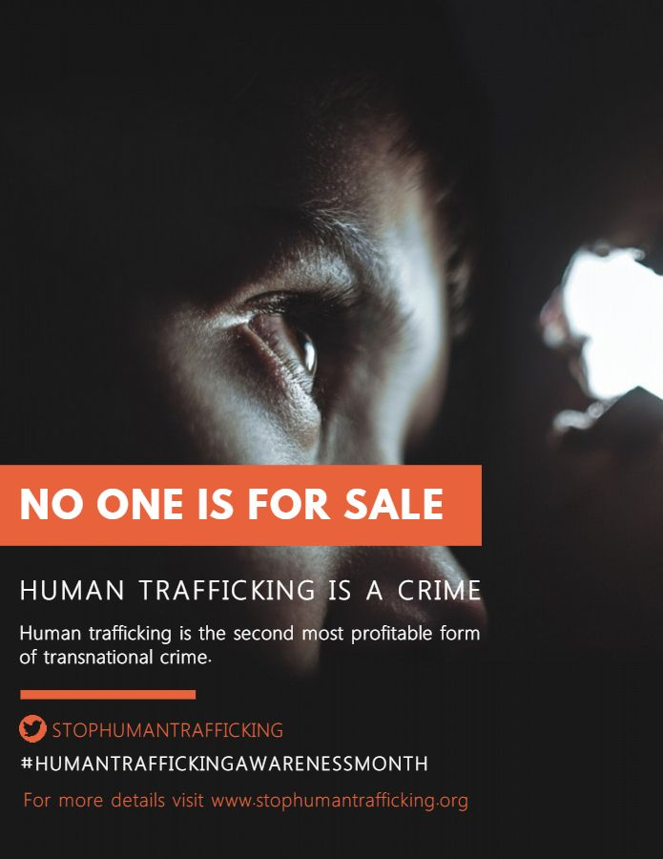 | hUMANS ARE  NOT FOR SALE  NO ONE IS FOR SALE  BREAK THE SILENCE AND  DON’T CLOSE YOUR EYES  TO HUMAN TRAFFICKING  IF NOT NOW, THEN WHEN  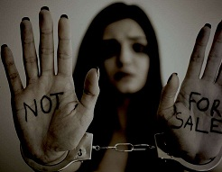

Human Trafficking Issue
Human trafficking is the most painful and prevalent injustice of our time. It is not only a crime; it is a blatant violation of human rights because no one has been given the right to hold someone in slavery or servitude. All human beings are born equal and free in terms of rights and dignity, therefore no one shall be subjected to inhuman treatment. The children, women and men who are most affected by Human trafficking are vulnerable in terms of poverty and low self-esteem. This makes them a target for sexual grooming, false recruitment promises and other abuses. The traffickers do not consider such human beings as humans rather they use them as a product to be sold for personal benefits. They exploit them for the purposes of sex or labor through fraud, force or coercion.
Since the Universal Declaration of Human Rights in 1948, human rights frameworks and standards have been normalized in several international treaties, protocols and standards. The International Covenant on Civil and Political Rights also proclaimed that "no one shall be held in slavery and servitude". The United Nations Protocol was intended to ensure that the trafficked people should not be treated as criminals rather they should be handled as victims (“Human Trafficking”). They should be given specific human rights protection that includes temporary shelter, medical and psychological services, compensation and access to justice.
The horrors of human trafficking are too big for anyone to solve but one can play a critical part in the anti-trafficking movement. There should be more organizations like the International Covenant on Civil and Political Rights to ensure the safety of all the citizens. There should be a platform where this issue can be discussed to a large group of people and where they get awareness about the suspects involved in human trafficking.

Work cited:
“Copy of Stop Child Slavery Poster Template.” PosterMyWall, https://www.postermywall.com/index.php/posterbuilder/copy/a25deffd55e4a1abdbca7ac76dccafcf. Accessed 9 Nov. 2019.
“Human Trafficking: A Human Rights Violation.” Laboratory to Combat Human Trafficking, 10 Dec. 2018, https://combathumantrafficking.org/2018/12/human-trafficking-human-rights-violation/.

