Jack Dolan
Media Advertising 3675 - 01
Market campaign
Dodge Trucks

Table of Contents

- Page 1 ------------ Cover Page
- Page 2 ------------- Table of contents
- Page 3 -------------- Mission and Vision Statement
- Page 4 -------------- Product Profile
- Page 5 -------------- Question 1+2 Graphs (demographics)
- Page 6 -------------- Question 3+4 Graphs (Opinion/Reasons)
- Page 7 -------------- Question 6+7 Graphs (Quality Assessment/ Innovation)
- Page 8 -------------- Question 8+9 Graphs (Resale Value/ Preference)
- Page 9 -------------- Survey questions 1-6
- Page 10 -------------- Survey questions 7-12
- Page 11 -------------- Survey questions 13-19
- Page 12 -------------Survey questions 20-25
- Page 13 ------------- Dodge S.W.O.T Analysis
- Page 14 ------------- Target Audience
- Page 15 -------------Principle Benefits, Objectives, Strategies
- Page 16 -------------references

Mission and Vision Statement

  - The mission of company is to be a premier quality vehicle retailer in the world, providing our team members, customers and community with best opportunities to develop themselves(Autoguide.com, 2019)

  - We are dedicated to provide convenient, friendly and rewarding experience to our customers and employees by listening to their changing needs (Comparably.com, 2019)

Mission of the company is to help and reach at some point in the short run and improve its operations. The mission of company is to be a premier quality car retailer which will be done with the help of all relevant stakeholder. Vision is a much broader term as compared to mission, vision of company also revolves around the stakeholders but it is wider as compared to mission statement.

Product Profile

- During the recession, company had to cut on its product range but now it continues to offer a considerable number of vehicles. Most of these vehicles come with powerful V6 engines. Dodge began manufacturing own vehicles in 1915(Dodge.com, 2019).

After its 2009 reorganization, Dodge’s truck brand, including the 1500 pickup truck, Heavy Duty models and the Dakota mid-size pickup, was spun-off into the Ram truck brand. Initially a parts supplier, Dodge began manufacturing its own vehicles in 1915. In 1928 Chrysler took over control of the company and it has remained under the Chrysler umbrella since.

Questions 1 & 2

There were 13 males and 12 females who participated in the survey. Majority of people were between 41 and 45 years of age whereas below 35 were the least represented. There were equal number of people in 25-40 and 46-50 years age groups.

Questions 3 and 4

Majority of people have used some brand of dodge cars and those who have not done either cannot afford it or they are already using some other car brand.

Questions 6 & 7

Majority of people did not like the quality of cars made by dodge whereas minority of people marked them as being high quality. In line with this, a majority of people think that company is not providing innovation in its products.

Questions 8 and 9

In line with the responses to the last questions, majority of people will not prefer dodge cars or trucks over other brands available in the market. Resale value of the brand is thought to be very good by majority of respondents.

Name:
Profession:
Affiliations:

Q1. What is your Gender?
- Male 2. Female 3. Other
Q2. What is Your Age?
- Below 35
- 35 – 40
- 41 – 45
- 46 – 50
- Above 50
Q3. Have you ever used or using a dodge car/truck?
- Yes 2. No
Q4. If “yes” what is your first reaction to the Product?
- Very Positive 2. Somewhat Positive 3. Neutral
4. Somewhat Negative 5. Very Negative
Q5. If “No” State the Reason.

Q6. How would you rate the quality of the product?
- Very High 2. High Quality 3. Neither
4. Low Quality 5. Very Low Quality

Q7. How innovative are the products of Dodge?
- Extremely Innovative 2. Very Innovative 3. Somewhat Innovative
4. Not so Innovative 5. Not at all Innovative
Q8. Do you think that Dodge is something you will preferred over other companies like Ford etc.?
- Definitely 2. Probably 3. Don’t know 4. Probably Not
5. Definitely not
Q9. How would you rate the sell on value of the product?
- Excellent 2. Good 3. Average 4. Below Average
5. Poor
Q10. How likely is that you would recommend Dodge over other products to a friend?
Not at All Definitely
1 | 2 | 3 | 4 | 5 | 6 | 7 | 8 | 9 | 10

Q11. List the five things that you would most likely to improve in Dodge cars/trucks.

Q 12. How the products of Dodge are visually appealing?
- Extremely Appealing 2. Very Appealing 3. Somewhat Appealing
4. Not so Appealing 5. Not at all Appealing
Q 13. What Separates Dodge from other products?
- Brand Name 2. Quality 3. High Technology 4. Price
5. Aesthetics
Q 14. What is your point of view regarding brand position of Dodge?
- Very high 2. High 3. Average 4. Below Average
5. Very Low
Q 15. While purchasing a car which factor will you prefer the most?
- Imported used car 2. An imported New car 3. Local old car
4. Locally made new car 5. Any other
Q 16. What is the source of information you will consider while buying a car?
- Internet 2. Car Dealers 3. Family & friends
4. Advertisements 5. Blogs
Q17. While buying a sports car, which brand will you prefer over Dodge?
- Koenigsegg 2. McLaren 3. Bentley 4. Porsche
5. BMW 6. Nissan
Q 18. What type of Dodge vehicle would you most likely prefer?
- SUV 2. Van 3. Sports Car 4. Hatchback
5. Other
Q19. Would you prefer any different brand over dodge, if you can get same specification for same price?
- Yes 2. No

Q 20. How many types of Dodge cars are you familiar with?

Q 21. What are some of the words that come to your mind when you hear about Dodge cars?

Q 22. What aspect has driven you the most to buy a car?

Q 23. If you are buying a dodge automobile, what is your underlying motive behind it?
- Emotions 2. Enjoyment 3. Past Experience
4. Status 5. Other

Q 24. If a celebrity you love, was representing Dodge. Would that change your favoritism towards the brand?
- Yes 2. No
Q 25. How much you prefer Aesthetics over quality?
- Very 2. Average 3. Below Average 4. Not at all

Strengths | - All Ram trucks won 2019 motor trend of the year  - Highest towing capacity for mid-sized pickup trucks  - Dodge has the number on diesel engine year after year since 2010  - Consistent in its positioning of a power-packed all-terrain vehicle  - Clear positioning and target audience
Weakness | - Scored low in interior aesthetics  - Quality assessment scored lower then top competitor Ford  - Truck manufactured before 2008 tend to have fender rust which tarnished Dodges reputation in the long run  - Dodge has gained a lot of criticism with their gas powered engines throughout the years  - Been the brunt of criticism for their poor sales service.
Opportunity | - Set its trucks apart by the liter size of its pickup truck engines  - Create a modernized interior with gadgets adaptable to modern technology (Bluetooth, Apple car play, etc..)  - High Growth Potential: The market for trucks had gone up 8% in comparison to cars which had only gone up 5%  - Changing customer needs: Customer priorities when purchasing a vehicle have been geared towards safety which has brought the demand for larger vehicle much higher
Threats | - Other foreign and domestic car brands such as Chevy, GMC, Ford, Toyota, etc.…  - Car companies that are becoming innovative in the electric vehicle category  - Internal brands such as Jeep are significant competitors to dodge trucks  - High cost of production: increasing fuel cost, the growing cost of raw materials.
Dodge S.W.O.T Analysis

Target Audience
Target Name | - Blue collar workers  - Equipment transporters  - Companies
Demographic  description | - Males within the age range of 41-45 years old  - Average household income of $70,000 a year  - Small town rural areas
Needs | - Modernized up to date interior gadgets (Bluetooth, Apple car play, heated front/ rear seats, aesthetic interior lighting, etc.…)  - Modern exterior utensils (back up camera, trailer assist, lighting options, bed accessories)  - Off-road usability 4 X 4
Enemies | - Electric Cars/ trucks  - Foreign brands that outsource manufacturing for a lesser price  - Other domestic truck companies
Insights | - Durability/ dependability  - Efficiency  - Versatile to all driving/ towing needs  - Style/ looks
How they are buying | - Brand dealerships  - Factory configurators  - Used car dealerships  - Online resale platforms
How they are heard about | - Brand commercials  - Dealership commercials/ advertisements  - Reviewers/ influencers
Target emotions | - Excitement  - Happiness/ joy

Principle Benefits

The principle benefits of owning a Dodge Ram is the satisfaction of knowing the product you are buying is built extremely tough, and can work effortlessly through any conditions/ terrain. Customers buy a dodge truck feel as if they bought a hassle free vehicle that was built to work, and stay working. Unlike other truck brands Dodge Ram trucks require little maintenance and have significantly less mechanical problems compared to their competitors. The goal of this campaign is to have Ram trucks become the number one seller on the market.

Principle Objective
The main objective of this campaign is to inform customers in the market of purchasing a truck that Ram trucks are the best bang for their buck in this category. We want to inform the public of all the benefits that come with purchasing a Dodge Ram such as its year after year positioning as the number one power- packed all-terrain vehicle, highest towing capacity to competitors, and the groundbreaking technology being incorporated into the vehicles that keeps them a step ahead of other brands.

Principle Strategies

- Create a commercial that displays advantages Dodge vehicles have over other brands
- Have a Ram truck blowing past competitors in an uphill tow
- owners of competitor’s test driving a dodge truck expressing their regret of not purchasing a Dodge.

- Have a mobile hill climb/ Off-road course to setup in major cities to have a first person visual of the benefits Dodge trucks offer.

#Dodge the problem with a Ram

Direct marketing strategy
The objective of the direct marketing strategy is to help Dodge truck to build relationship with customers. Dodge Truck uses direct marketing to create awareness on the available truck model, which is a key in building a strong brand in the market. Dodge Truck uses internet, advertisement, database and telemarketing to reach out to customers. Dodge Truck directs marketing to focus on outdoor advertisement. The outdoor advertisement will be placed along the major roads in major cities. The message on the outdoor will focus on the kind of products and offers being provided by the company. Illustrated figure 1 and 2 are the images of outdoors used for advertisement.
Figure 1: Outdoor advertisement
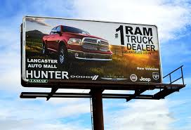

Figure 2: outdoor advertisement
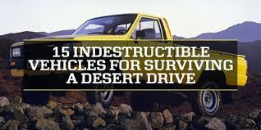

Magazine ad image & copy
The magazine ad is used as a marketing tool for products with focus on specific market. The use of magazine ad image is used by Dodge Truck to promote its trucks with focus to middle and upper income earners. The magazine ad provides clear description of the trucks being sold by the company and specific advantage over other trucks in the market.

Figure 3: Magazine ads image (Product promotion)

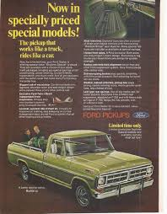

Figure 4: Magazine ad image
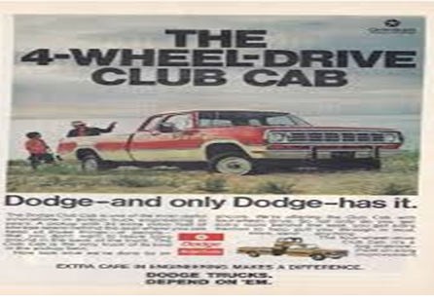

Social media strategy
The advanced technology has changed marketing industry. It has brought several methods of advertisement, necessary for necessary for reaching clients. The use of social media has emerged as the best strategy which can be used to reach wider market with fewer budgets. Dodge Truck social media strategy includes the use of social media accounts such as facebook, twitter, LinkedIn and Instagram. In order for Dodge Truck to implement social media market strategy well, the goal and objectives of the marketing will be set. The goal of social media marketing is to improve the market share through creation of product awareness. The social media will be used to reach many people in the market and therefore, it will be market focused (McMain, 2015). Therefore, Dodge Truck to establish a social media pages where products will be posted. Dodge truck social media to have an active social media page where Dodge truck’s products are posted and shared with clients. According to Barnhart (2018) social media help in connecting with customers and other stakeholders of a company. It is also used to create awareness and therefore, Dodge Truck will use the social media platform to connect with customers through its social media pages. Social media is essential for creating brand awareness.
Figure 5: Dodge Truck’s social media page
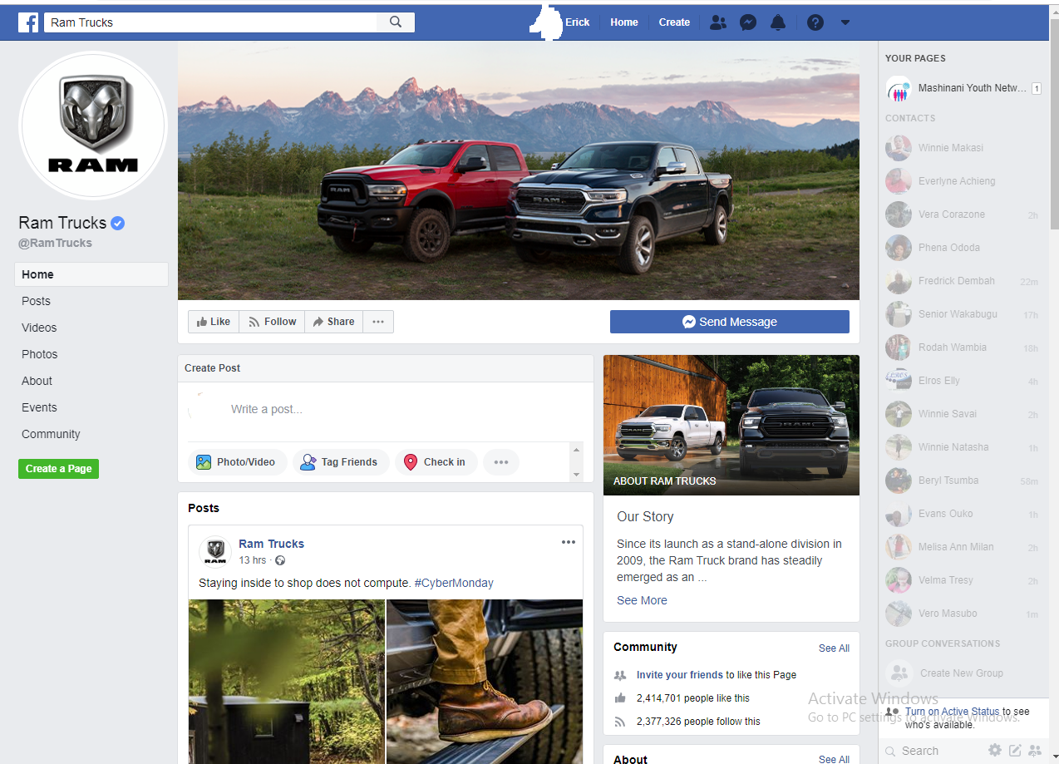

Figure 6: Social media message to clients promoting a truck during BlackFriday
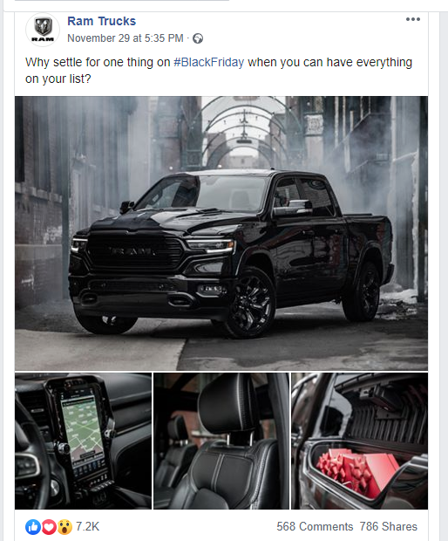

TV commercial storyboards and script
TV commercial story and script is an important element in marketing. According to (), it is used to create product awareness within a specific market segment. The TV commercial storyboard is paid advertisement and therefore, Dodge Truck will have 3 ads every day on major media in the country. The objective of TV commercial storyboard and scripts is to create awareness of the product and help in building the brand of the company. The focus of the TV commercial will be to reach Dodge Truck’s market segment.

Figure 7: TV commercial storyboards of variety of Dodge truck
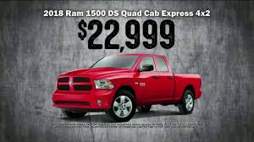
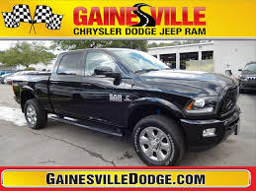
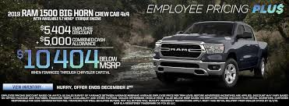
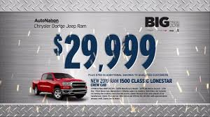
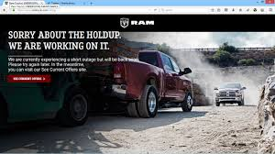
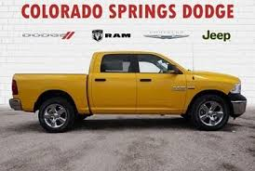
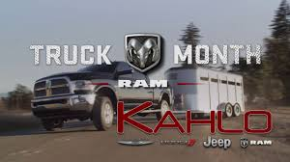
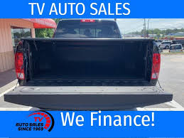
Promotion
The goal of promotion is to create awareness of the new Dodge Truck, which are being offered by the company. The promotions are done in partnership with Public Relations firm and media house to highlight the market on the new products, which are offered in the market. The promotion usually run for three months with billboards and media campaign being conducted to ensure that the new products are highlighted in the market. Dodge offers discounts as well to individuals and companies. Customers who uses VISSA card to purchase RAM Truck gets $50 and other benefits are also offered to ensure that clients are able to get the truck and for the company to maintain a strong presence in the market.
Figure8: Promotion of Truck conducted by the company
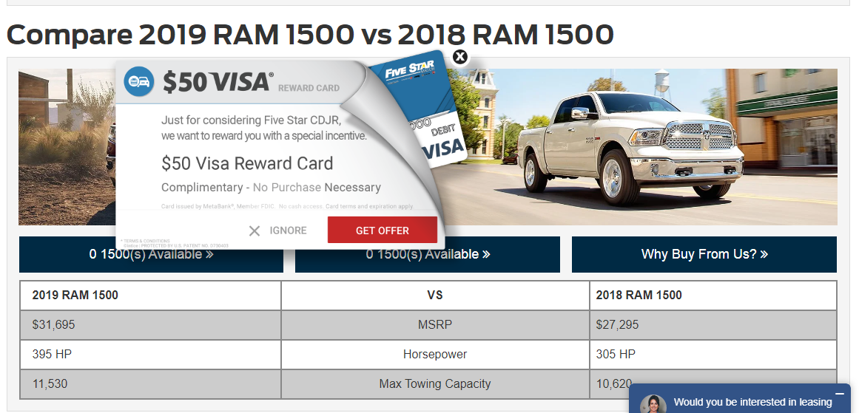

References
Barnhart, B. (2018). How to build your social media marketing strategy.
https://sproutsocial.com/insights/social-media-marketing-strategy/ , 2-34.
Effing, R. (2014). Social Media Strategy Design.
https://www.researchgate.net/publication/242334919_Social_Media_Strategy_Design , 2-35.
McMain, M. (2015). Social Media Strategy Workshop.
https://www.nwoinnovation.ca/upload/documents/social-media-strategy-presentation.pdf , 2--34.
- Autoguide.com. (2019). https://www.autoguide.com/new-
cars/dodge/. Retrieved from
- https://www.autoguide.com/new-cars/dodge/:
- https://www.autoguide.com/new-cars/dodge/
Columbuscjd.com. (2019).
- https://www.columbuscjd.com/vision-statement.html.
- Retrieved from https://www.columbuscjd.com/vision-
- statement.html: https://www.columbuscjd.com/vision-
statement.html
Comparably.com. (2019).
- https://www.comparably.com/companies/dodge/mission.
Retrieved from https://www.comparably.com:
https://www.comparably.com/companies/dodge/mission
Dodge.com. (2019). https://www.dodgegarage.com/.
Retrieved from https://www.dodgegarage.com/:
https://www.dodgegarage.com/

References

