Neural development during Prenatal and Post natal periods
Name
Institution

Abstract
This paper is aimed at exploring and documenting various stages of brain development from the time of conception to four weeks after birth; germinal to neonatal period. During these periods, human brain undergoes series of dramatic changes aimed at incorporating the structural and functional modalities to the brain so that it could enable the newborn to accommodate his surroundings more effectually. Based on the MRI images and a bulk of preexisting literature, a thorough depiction of brain development will be presented. The conclusion section, in the end, will attempt to infer meaningful takeaways from the textual activity; wrapping the whole into single paragraph.

Introduction
Needless to say, human brain is the most integral part of body, responsible for both physiological and psychological responses (Slater et. al., 1988). It is referred to as the command center of body’s nervous system as it is involved in receiving sensory signals from the organs and taking them to the associative neurons of the brain for response- related processing. Although human brain is quite smaller than the body size however this ratio is substantially greater than other mammals (Leo et. al., 2016).
As far as the parts of human brain are concerned, various compartments are there to perform their particular functions. The largest part of human brain is cerebrum that is further divided into left and right hemispheres—the mirror images of each other (Slater et. al., 1988). The outermost layer of cerebrum is known as Cerebral Cortex that comprises four lobes; Occipital, Temporal, Parietal and Frontal. Due to its substantial structural complexities, Cerebrum is referred to as the generation site of thoughts (Huttenlocher et. al., 1997). Its lobes are responsible for various sensory processing; occipital lobe—present at the back of the skull—is responsible for collecting and processing the visual information from eyes; the functioning of temporal lobe is associated with the language and sound and it also comprises Amygdala and hippocampus that are the emotion and memory centers of brain; parietal lobe, on the other hand, controls the visvo- spatial functioning and navigation (Slater et. al., 1988).
Most of the executive functioning of brain is controlled by the frontal lobe of Cerebral Cortex. These functions include time and resource management, attention, switching of attention, planning and organizing, remembering details, moral sense, learning, doing things based on the personal and mastery experiences, multitasking, maintaining relationships and performing academic or occupational functioning (Huttenlocher et. al., 1997).
Like all the vertebrates, human brain also develops from three areas; hindbrain, forebrain and midbrain; containing fluid- filled cavities known as Ventricles. Forebrain comprises cerebrum, midbrain comprises brainstem whereas hindbrain consists of cerebellum, Pons and Medulla Oblongata. Cerebellum plays vital role in the motor movement and maintenance of body balance while sitting, standing, walking, running or playing (Leo et. al., 2016).
The brain stem acts as a junction between brain and spinal cord. It encapsulates medulla Oblongata, Pons and midbrain. The primordial function of brain stem is to act as a rely center between body and brain, supply a few cranial nerves to the head and face, control and monitor vital functions such as breathing, heart rate and consciousness (Slater et. al., 1988).
At the junction of brain stem and cerebrum, thalamus and hypothalamus are present—known as limbic system of brain. Thalamus acts as a relay center for the motor and sensory signals between sense organs and Cerebral Cortex of the brain aimed at communicating signals for alertness, consciousness and sleep (Collier & Barr, 2001). Hypothalamus, on the other hand, is involved in linking endocrine system with the nervous system particularly in Hypothalamus, Pituitary and Adrenal Axis (HPA-Axis) (Johnson & Morton, 1991).
Hence, brain plays an integral role in the generation and maintenance of vital, motor and executive functioning. Developmental Psychologists study the process of human development related to cognitive, physical and psychosocial domains. For that matter, development is divided into various stages including prenatal, neonatal, early, middle and late childhood, adolescence, and early, middle and late adulthood till ageing (Collier & Barr, 2001). The spans that would be embraced thorough contemplation are prenatal (week 1 to birth) and neonatal periods (birth to 2 weeks) that is highly influenced by genetics and environmental factors. Prenatal period is further divided into three segments; the germinal period, embryonic period and fetal period (Leo et. al., 2016).
Main body
As mentioned above, prenatal period is further divided into three stages; germinal, embryonic and fetal; these stages along with the after-pregnancy development would be discussed with reference to the brain development. Germinal stage:
This stage lasts from conception to two weeks known as the period of implantation when male and female gametes unite in the fallopian tube. Conception is referred to the union of male sperm and female egg in the fallopian tube of female followed by the formation of single- celled entity—zygote. During conception, the DNA from father and mother combine to develop individual with the identical physical and psychological characteristics (Leo et. al., 2016). As soon as the zygote forms, the process of mitosis—rapid cell division is initiated. During first five days of zygote formation, approximately one hundred cells are formed. With the passing time cells undergo rapid division and become specialized particularly at germinal stage, umbilical cord, placenta and amniotic fluid are formed that assist embryo development beginning after germinal stage. It is important to note that no brain or neurological development starts at this stage (Leo et. al., 2016).
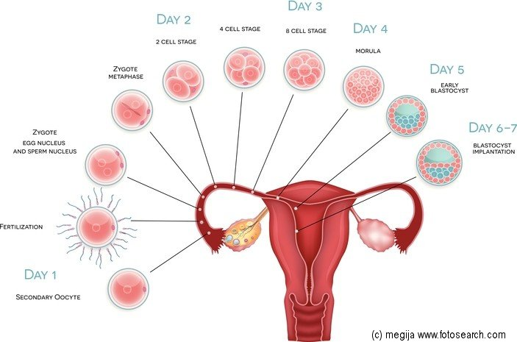
Image: The process of conception
Embryonic stage:
Embryonic stage lasts from week 2 to week 8 of pregnancy. Zygote at the fallopian tubes moves down the uterus and implants itself there for further growth and development (Collier & Barr, 2001). This newly implanted multi-cellular entity is known as embryo. Placenta is referred to as the clusters of blood vessels that are formed to support the further growth of embryo. Placenta is joined with uterus through umbilical cord which supplies water, nutrients and oxygen to the embryo from mother’s blood (Leo et. al., 2016).
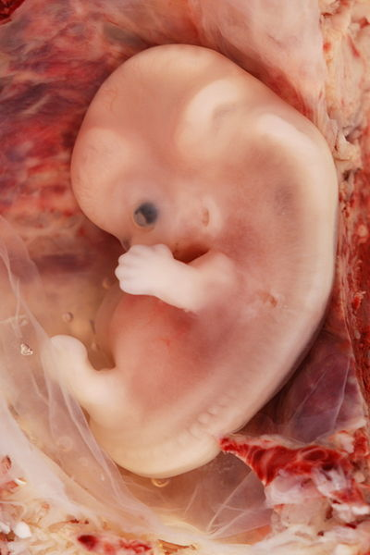
Image: Embryo at the second stage of prenatal development
At this stage, the development of nervous system begins. Embryo disk is separated into three thick layers known as endoderm, ectoderm and mesoderm. The outermost layer—ectoderm develops as the outer skin layers and nervous system in the later developmental stages (Collier & Barr, 2001). Mesoderm forms visceral organs of the body such as bones, muscles, reproductive system and so on whereas endoderm forms urinary, digestive and respiratory system (Leo et. al., 2016). The very first part of brain that develops in the embryo is neural tube that later becomes brain and spinal cord. Soon as the neural tube is developed, heart starts working and pumping oxygen- rich blood to the neurons for further development in later stage.
Fetal stage:
The fetal stage lasts from week 9 till birth. When embryo becomes nine weeks old, it is called as fetus. At this stage, fetus resembles the shape of a kidney and presents subtle recognizable version of human being. During the week 9 and 12, legs and arms start moving which indicates the development of spinal cord, responsible for generating reflex actions. At the 12th week, the sense of hearing is developed indicating that brain is able enough to process the auditory stimulus from the outside world (Leo et. al., 2016).
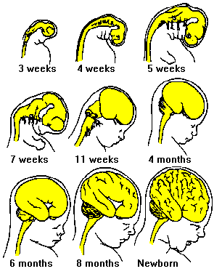
Image: Process of brain development from week 3 to birth
After week 12th the brain continues to develop and grow and from week 16 to 18 it becomes double in size. This period is characterized by the rapid growth and enlargement of Cerebral Cortex and fetus spends most of its time awaking, listening to the outside loudness and responds accordingly through moving his limbs. He moves his limbs with more coordination, indicating that neural connections of brain have become more complex and diversified. Eventually, nervous system starts taking hold over most of the physiological functions of fetus and interestingly, personality development as well (Leo et. al., 2016). By the end of 29th week, thalamus—the relay center of brain starts mediating sensory and motor outputs in more sophisticated manner. The hippocampus starts developing and storing memories (Collier & Barr, 2001). This is why, fetus becomes able to distinguish between different voices and sounds after birth.
Neonatal development after birth:
The neonatal period starts after birth and lasts for one month period. During this period, the sensory and motor functioning of brain becomes twofold as neonate comes in direct contact with the outside world (Leo et. al., 2016). His survival is based on the reflexes such as crying, sleeping and feeding however his observation tendency becomes diversified and he uses auditory and visual senses to make sense of his surrounding environment. The development of neural connections becomes more fast (Huang, 2019).
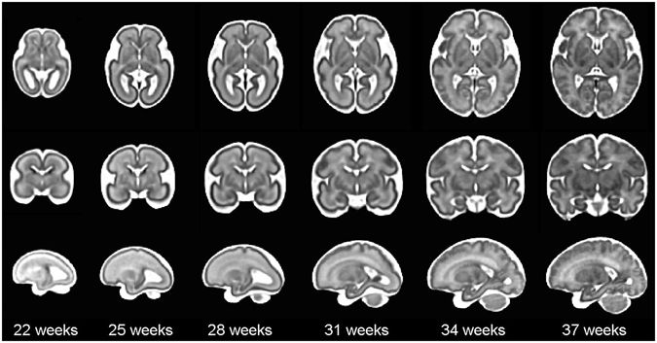
Image: The MRI scan of brain during fatal period
Factors affecting brain development:
Apart from genetics, there is a variety of factors that affect the neurological development of newborn; depending on the maternal influences. These factors are named as Teratogens.
Teratogens:
Teratogen is an environmental, chemical, biological or physical substance having detrimental effects on the neurological development of fetus (Bakkebo et. al., 2016). Exposure of mother to these agents beyond the optimal ranges brings substantial adverse consequences in form of birth defects. Teratogens might have varying degree of birth defects in the newborn depending on the severity level, dose, heredity, age of Teratogen and collaboration of various Teratogen agents. Following Teratogens might be proven dangerous when used during pregnancy; prescription drugs, alcohol and tobacco.
Alcohol: Alcohol consumption during pregnancy is found to have adverse fatal complication particularly in relation to their mental health. A bulk of literature is evident that alcohol consumption of mother above the expected levels leads her child to develop Fetal Alcohol Spectrum Disorder (FASD) having permanent and durable long and short- term physiological, psychological and neurological impacts on newborn (Bakkebo et. al., 2016). However, it is still inconclusive that how much alcohol is too much; therefore medical professionals recommend that alcohol consumption must be avoided completely in order to minimize the risk of FASD. Children with FASD are found to have abnormal facial features including small eye opening, flat nose and small upper lip. Moreover, cognitive conditions associated with FASD include poor impulse control, planning, judgment, learning, attention and organizing skills. Many studies have found that if mother is alcohol addict, her child becomes predisposed with the same tendency in future (Alván et. al., 1995).
Prescription or illegal drug abuse: Use of drugs above the prescribed levels, illegal drug abuse and over- the- counter drug use might be harmful during pregnancy. These drugs commonly include methamphetamine, cocaine and heroin that bring a host of problems on the part of new born (Alván et. al., 1995). Babies of drug abusing mothers are at higher risk of premature birth, physical defects and with low birth weight. These birth defects end up developing attention and behavioral problems.
Smoking: smoking is included in the class of Teratogens because it contains nicotine. When mother smokes, the nicotine is absorbed in the blood stream through lungs. This blood is then taken to placenta through umbilical cord where nicotine hinders the absorption of enough oxygen in fetus; smoking in pregnant women results in Sudden Infant Death Syndrome (SIDS), premature birth with low birth weight, still birth and complicated birth. Other consequences of smoking include colic pain (a form of pain due to muscular contraction in the body that starts and ends abruptly), inattentiveness, learning and memory issues and muscle tension (Alván et. al., 1995).
Maternal Stress and Depression: Any form of stress taken by the mother can have negative impact on the health of newborn. As a result of stress, cortisol production in the blood is elevated; which takes the body to fight or flight situation; lowering the functioning of all the body organs so that energy could be conserved for taking necessary actions (Alván et. al., 1995). Chronic stress generates constant production of cortisol in the blood which is then taken to the baby where it disrupts the normal functioning of his brain and other body organs. Negative outcomes of stress and depression can be seen in terms of anti-social tendency of the child in future, memory and attention issues and emotional problems (Alván et. al., 1995).
Conclusion
In a nutshell, the prenatal and post-natal periods of cognitive development are highly sensitive in nature and require substantial attention from the mother and healthcare practitioners in eliminating the factors that interfere with the optimal course of development; apart from genetics. It was elaborated that brain development of fetus follows intermittent patterns ranging from subtle arrangements to abrupt and dramatic changes. These changes start from fundamental neural plate and continue even after birth under the influence of environmental factors.

References
Alván G, Danielsson BR, Kihlström I, Lundborg P, Prame B, Ridley E, Sannerstedt R. (1995). Classification of drugs for teratogenic risk. Eur J Clin Pharmacol., 48, 177–178.
Bakkebo, T., Widnes, S.F., Aamlid, S.S., and Schjott, J. (2016). Physicians’ perception of teratogenic risk and confidence in prescribing drugs in pregnancy—influence of Norwegian drug information centers. Clin Ther., 38, 1102–1108.
Collier C., Barr R. (2001). Brain biology, learning and memory: Handbook of Neural Development. Blackwell Publishing; Malden, MA, USA.139–168.
Huang, Z. (2019). Molecular regulation of neuronal migration during neocortical development. Molecular and Cellular Neuroscience, 42(1), 11–22. doi: 10.1016/j.mcn.2009.06.003.
Huttenlocher, P. R., Dabholkar, A. S. (1997). Regional differences in synaptogenesis in human cerebral cortex. The Journal of Comparative Neurology, 387(2), 167–178. doi: 10.1002/(SICI)1096-9861(19971020)387:2
Johnson M. H., Morton J. (1991). Biology and Cognitive Development: The Case of Face Recognition. Blackwell; Oxford, UK.
Leo I., Valenza E., Gava L., Simion F. (2016). Perceptual completion in newborn human infants. Child Dev., 77, 1810–1821. doi: 10.1111/j.1467-8624.2006.00975.x.
Slater A., Morison V., Somers M. Orientation discrimination and cortical function in the human newborn. Perception. 1988;17:597–602.

