Title
Name
Institution

Solution of the Numerical
η = k U Z ………………………… (1)
Whereas, k = 1.1 × 10⁻⁹ V⁻¹
U = 100 k V
Z = 74
Putting values in the equation (1)
η = 1.1× 10⁻⁹ V⁻¹ × 100 × 10³ V × 74
η = 74 ×1.1 × 100 × 10⁻⁹⁺³
η = 8.14 × 10⁻³
Why many features of X-ray tubes are designed for dissipation of heat?
At the anode target, approximately 99% kinetic energy undergoes dissipation in form of heat. As a result of this continuous X-ray emission activity from cathode to anode, X-ray tube is having destructive consequences in terms of malfunctioning of temperature-specific X-ray tube. Hence, it is quite essential to dissipate heat from X-Ray tube. Cooling, if, accomplished in inadequate manner, is potent enough to disrupt the working X-ray tube in two possible ways. First one is; vacuum required for the appropriate working of X-rays is affected when sublimation of anode target material takes place under high temperature. Cathode—the tungsten filament, attracts the damaging ions from the target material under surpassing vapor pressure.
So it is important to ensure that X-ray tube is not allowed to become overheated. With the association of fault protection, careful monitoring of cooling process must be done in order to let the X-Ray tube function properly. For undertaking cooling process, a water or air cooling device is attached with the tube. In this way, extra heat energy is absorbed by water or air and X-ray tube continues to function properly.
Describe some of the features of a typical rotating anode X-ray tube.
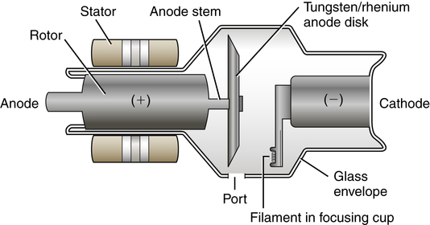
Rotating X-ray tube is called so because it is having a rotating anode. The fundamental rationale behind the introduction of rotating anode is the dissipation of exceeding heat energy. If X-ray beam keeps penetrating same spot on anode interminably, the chances of overheating become irrefutable. Hence, its distinctive feature is “rotating anode” for mitigating the consequences of overheating.

