Title
Name
Institution

Cellular transportation
Cell membrane acts as a barrier between the cytoplasm and outside medium of the cell; various metabolic activities taking place in the cell lead to the production of useful and waste substance. Both of these are taken to the outside environment for their further utilization or removal. Following mechanisms of transportation allow substances to move from one cell to another (Friedman, 2008).
Simple diffusion:
In simple diffusion, molecules or substances move from an area of higher concentration to the area where there concentration is low. This process continues till the concentration of molecules become equal on both the sides. It must be noted that diffusion is a passive process; it starts by itself. Diffusion occurs both in gases and liquids (Pratt et. al., 2002).
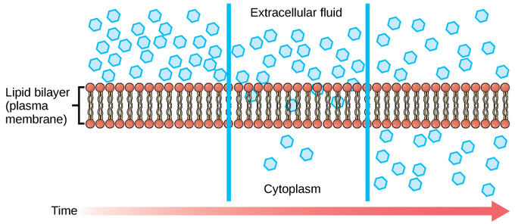
Image: movement of water molecules from extracellular fluid to cytoplasm
Osmosis
Osmosis is referred to as the movement of water molecules from an area where solute concentration is low to an area where there is higher solute concentration. This type of transportation involves both solutes and solvents; where solvent is always water and solutes are mainly dissolves salts (Pratt et. al., 2002).
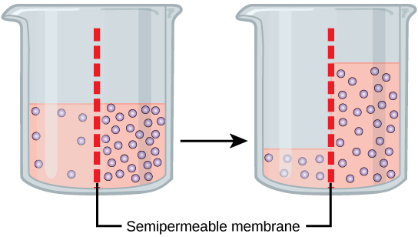

Image: purple dots indicate solute whereas pink liquid is water. Water moves to the area with less concentration of solute molecules until concentration of both the molecules becomes equal
Facilitated diffusion:
Facilitated diffusion is similar to the simple diffusion in terms of the movement of gas or water molecules from higher to lower concentration however this transportation is facilitated by special proteins that pump molecules inside or outside the membrane in order to equalize their concentration. This process does not happen passively rather specialized membrane proteins are required to initiate and carry facilitated diffusion (Friedman, 2008). It does not require energy to pump the molecules; rather proteins carry this function thorough changing their shaped after bonding with the molecules that they are willing to transport. It either happens via channel proteins or carrier proteins (Pratt et. al., 2002).
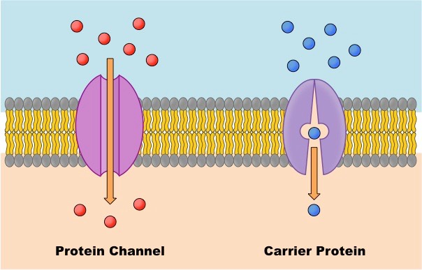
Image: molecules moving from higher to lower concentration through specified protein channels either through carrier mechanism or channel mechanism
Active transport
Active transport is similar to the facilitated diffusion in terms of the movement of gas or water molecules from higher to lower concentration however this transportation is facilitated by special proteins that pump molecules inside or outside the membrane in order to equalize their concentration with the help of energy. This process does not happen without ATP involvement because some molecules are larger and cannot bind with the proteins. This is the basic difference between both types of transportation as well (Friedman, 2008).

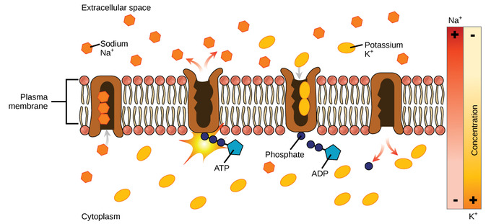
Image: sodium potassium pump (specialized proteins) pumping potassium ions outside the cell and sodium ions inside the cell where there concentration is lower—with the help of ATP
Hence, all the modes of transportation perform similar functions but differ in the ways through which they perform their functions and the nature of transportation they carry. Some use specialized proteins, some do not, some use proteins with energy and some do it without energy. Some transport both gas and water molecules whereas some transport only water.

References
Pratt, C. A., Voet, D., Voet, J. G. (2002). Fundamentals of biochemistry upgrade. New York: Wiley. pp. 264–266
Friedman, M. (2008). Principles and models of biological transport. Springer.

