Student
Teacher
Class
Date
Rhetorical Analysis, Meat’s not Green!
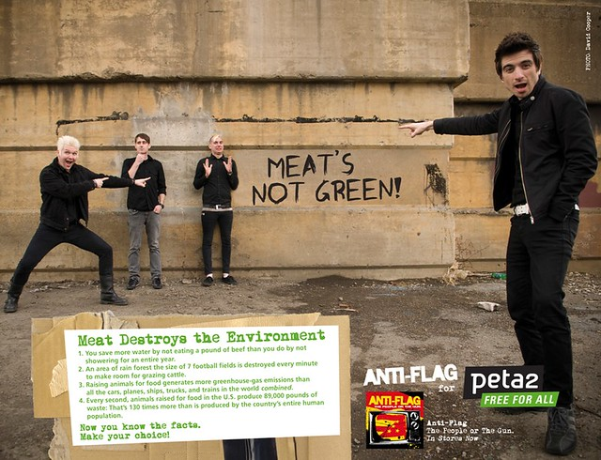
The main focus of the advertisement is the slogan; Meat’s not Green. This slogan is presented in bold black color so that it could be more captivating for audience. Meat’s Not Green presents the idea that only saving non- renewable resources would not be sufficient to protect earth from global warming rather avoiding live stock consumption is actually the durable treatment of this global trouble.
The advertisement presents a locality street where wall chalking is used for imprinting the slogan; “Meat’s not Green” whereas four male representatives belonging to various age-groups are pointing to the slogan with varying facial expressions and body gestures. The person at the front side is wearing black attire and pointing to the slogan with emphasizing body language and facial expressions. It is worth noting that this individual is apparently a youngster who is concerned about the global warming issue and future of the earth due to which he points to the slogan and adds to the significance of its latent meaning.
The other person is a middle- aged man at the most right side of the image with white hair; he is wearing black dress as well. He, too, points to the slogan for emphasizing its meaning however unlike the first one, he is found to be in more informal and lighter mood. As far as his emotional state is concerned, he seems resilient and optimistic with positive body language. This depiction indicates that although global warming is a devastating issue yet we can overcome this through best possible efforts.
The third person stands next to the above presented man; wears black dress and seems like a teenager. The notable thing about this person is his body gestures and facial expressions; he seems thoughtful about the newly learned facts regarding meat destruction. His gestures depict the thoughtfulness of common teenager about the potential future climate issues resulting from global warming and their associated solution suggesting the active mitigating of meat consumption due to several logical reasons.
The fourth person is standing next to the above mentioned person, just right to the slogan. He is a teenager and wearing black dress as well. Like others, his body language and emotional depiction is worth noting. His body language is quite questionable; he seems frightened as depicted through the position of his hands and facial expressions. It seems as if he is completely aware of the potential destructions of global warming and wants ultimate, everlasting and effective solutions to reduce this global threat.
As far as the color transitions and font styles are concerned, black color is dominating followed by the green. The slogan is written in black and larger text that are grabbing audience interest in fairly captivating manner. However, description of the slogan; Meat destroys the environment is written in small, green font placed extreme right below the banner. It is quite hard to read it without paying considerable attention, only those who are willing enough can read it after paying deliberate attention. This detailed text box written in green color defines the purpose and explanation of the slogan and underlying reasons behind calling meat as a polluting agent.
In a nutshell, this advertisement casts youngsters and highlights the significance of teen interests in realizing the adverse impact of meat consumption on the environment as live stock uses considerable green resources for survival and produces waste excretions that pollute the earth more than the man himself. Hence, through presenting logical facts and emotional depictions, this advertisement creates a meaningful persuasive piece of visual imagery for galvanizing the youth to contribute their meaningful efforts to lessen the impact of global warming on earth.

