Cone Cells
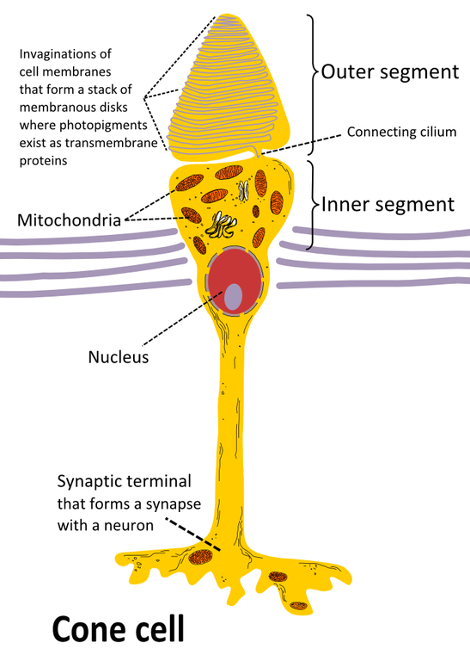 | - Present in the retina of vertebrate eye, cone cells are photoreceptor cells responsible for receiving different wavelengths of light and making the colored vision possible at day time (Sloan et. al., 1990)  - Its structure consists of synaptic terminal, inner and outer segment, interior nucleus and numerous mitochondria  - Synaptic terminal, as the name indicates, is responsible for the process of synapse with other neurons (Oyster, 1999)  - Inner segment having organelles and cell nucleus is connected to the outer segment with cilium having light absorbing material (Schwartz, 2000)  - Cones are less sensitive to the light as compared to rods in retina and are linked to the perception of colors (Oyster, 1999)  - Their response time to stimuli is greater than rods therefore they perceive the details of changing image and scenery more rapidly (Schwartz, 2000)  - L-cones, M-cones, and S-cones are the three major types of cones characterized by the sensitivity to long, medium and short wavelengths of light (Sloan et. al., 1990)  - If cones do not function properly, one might suffer from color blindness (Sloan et. al., 1990)

References
Oyster, C. W. (1999). The human eye: structure and function. Sinauer Associates.
Sloan, K. R. Curcio, C. A. Kalina, R. E. Hendrickson, A. E. (1990). Human photoreceptor topography. J Comp Neurol., 292 (4), 497–523. doi:10.1002/cne.902920402
Schwartz, J. Kandel, E. R., H., Jessell, T. M. et. al. (2000). Principles of Neural Science (4th ed.). New York: McGraw-Hill., 507–513.

