Microorganisms
Name
Institution

Introduction
This paper is concerned with the selection, description and documentation of some microorganisms. Their physical properties e.g., their structure, function, virulence, treatment and use will be discussed after deliberate painstaking analysis from the pre-existing relevant literature. Identity of selected microorganisms will be disclosed in the later sections.

Microorganisms
Microorganisms are referred as living beings that are hard to be seen with naked eye and are visible only through microscope. These organisms can exist in form of single cell and colonies. There are five primary categories of microorganisms:
- Bacteria
- Virus
- Fungi
- Protozoa
- Algae
Microorganisms will be selected from above mentioned categories. Let’s discuss them one by one.

Organism I: Escherichia coli (Bacteria)
Table 1
Tabular description of selected bacteria; E. coli
Sr. | Properties | Description
1 | Biological name | Escherichia coli
2 | Type and structure | Gram negative, facultative anaerobic and rod shaped,  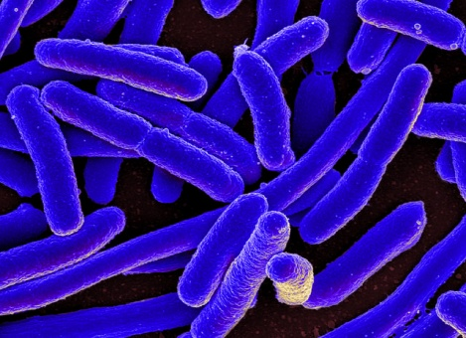  Image: Microscopic view of E. coli
3 | Class, Family | Gammaproteobacteria, Enterobacteriaceae
4 | Gram Reaction | It produces pink stains when subjected to gram solution e.g., Crystal violet, Iodine stain and Carbol Fuschin. Pink color is the indication of absence of thick peptidoglycan cell wall responsible for purple color (Kaper, Nataro & Mobley, 2004).  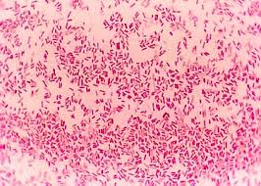  Image: Pink stains of E. coli after gram test indicating their gram negative nature
5 | Habitat | They live in the skin of animals and intestines of healthy humans and animals. Besides this, air, water and soil also contain these bacteria (Qadri et. al., 2005).
6 | Mode of transmission | Various modes of transmission include (Qadri et, al., 2005):  - Untreated milk: From the milking equipment and cow’s udder; these bacteria can be transferred to humans in case they consume unpasteurized milk.  - Meat: as it lives in animal’s intestines, uncooked or improperly cooked meat has the potential to transfer this into human’s body.  - Water: drinking water enriched with E. coli can act as a strong mode of transmission.  - Animals: Skin of pets and zoo animals contains these bacteria which can be transferred to humans through touching.  - Humans: touching an infected person and forgetting washing hands before eating something or taking hands to mouth can cause their transmittal readily.  - Vegetables and Fruits: manure from animals mixed with water which is being used in agriculture, it can be transmitted from such vegetables to humans during consumption.
7 | Virulence | It is potent enough to spread following diseases: fever, abdominal cramps, blood vomiting, dehydration, fatigue, nausea and kidney failure (in severe instances) (Weintraub, 2007)
8 | Treatment | Although its treatment is readily available yet symptoms can be eliminated by various evidence-based home remedies within few days. Treatment is typically concerned with the precautionary measurements encapsulating (Weintraub, 2007):  - Avoid drinking contaminated water and edibles  - Eat properly cooked meat  - Boil milk before use  - Wash hands after touching contaminated animal or individual
9 | Benefit | Keep digestive track healthy and up-to-date (Kaper, Nataro & Mobley, 2004).

Organism II: Human Immunodeficiency Virus HIV (Virus)
Table 2
Tabular description of human immunodeficiency virus (HIV)
Sr. | Properties | Description
1 | Biological name | Human Immunodeficiency Virus-HIV
2 | Physical structure | Round shaped having two single RNA strands used for carrying genetic information to affected person. They lack their own bio-machinery for metabolism and other significant cellular activities therefore they completely take hold over human’s biological mechanisms, leaving them with compromised immune system (Albert et. al, 2014).  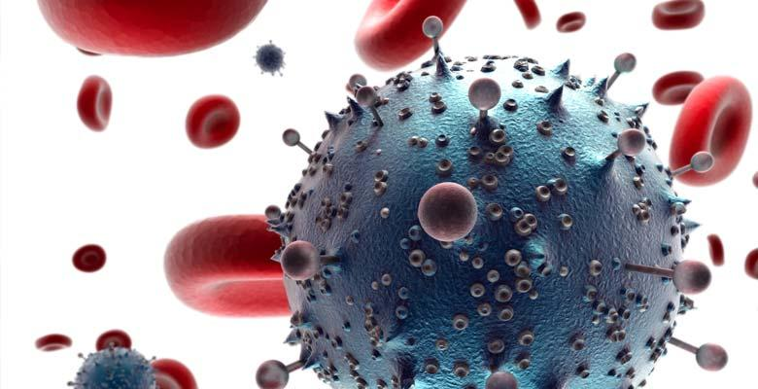  Image: microscopic view of HIV
3 | Family, Genus | Retroviridae, Lentivirus
4 | Habitat | It is found within human beings. Common habitat includes blood, semen, feces, saliva, breast milk, vaginal and cervical secretions (Aral, 2007).
5 | Mode of transmission | It has diverse modes of transmission including (Gazzard et. al., 2011):  - Sexual intercourse between infected and healthy individuals  - Sharing needles  - Blood transfusion  - Mother to child (prenatal transmission)
6 | Virulence | It causes Acquired Immunodeficiency Syndrome (AIDS) which is a burning medical crisis in current era despite technological advancements. Its symptoms include (Aral, 2007).  - Cough and shortened breathe  - Night sweats  - Recurrent fever  - Sores, lesions and rashes around mouth or genitals  - Diarrhea  - Weight loss  - Nausea  - Sore throat  - Headache  - Muscle aches  - Join pain  - Neurological conditions e.g., memory and nervousness
7 | Treatment | Widely-acknowledged treatments for AIDS include (Aral, 2007):  - Protease inhibitors (PIs): These drugs include substances that inactivate protein necessary for virus to replicate its DNA.  - Fusion inhibitors: These drugs inhibit the entrance of HIV into the most supreme immune system cell e.g., CD4 T cells.  - Non-nucleoside reverse transcriptase inhibitors (NNRTIs): These drugs inhibit a protein required by HIV for the formation of new nucleosides.  - Nucleoside or nucleotide reverse transcriptase inhibitors (NRTIs): These drugs inhibit a protein required by HIV for the formation of new nucleotides. As these are artificial and faulty versions of proteins required by HIV for its replication. Hence, faulty versions lead to faulty replication and ultimately their death.  - Integrase inhibitors: Integrase is an enzyme that HIV uses to insert genetic material into human CD4 T cell. Integrate inhibitors suppress their formation.

Organism III: Yeast (Fungi)
Table 3
Tabular description of yeast
Sr. | Properties | Description
1 | Biological name | Saccharomyces cerevisiae
2 | Physical Structure | They are egg shaped structures which are visible only with microscope. It is also called sugar eating fungi because it uses different forms of carbohydrates for survival (Townsend et. al., 2006).  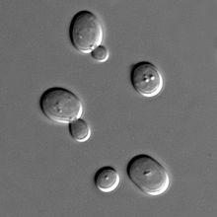  Image: microscopic view of yeast
3 | Family, Genus | Saccharomycetaceae, Saccharomyces
5 | Habitat | They are found in diverse environment including soil, fruit and vegetable leaves, fruits and flowers, skin surface of warm-blooded animals and their intestinal track as well (Cimolai, Gill & Church, 1987).
6 | Mode of transmission | Consuming infected fruits and vegetables without washing appropriately. Eating improperly cooked meat (Townsend et. al., 2006).
7 | Virulence | The most common virulence includes vaginitis. Symptoms are as follows (Wang et. al., 2012):  - Vaginal irritation and itching  - Pain after intercourse  - Pain after urination  - Light vaginal spotting  - Change in color and amount of vaginal discharges
8 | Treatment | Diflucan is an oral medication used for mitigating vaginitis. Furthermore, various preventive measures help reduce its onset instances including (Wang et. al., 2012):  - Avoiding hot bathing  - Avoiding Excessive vaginal bathing  - Yeast grows rapidly in moist, avoiding areas from being moist for longer times is beneficial for it.  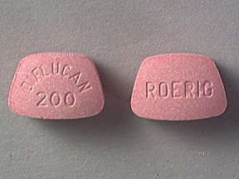  Image: Diflucan for vaginal yeast infection
9 | Benefits | - Its inactive form boosts immunity  - lowers the cholesterol down  - protects body against oxidative damage  - Its active form is used in baking industries (Cimolai, Gill & Church, 1987).

Organism IV: Plasmodium falciparum (Protozoa)
Table 4
Tabular representation of Plasmodium falciparum
Sr. | Properties | Description
1 | Biological name | Plasmodium falciparum
2 | Physical Structure | It is unicellular parasite in humans exclusively responsible for malaria (Miller et. al., 2002).  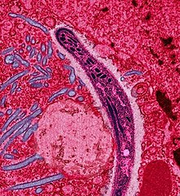  Image: Plasmodium falciparum microscopic view
3 | Family, Genus | Plasmodiidae, Malaria parasite
4 | Habitat | It is present in contaminated water. It spends it lifetime within the body of anopheles mosquito where it remains inactive till its transference into the body of vertebrate host (Pain & Hertz, 2009).
6 | Mode of transmission | Its mode of transmission is ‘anopheles mosquito biting.” When this mosquito bites humans, it is transferred to the human blood and pathogenic activity is initiated (Miller et. al., 2003).
7 | Virulence | It is responsible for malaria which includes following symptoms (Miller et. al., 2002):  - Nausea  - Vomiting  - Abdominal pain  - Fever  - Night sweats  - Headache  - Shaking chills ranging from light to severe  - Anemia  - Muscle pain  - Bloody stools  - Convulsions
8 | Treatment | - Chloroquine Phosphate: it is typically used for killing all sort of pathogenic parasites but is no longer effective for malaria because plasmodium has now become resistant to it.  - Artemisinin-based combination therapies (ACTs): it is used as a first line treatment for treating malaria because it encapsulates number of drugs that act on the plasmodium with unique mechanisms.  - Other Drugs: other drugs encompass  - Combination of atovaquone and proguanil (Malarone)  - Quinine sulfate (Qualaquin) with doxycycline (Vibramycin, Monodox, others)  - Mefloquine  - Primaquine phosphate (Miller et. al., 2002).

Organism V: Chlorella Vulgaris Algae
Table 5
Tabular representation of Chlorella vulgaris
Sr. | Properties | Description
1 | Biological name | Chlorella vulgaris
2 | Structure | It is spherical in shape 1-2 micrometer in diameter. It is single celled green algae found in water having chlorophyll a and b (Rashid et. al., 2014).  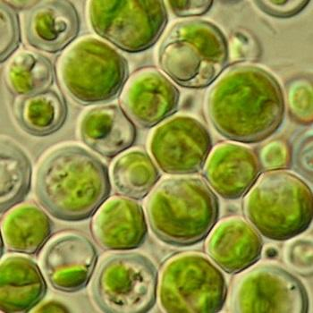  Image: microscopic view of Chlorella vulgaris  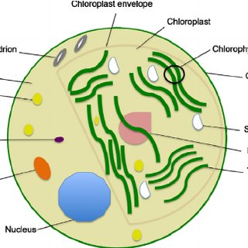  Image: diagrammatic representation of chlorella
3 | Family & Genus | Chlorellaceae, Chlorella
5 | Habitat | It is found in fresh water. Where it uses exhaled carbon dioxide of water animals for making food whereas provides them with fresh oxygen as an end-product of photosynthesis (Sinclair et. al., 1990).
6 | Mode of transmission and  Virulence | Chlorella vulgaris is enriched with minerals, vitamins and basic nutrients that help growing and repairing human body cells. This is why it is used to make chlorella drug which is highly effective for humans. It is produced in Japan and used world-wide as a medical drug.  Its over-dosage can be harmful due to associated side effects. After drinking fresh water contaminated with this organism and high dose of chlorella drug, immune-compromised individuals may get (Sinclair et. al., 1990):  - Green discoloration of stools  - Abdominal cramping  - Diarrhea  - Nausea  - Flatulence  - Asthma or breathing problems  - Photosensitivity
7 | Treatment | Its treatment mostly includes drug treatment:  antithrombin alfa, antithrombin III, argatroban, bemiparin  bivalirudin, dabigatran, dalteparin, enoxaparin, fondaparinux, heparin, lepirudin, phenindione, protamine, tinzaparin, warfarin (Helle et. al., 2009)
8 | Benefit | Chlorella drug is made from this organism. It is used (Helle et. al., 2009):  - To treat Parkinson’s disease  - Increasing tolerance for chemotherapy  - It has anti-tumor abilities  - Helps in shuttling toxins  - Improves blood sugar and cholesterol level

References
Kaper, J. B., Nataro, J. P., (2004). Mobley H.L. Pathogenic Escherichia coli. Nat. Rev. Microbiol., 2, 123–140. doi: 10.1038/nrmicro818
Qadri, F., Svennerholm A. M., Faruque, A. S., Sack, R. B. (2005). Enterotoxigenic Escherichia coli in developing countries: Epidemiology, microbiology, clinical features, treatment, and prevention. Clin. Microbiol. Rev., 18, 465–483. doi: 10.1128/CMR.18.3.465-483.2005.
Weintraub, A., (2007). Enteroaggregative Escherichia coli: Epidemiology, virulence and detection. J. Med. Microbiol., 56, 4–8. doi: 10.1099/jmm.0.46930-0.
Albert, J., Navér, L., Böttiger, Y., et al. (2013). Prophylaxis and treatment of HIV-1 infection in pregnancy: Swedish recommendations 2013. Scand J Infect Dis, 46, 401–11.
Gazzard, B., Clumeck, N., d’Arminio Monforte, A., et al. (2008). Indicator disease-guided testing for HIV—the next step for Europe? HIV Med, 9(Suppl), 34–40.
Aral, S. O., Fenton, K. A., & Holmes, K. K. (2007). Sexually transmitted diseases in the USA: Temporal trends. Sexually Transmitted Infections, 83(4), 257–266.
Townsend, J. P., Adams, R. I., Nielsen, K. M., & Taylor, J. W (2006) Population structure and gene evolution in Saccharomyces cerevisiae. FEMS Yeast Research 6: 702–715.
Cimolai, N., Gill, M. J, Church, D. (1987) Saccharomyces cerevisiae fungemia: case report and review of the literature. Diagnostic Microbiology and Infectious Disease 8: 113–117
Wang, Q. M, Liu, W. Q., Liti, G., et al. (2012). Surprisingly diverged populations of Saccharomyces cerevisiae in natural environments remote from human activity. Mol Ecol., 21, 5404–17.
Miller, L. H., Baruch, D. I., Marsh, K., Doumbo, O. K. (2002). The pathogenic basis of malaria. Nature., 415, 673–679.
Pain, A., Hertz, F. C. (2009). Plasmodium genomics: latest milestone. Nat. Rev. Microbiol., 7, 180–181.
Miller, L. H., Aravind, L., Iyer, L. M., Wellems, T. E. (2003). Plasmodium biology: genomic gleanings. Cell., 115, 771–785.
Rashid, N. et al. (2014). Current status, issues and developments in microalgae derived biodiesel production. Renewable and Sustainable Energy Reviews, 40, 760–778.
Sinclair, H. M. (1990). Essential fatty acids—a historical perspective. Biochemical Society Transactions, 18 (5), 756–761.
Halle, I., Janczyk, P., Freyer, G., Souffrant, W. B. (2009). Microalgae Chlorella vulgaris effectiveness. Biomed, 12, 5–13.
Images:
https://www.microscopemaster.com/e-coli-under-microscope.html
http://faculty.ccbcmd.edu/courses/bio141/lecguide/unit3/bacpath/diseases/blood/gnrod.html
https://www.avert.org/professionals/hiv-science/overview
https://redstaryeast.com/science-yeast/what-is-yeast/
https://www.webmd.com/drugs/2/drug-3774-5052/diflucan-oral/fluconazole-oral/details
https://en.wikipedia.org/wiki/Plasmodium
https://algaeresearchsupply.com/products/algae-culture-chlorella-vulgaris
https://www.researchgate.net/publication/261918083_Morphology_composition_production_processing_and_applications_of_Chlorella_vulgaris_A_review

