HCUP Report
Name
Institution

Introduction
This assignment is concerned with the representation of thoughts, ideas and comments about the significant source of healthcare statistics, the Healthcare Cost and Utilization Project (HCUP) in order communicate its effectiveness to the CEO who is completely alien to this project. First, brief introduction of HCUP will be presented with its URL, next the type of data will be presented in addition to the associated users. In order to conclude its significance, a brief will be selected presenting its statistics in terms of appropriate graphical form. Conclusion section, in the end, will encapsulate what I learned from this activity.
The Healthcare Cost and Utilization Project (HCUP)
Introduction
Sponsored by the Agency for Healthcare Research and Quality, this website contains a verity of database or statistical tools that enable professionals to have healthcare statistics nationwide whenever research is required. Its products include:
- HCUP Database: it carries information about the number of provisions of ambulatory services, in-patient stays and visits to emergency department.
- HCUP-net: it provides instant access to the healthcare information acting as an excellent online query system.
- HCUP Fast Stats: in order to communicate more thorough understanding, this product gives graphical representation of healthcare statistics.
- HCUP Tools and Software: it provides elementary tools for HUCUP and associated databases.
- HCUP Reports: this section carries publications, findings and technical reports on HCUP issues.
URL: https://www.hcup-us.ahrq.gov/
Illustration of selected report

The selected report was Opioid-Related Hospital Stays among Women in the United States, 2016. This report (Weiss et. al., 2019) explained the prevalence of Opioid-dependence among white and black women. Opioid is a prescribed pain-killer effective for somatic relief (Islam & McRae, 2014). Women are more likely to be prescribed with the higher dosages of pain-killers which eventually end up in addiction. 2014 statistics demonstrate that prevalence of Opioid dependence was found higher among white women as compared to the black ones. This report presents a survey conducted during 2016 using National Inpatient Sample (NIS) of women with 15 or more years of age. Graphical representation is stated below. These statistics will be discussed one by one:
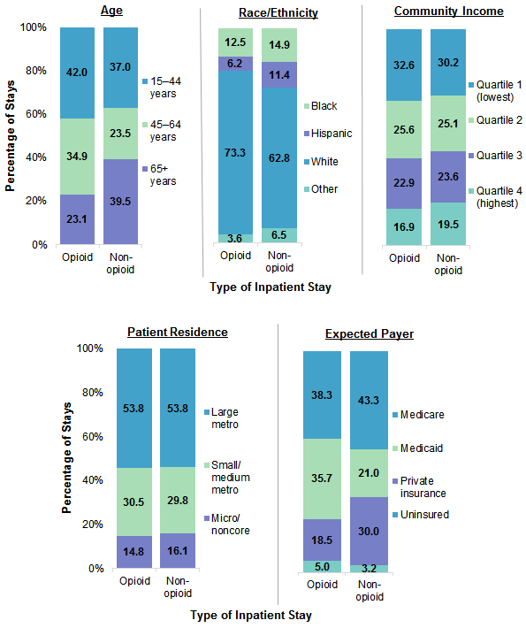
Image 1
Graphical representation of Opioid dependence with referece to various personal and social variables
- Opioid dependence with reference to age
Statistical data indicates that percentage of Opioid-dependency hospitals stays among women with 14-44 years is highest i.e., 42% whereas women belonging to 45-60 years and 65+ years demonsrated lower percentages of hospital stays i.e., 34.9% and 23.1% respectively.
- Opioid dependence with reference to ethnicity
Statistical data indicates that percentage of Opioid-dependency hospitals stays among white women the is highest i.e., 73.3% whereas women belonging to black, hispanic and other races demonsrated lower percentages of hospital stays i.e., 12.5%, 6.2%, and 3.6% respectively.
- Opioid dependence with reference to community income
Statistical data indicates that percentage of Opioid-dependency hospitals stays among women with highest income is the lowest i.e., 16.9% whereas women belonging to subsequent lower incomes ranges demonsrated higher percentages of hospital stays i.e., 22.9%, 25.6%, and 32.6% respectively.
- Opioid dependence with reference to patient residence
Statistical data indicates that percentage of Opioid-dependency hospitals stays among women residing in large metropolitan areas is highest i.e., 53.8% whereas women belonging to subsequent lower residential areas demonsrated higher percentages of hospital stays i.e., 30.5% and 14.5% respectively.
- Opioid dependence with reference to expected payer
Statistical data indicates that percentage of Opioid-dependency hospitals stays among women with medicaid and medicare payer is highest i.e., 35.7% and 38.5% respectively whereas women private insurance and unassured payer demonsrated lower percentages of hospital stays i.e., 18.5% and 5% respectively.
Conclusion
The above presented statistics enabled me to gain an objective and thorough understanding of the prevalence of Opioid dependency among women with reference to age, ethinicty, community income, residential area and expected payer. These statistics are helpful for investigating the causes of higher and lower percentages of hospital stays among women for example, why white women are more prone to acquire Opioid dependency? Why is its prevalence in women with government payer is higher than uninsured women? And which factors are responsible for higher hospital stays among women belonging to large metropolitan area? These statistics provides furture direction to qualitative and quantitaive research in healthcare field.

References
HCUP User Support (2018). HCUP. Retrieved from https://www.hcup-us.ahrq.gov/
Islam, M. M., & McRae, I. S. (2014). An inevitable wave of prescription drug monitoring programs in the context of prescription Opioids: pros, cons and tensions. BMC Pharmacol Toxicol, 15, 46. Retrieved from https://www.ncbi.nlm.nih.gov/pubmed/25127880
Weiss, A. J., McDermott, K. W., & Heslin K. C. (2016). Opioid-Related Hospital Stays among Women in the United States. HCUP. Retrieved from https://www.hcup-us.ahrq.gov/reports/statbriefs/sb247-Opioid-Hospital-Stays-Women.jsp

