Genogram and Ecomap
Name
Institution

Introduction
This assignment is concerned with the presentation and analysis of Eco-map and Genogram based on family interview. Family is having three siblings and mother and father. The purpose behind Eco-map is to identify the personal and environmental factors responsible for drug abuse, depression and relationship issues between these family members. After interviewing selected family, their Eco-map and Genogram will be developed; after analyzing it, further nursing interventions will be presented accordingly.
Body
Eco-map and Genogram
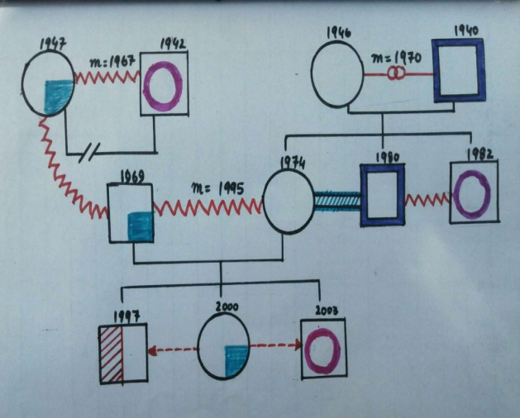
Image: Genogram of selected family
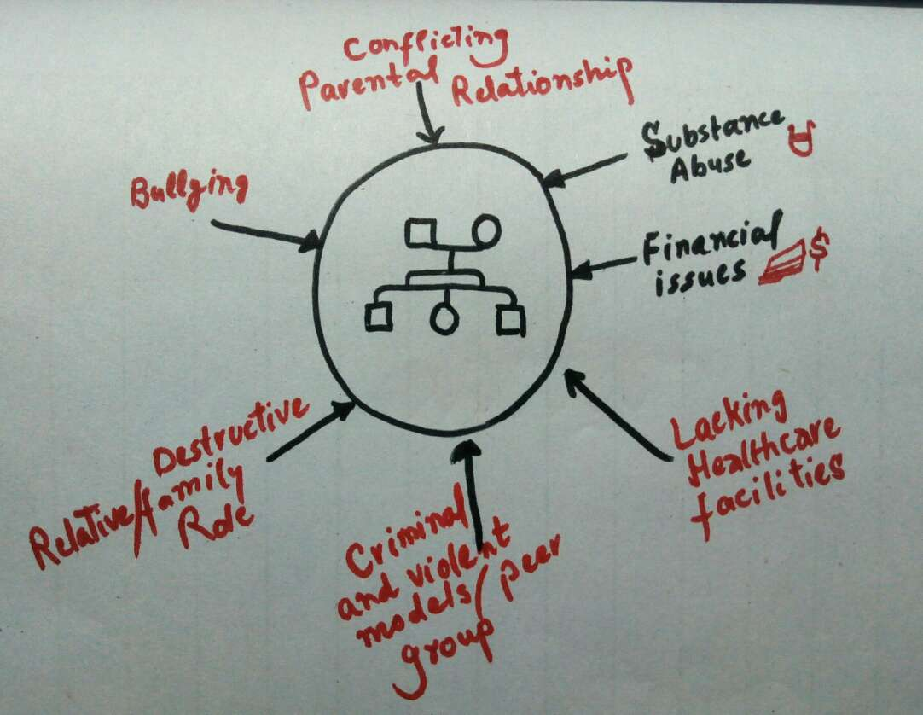
Image: Ecomap of selected family representing internal and external factors
Ecomap and Genogram are graphical representations of family history and their associated physical, mental and interpersonal issues so that healthcare worker could get a glimpse of current illness more instantly (Rohrbaugh et. al., 1992). Ecomap identifies internal and external stimulants that are potent enough to cause illness (McGoldrick, 1985).
Analysis of Ecomap and Genogram
Genogram
Generation III: Grandparents:
Starting from the paternal grandparents, they got married in 1967, had violent relationship and got separated. They had one child; mother was given the custody of her son. She was suffering from depression whereas father was a drug addict.
Maternal grandparents on the other hand, were married in 1970. They had strong intimate relationship with each other however, grandfather was a smoker. They had three children (one daughter, 2 sons)
Generation II: Father and Mother:
Father was born in 1969. He was suffering from depression; had violent relationship with his father but good relationship with mother.
Mother, on the other hand, was born in 1974; had two younger brothers only. One brother was drug addict whereas other was active smoker. She had good relationship with both the brothers whereas brothers had violent relationship with each other.
Generation I: Children
Three children (one daughter, two brothers) were born in 1997, 2000 and 2003. Eldest son was suspected to psychological illness. Daughter was found having depression whereas the younger siblings was suffering juvenile delinquency e.g., drug use and crimes at the very young age. Sister had indifferent relationship with her brothers.
Ecomap of Generation I
Interpersonal factors:
- Generation I observes their parents undergoing physical and verbal violence over even less-important matters.
- They have peer groups involved in criminal activities and violent crimes.
- They have relatives which play destructive role in family matters
- They are deprived of parental care, love, nurturance and emotional needs
- They are having a history of mental illness and drug abuse
Environmental factors:
- Their financial condition is bad due to their father having clinical depression and impaired occupational life
- Due to this, they have least access to healthcare facilities
- At school they face bullying over not having attractive appearance and poor performance
Nursing interventions
Based on the interpersonal and environmental factors and their behavioral problems, following nursing interventions can be applied:
- Sessions will be arranged for family counseling. Parents will be aimed at developing realization about the adverse consequences of violent activities in front of children because mind is so delicate entity (Jacob et. al., 2015).
- Father, suffering from depression, will be undergone psychotherapeutic interventions including antidepressants and Cognitive Behavioral Therapy particularly through reframing technique. In this way, he will be enabled to continue his occupational activities without any reluctance (Jacob et. al., 2015).
- Children will be counseled based on the theory of deterrence and positive reinforcement (Theorell et. al., 2015). Theory of deterrence states that human beings actively and innately avoid pain and unpleasant situations hence, these techniques will be used to discourage their criminal behavior and addiction. As far as positive reinforcement is concerned, they will be presented with something fruitful upon the completion of desired behavior.
- Their school teachers will be educated about the consequences of bullying on the academic performance and mental health of students (Jacob et. al., 2015). Hence, external and interpersonal factors will be addressed with appropriate interventions.
Conclusion
This assignment thoroughly presented the Genogram and Ecomap of a family with substance abuse, interpersonal relationship and mental health issues. After presenting these graphical representations, their detailed analysis was presented. In the end, nursing interventions were suggested based on the external and internal etiology.

References

Jacob, V., Chattopadhyay, S. K., Sipe, T. A., Thota, A. B., Byard, G. J., Chapman, D. P. (2015). Economics of collaborative care for management of depressive disorders: a community guide systematic review. Am J Prev Med., 42(5), 539–549. Retrieved from https://www.ncbi.nlm.nih.gov/pubmed/22516496
McGoldrick, X. I. (1985). Cenograms infamily assessment. New York: Norton Co, 39-124.
Rohrbaugh, N. I., Rogers, J., Goldrick, N. I. (1992). How do experts read family Genogram? Fan7 Systems Med, 10(l), 79-89.
Souza, P. I., Bellato, R. (2016). Genogram and Eco-Map As Tools For Understanding Family Care In Chronic Illness Of The Young. Texto contexto – enferm, 25(4), 201-206. Doi; http://dx.doi.org/10.1590/0104-07072016001530015
Theorell, T., Hammarström, A, A. G., Bendz, T. L, Grape, T. Hogstedt C. Marteinsdottir, I. Skoog, I. Hall, C. (2015). A systematic review including meta-analysis of work environment and depressive symptoms. BMC Public Health., 15, 738. Retrieved from https://www.ncbi.nlm.nih.gov/pubmed/26232123

