Name of Student
Name of Professor
Name of Class
Day Month Year
Cellular Respiration

Glycolysis: Glycolysis is referred to as series of chemical reactions that take place in the cytoplasm of cell. These reactions convert one glucose molecule (6 carbon molecule) into 2 pyruvates—a three carbon molecule that not only produces energy packets (ATP) but also reduces hydrogen carrying enzyme—NAD. Further, active transportation of pyruvate takes place from cytoplasm to mitochondria where coenzyme A combines with it producing Acetyl-coenzyme A along with carbon dioxide and hydrogen (Almeida et. al., 2004).
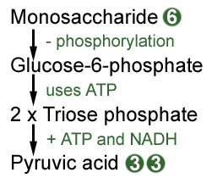
Pyruvate production in cytoplasm
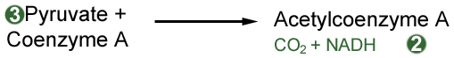
Production of Acetyl-coenzyme A
Net gain during this process: For each molecule of glucose break down, two molecules of ATP and two molecules of NADH are yielded; total 2 ATPs are produced.
Krebs cycle: It is the next step in cellular respiration which takes place inside the mitochondrial matrix. Acetyl-coenzyme A produced in the previous step then actively moves to the mitochondrial matrix where it is reacts with oxaloacetic acid for citric acid formation. Citric acid is then converted into ATP, NADH and FADH through chemical breakdown. Hydrogen carried by NADH and FADH are then used to make ATP in the next stage (Kreb, 1937).
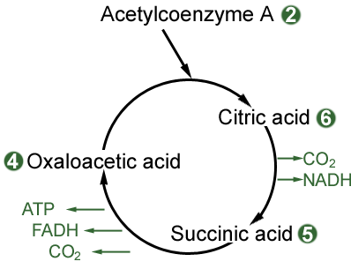
Net gain is 2 molecules of FADH2 and six molecules of NADH2, for each two acetyl CoA enzyme whereas that of ATP is 2.
Electron transport Chain: this is the next step in cellular respiration which takes place inside the mitochondrial membrane—folded into cristae. The rationale that nature selected this area for electron transport chain is its larger surface area conductive to step-by-step reactions. NADH and FADH produced in the previous steps bring Hydrogen with them which is then converted into Hydrogen ion and electrons. Electron then passes through series of carriers resulting in energy loss—the crux of ATP formation. On the other hand, larger accumulation of hydrogen ions causes elevated membrane pH. But no worries, oxygen molecules are there which react with hydrogen ions to produce water molecules. This is where “inhaled” oxygen is actually used (Kleinzeller, 1941).
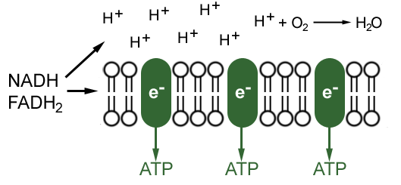
Total ATP gain from the electron transport chain is 34.
Net gain of ATP for all the three reactions is 38.
Difference between substrate and oxidative phosphorylation
In the substrate level phosphorylation, ADP is directly combined with Phosphate with the help of energy coming from coupled reaction. This reaction requires sufficient amount of energy for active combination. On the other hand, NADH and FADH₂ undergo oxidation generating ATP as an end product. This happens with the subsequent transportation of electrons and proton pumping. The resulting electrochemical gradient produces power that helps generating ATP (Christos et. al., 2018)

Works cited
Almeida, A., Moncada, S. and Bolanos, J. P. “Nitric oxide switches on glycolysis through the AMP protein kinase and 6-phosphofructo-2-kinase pathway. Nat. Cell Biol. Vol. 6, 2004, pp.45-51.
Kleinzeller A. “The formation of succinic acid in yeast.” Biochem J. vol.35, no.4, 1941, pp.495–501.
Krebs, HA. “Dismutation of pyruvic acid in Gonococcus and Staphylococcus.” Biochem J., vol.31, no.4, 1937, pp.661–671.
Christos Chinopoulos and Thomas N. Seyfried. “Mitochondrial Substrate-Level Phosphorylation as Energy Source for Glioblastoma: Review and Hypothesis.” ASN—Neuro, vol. 10, 2018.

