Name: Christine Jones #6860018
Date: 4/29/19
Instructor: Jordanna Sheer mohamed
Course:

This worksheet is scored on a “point system”: each question lists the total possible points for a correct answer. The entire worksheet is worth 100 points
Section 1: Plate Tectonics
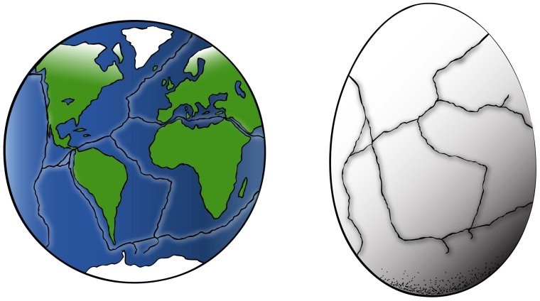
1. How many “plates” do you notice (easier to count on the egg)? (5 points)
There are seven tectonic plates in total
2. How many landmasses do you see present? (5 points)
Total of five landmasses are present when we see the surface of earth colored in green.
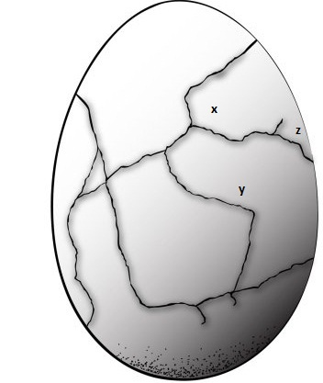

3. Are X and Y on the same plate? (5 points)
No, X and Y are present at different plates because they are completely separated by the cracks on earth’s lithosphere.
4. Are Y & Z on the same plate? (5 points)
No, Y and Z are present at different plates because they are completely separated by the cracks on earth’s lithosphere
5. Are X & Z on the same plate?(5 points)
Yes, X and Z are still present at the same plate because X and Y plates are having incomplete divergent boundary which will end up separating X from Z.
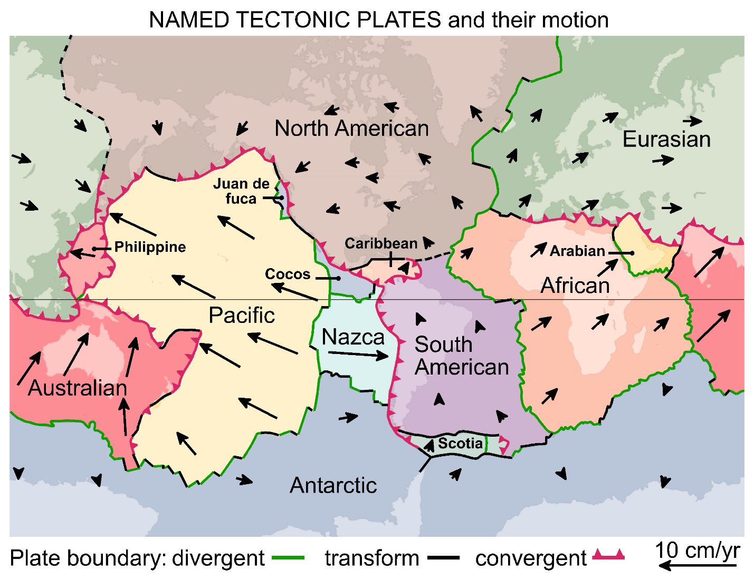
6. Complete the table below based on the map shown above. (5 points total for the table)
Plates | Type of Boundary
North American Plate and the Pacific plate | Transform boundary
North American Plate and the Caribbean plate | Transform boundary
North American Plate and the Juan de Fuca plate | Divergent (due to subduction)
Australian Plate and the Eurasian Plate | No boundary
Nazca Plate and South American Plate | Convergent
7. Describe what happens at each type of boundary. (5 points for each plate boundary: 15 points total)
  - Divergent
Divergent boundary is formed when two boundary plates collide with each other where one plate eventually slides under the other boundary which is known as the process of subduction.
b. Convergent
In convergent plate boundaries, plates moves away from each other.
c. Transform
Transform fault is created when one lithosphere plate slide past the other in horizontal manner.
8. Study the direction the plates are all moving. What do you think this map will look like in another 50 million years, how do you think the location of the continents will have changed? Response should be at least 2 – 3 sentences. (5 points total)
System of plates makes up earth’s continents and they constantly travel with the speed of 30mm per year. After fifty million years, it is estimated that Australia might collide with Southeast Asia, South Europe might put up against Africa and Atlantic Ocean might be bigger than what it is now.
Section 2: Volcanoes
9. Which type of volcanoes are most often found in oceans? (5 points)
Low silica shield magma volcanoes are found in the oceans because ocean crust is comparatively thinner than that of continental crust and it takes less time to for magma to reach surface due to which silica does not find enough time to incorporate in magma.
10. In which type of volcano does the oceanic crust descend beneath the thicker continental crust? (5 points)
In Strato-volcanoes the oceanic crust descends beneath the thicker continental crust.
11. Describe each type of volcano, with 2 to 3 sentences, and give an example. You will use your textbook for this question. (5 points for each volcano type: 15 points total)
a. Stratovolcano:
These volcanoes contain viscous high silica magma with gaseous pressure due to which, eruption of magma fragments is triggered. Here, the oceanic crust descends beneath the thicker continental crust.
b. Cinder Cone:
They are conical in shape and contain low silica magma with plenty of dissolved gasses due to which volcanic activity can be seen similar to “shaken cane” giving away soda spraying.
c. Shield:
Low silica shield magma volcanoes are found in the oceans because ocean crust is comparatively thinner than that of continental crust and it takes less time to reach surface due to which silica does not find enough time to incorporate in magma.
Section 3: Earthquakes

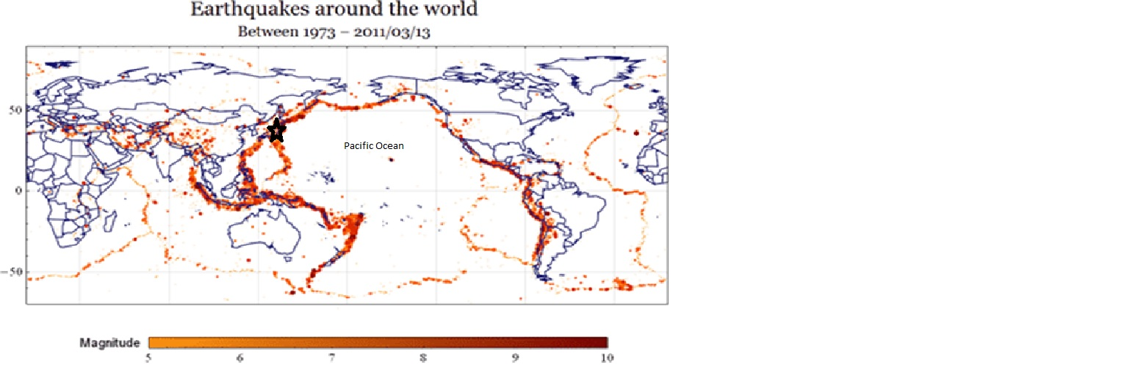
Atlantic Ocean
Indian Ocean
Arctic Ocean
Southern Ocean
12. Do earthquakes occur around the coastlines of all oceans? (2 points)
No, they do not occur around the coastlines of all the oceans.
13. If you responded no, give an example of an ocean with no earthquakes around the edges. (3 points)
Antarctic Ocean does not have earthquakes around the edges.
14. Do earthquakes occur only along coastlines? (2 points)
No, they do not occur only along coastlines.
15. If you responded no, give an example of an area where earthquakes occur in the middle of an ocean and in the middle of a continent. (3 points)
Indonesia is located in the southern Asia between pacific and Indian ocean that is having quite active seismic area.
16.Do earthquakes occur only in one particular climate, such as where it is hot? (2 points)
They occur in hot climate but on “only” in the hot one. They may occur around the cold areas, coastal areas and fault lines.
17. If you responded no, give an example of an area where earthquakes occur in hot climate and a cold climate. (3 points)
Indonesia is the example of hot area where earthquake occur whereas Tibet (China) is the example of cold climate that is conductive to earthquake activities.
18. Compare the Named Plate Tectonics map in Section 1 and the Earthquake Map in Section 3. Based on these, why do earthquakes occur where they do? Response must be at least one complete sentence. (5 points)
The areas located at ocean edges and where tectonic plate boundaries are present earthquakes are more likely to occur; for example Japan, because it comprises a long island chain between the sea of Japan, Philippine and Okhotsk. It is in the Pacific Ocean—the east and north Asia.
19. Find Japan on the Earthquake map (labeled with a black star). Explain why Japan has so many earthquakes. Response must be at least two complete sentences. (5 points)
Ring of Fire (ROF) is referred to as a major area in the Pacific Ocean Basin which is the center of many volcanic eruptions and earthquake activities. Approximately 90% of the earthquakes in the world happen in this area. Japan is located along the ROF this is why it has so many earthquakes.

