Diabetes Teaching Plan
Name
Institution

Background and Purpose
Sociocultural studies indicate that culture has long lasting and somewhat genetic effects on the individuals for understanding and embracing meaning to the worldly phenomenon (Bandura, 2002). Individuals belonging to different cultural backgrounds possess varying outlooks, attitudes, orientations, perceptions and preferences towards life due to which their definition of even trivial entities follows holistically unique patterns; achievement of universality is something next to impossible.
Moving towards second factor; a bulk of literature suggests that precipitating causes behind diabetes type 2 onset fall under lifestyle factors in most of the cases. Diabetes is a condition in which our body either does not develop enough insulin (a hormone that converts blood glucose into glycogen in the liver) or it develops insulin with impaired functionality (Menke et. al., 2015). Sedentary lifestyle is the most striking reason behind diabetes type 2. Type 1, on the other hand is genetic in nature and only medical treatment proves to be effective.
Combining the cultural diversity and diabetes, it can be deduced that applying effective teaching strategies to develop universal definitions of diabetes and its management techniques in culturally diverse individuals is irrefutably significant and acts as a prerequisite to the maintenance of healthcare quality for minorities (Weitzman et. al., 2013). This is because culturally different individuals possess deviating schemas about the definition of diabetes, its underlying causes and management techniques that is quite important to be synchronized with the universally accepted medical terms.
The awareness about the requirement of cultural sensitivity is undoubtedly the first step towards providing competent and sensitive diabetes education. Cultural sensitivity is much more than limited comprehension about cultural values, actions, thoughts, customs, languages and beliefs (Horvat et. al., 2014).
Development of positive and mutually respectful relationship among healthcare providers and diabetics is the end product of effective educational plans of concerning diabetes. Increased understanding of the patients will lead to their enhanced engagement and participation in the healthcare activities and achievement of desired healthcare goals for improving quality of life.
Goals and Objectives
Education plan will be aimed at following objectives and its associated outcomes:
- Acknowledgement about the unique healthcare perceptions for the individual belonging to varying cultural background
- Consideration of the learning background of patient about diabetes i.e., what was the source of information for him up till now
- Identification of potential barriers in diabetes management activities through collaborative efforts of healthcare providers and patients
- Conveying accurate, authentic and universally acceptable knowledge to the patient that is highly understandable for him.
- Addressing the limitations of self management techniques proactively in terms of patient’s will to adhere to them with reference to their cultural appropriateness.
- Identification and utilization of educational resources and materials that are purely synchronizing with the literacy level, age and culture of the patient.
- Identification and referral of patients to the diabetes care centers for fulfilling their needs in case of limited allocation of healthcare resources to them
- Education of patient about the milieu in which healthcare prevention and management plans are being executed
- Incorporate and dignify sensitivity while introducing patients to the instructional process regardless of their cultural back ground.
Outcomes
Based on the above mentioned objectives and goals, the outcome of healthcare educational plan would be; fostering interaction between patients and care providers, enabling patients to understand the causes, symptoms and treatment options of diabetes and enhancing their quality of care.
Methods of instructions
The method of instructions that I chose to convey diabetes education is “audio visual aids.” Although language acts as a barrier between healthcare providers and culturally diverse patients yet the other form of communication i.e., non- verbal or gestural might be used to convey necessary education about the basic etiological and preventive components of diabetes (Kutob et. al., 2013).
For that matter, diabetes patients will be enrolled in an illustrative classroom in which they will be taught simple biological mechanisms behind diabetes, incorporation of physical, psychological, environmental, genetic and social factors in diabetes onset, and universally acceptable intervention techniques to overcome this disorder.
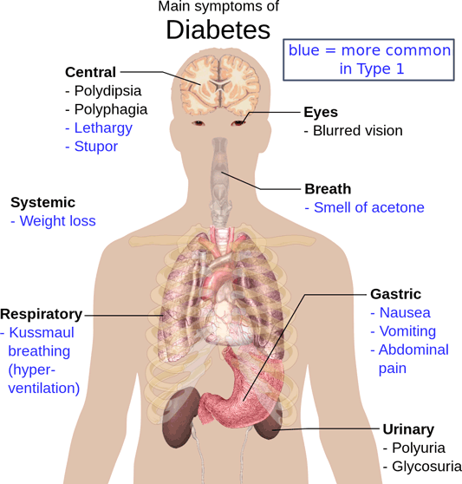
Image
Example of the illustration for making the patient understand their symptoms
Illustration of the molecular mechanisms (for instance, the involvement of beta cells of pancreas in the production of insulin and metabolism of glucose and relationship between insulin and glucose levels), the potential link between physical, psychological, environmental, genetic and social factors and diabetes (for example, stress is a psychological phenomenon in which cortisol hormone is released; this hormone reduces the functioning of body organs, leaving the body to function at same pace as far as patient feels stressed. This hormone also affects the functioning of beta cells that produce insulin for glucose metabolism) and appropriate interventions (i.e., medical treatment and the mechanism of action of medicine, exercise, diet, mindfulness and stress management techniques) through video and picture presentation. After demonstrating the pictures and informational videos, questions of the patients would be addressed through hiring multilingual professional for translation purpose. In this way, instructional process is expected to yield fruitful results.
Resources
This program may require professional assistance and substantial fiscal resources however it will definitely ensure the education of culturally diverse individuals about diabetes and eventually their enhanced quality of living when they would start understating the phenomenon completely and participate in the healthcare operations actively.
Evaluation of the effectiveness
Effectiveness of this plan would be evaluated using survey or interviews. Survey might include simple questions i.e., did you benefit from the illustrative process? Answer would be simple yes or no. Survey might also consist of the variety of questions in which all the aspects of this education plan would be covered. Interviews are also effective tools in exploring the effectiveness of this program profoundly. Evaluations will identify significant areas of improvement and will offer feedbacks for further implications. These feedbacks can be used not only for evaluating the effectiveness of current plan but also opens up many ways to improvise and harmonize the plan with patient’s needs.

References
Menke, A., Casagrande, S., Geiss, L., Cowie, C. C. (2015). Prevalence of and trends in diabetes among adults in the United States, 1988–2012. JAMA, 314(10),1021–9.
Bandura, A. (2002). Social Cognitive Theory in Cultural Context. Applied Psychology, 51(2), 269-290.
Weitzman, P. F., Caballero, A. E., Ferro, A., Becker, A. E. (2013). Bodily aesthetic ideals in minorities in type 2 diabetes: implications for treatment adherence, access and outcomes. Diabetes Educ., 39(6), 856–63
Horvat, L., Horey, D., Romios, P., Kis-Rigo, J. (2014). Cultural competence education for health professionals. Cochrane Database Syst., 5 (5). doi: 10.1002/14651858.CD009405
Kutob, R. M., Bormanis, J., Crago, M., Harris, J. (2013). Cultural competence education for practicing physicians: lessons in cultural humility, nonjudgmental behaviors, and health beliefs elicitation. J Contin Educ Health Prof., 33(3),164–73.

