Student
Professor
Class
Day Month Year
Human Kidney Anatomy and Physiology

INTRODUCTION
The H&P-II topic that I selected to embrace thorough discussion is Human Kidney. This paper is concerned with the exploration, elaboration and documentation of kidney histology, its structure, function, complications, associated treatments and side effects. Conclusion section, in the end, will wrap whole text of the article into single paragraph deducing meaningful inferences from the textual activity.
Kidney Anatomy and Physiology
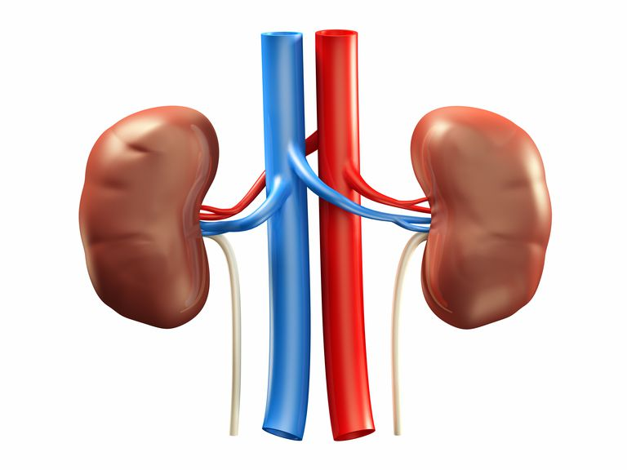
Image 1: Outside view of kidneys
Kidneys are an integral part of Urinary System. They are two in number and are located slightly backside of the abdominal cavity (Seely, 2017). Their average weight is approximately 4-5 ounce but the proportion of blood they receive surpasses other organs i.e., 20% of the blood pumped by the heart. Kidney is the production site of urine which is then poured into associated structures and eventually expelled out of the body (Piolanti et. al., 2015).
The blood supply in kidney takes place through renal artery which brings oxygenated blood whereas for the removal of processed blood from kidneys back to the circulation is accomplished through renal vein. The inner portion of the kidney is referred to as renal medulla whereas renal cortex makes up the outer region (Seely, 2017). Other portions include pyramids, renal papilla, renal sinus, minor calyx, major calyx and renal column that are labeled below:
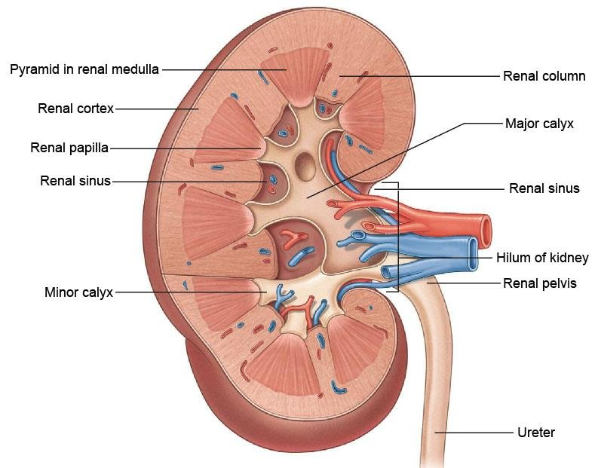
Image 2: Structure of kidney with its labeled parts
Nephrons are the basic structural and functional units of kidney (Seely, 2017). Each kidney contains over millions of Nephrons—extending from medulla to cortex.
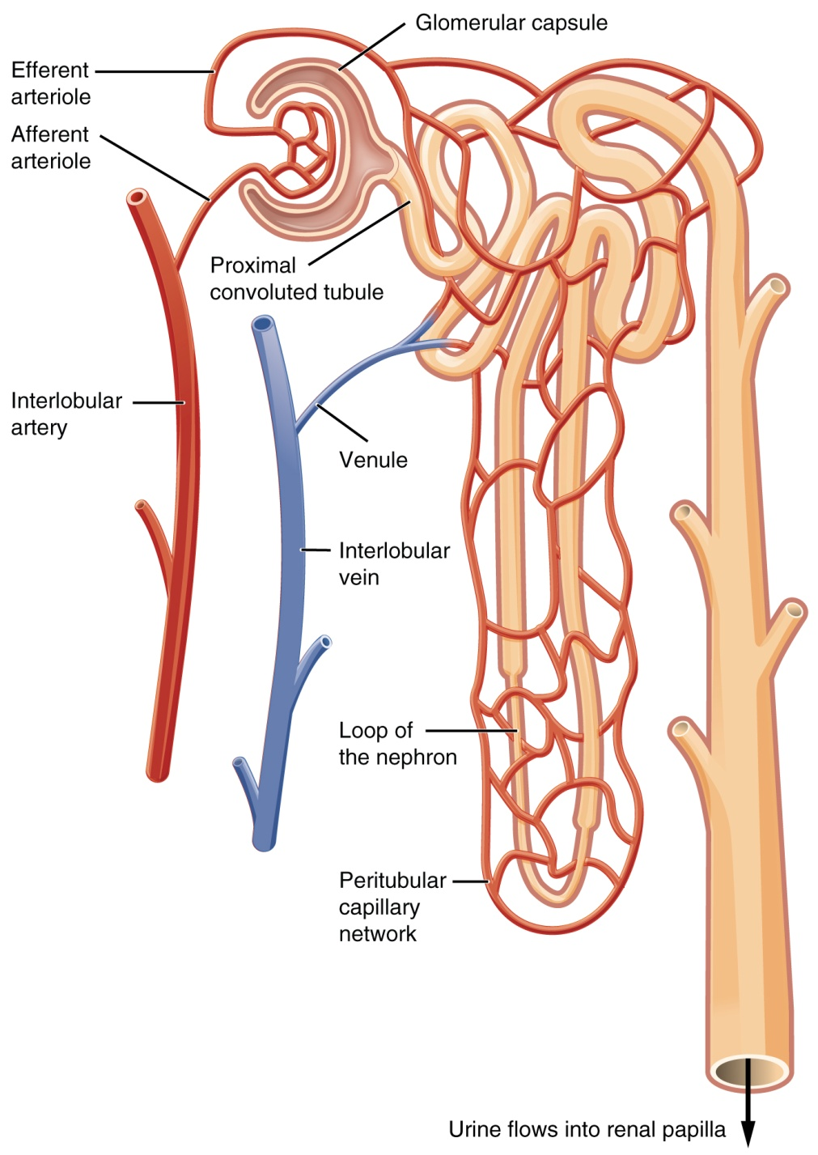
Image 3: Structure of Nephron and its labeled parts
Nephrons consist of Nephron tubule and glomerulus—a ball shaped capillary cluster exclusively responsible for the absorption of waste substances and water from the blood and prevention of large protein molecules and nutrients (Seely, 2017). On the other hand, Nephron tubule allows the re-absorption of useful substances back to the blood. Other parts of the Nephron are presented and labeled in Image 3.
As far as histology of kidney is concerned, the renal parenchyma consists of four portions; blood vessels, interstitium, tubules and glomeruli. Glomeruli are complicated vascular structures made up of endothelial, epithelial, mesangial cells and capillaries tuft—arranged around strong basement membrane (Seely, 2017).
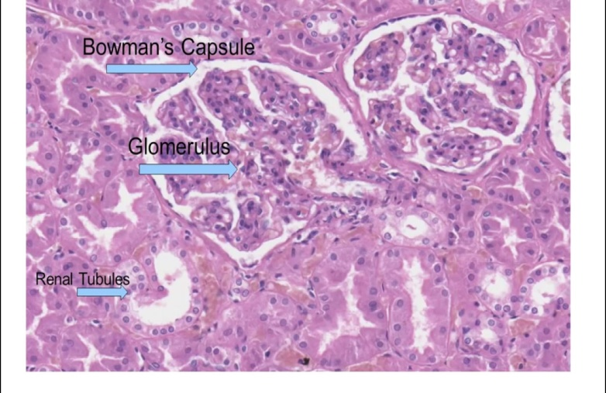
Image 4: Kidney histology
As far functions of kidneys are concerned, below is the detailed description of their primordial and secondary functioning. Their basic function is to maintain homeostasis and electrolyte balance however other wide range of functions is also performed by them:
1. Water excretion
Kidney removes various waste fluids and salts in urine and uric acid. Both the fluids contain waste materials absorbed from the blood after oxidation of food and its conversion to basic elements.
2. Re-absorption of nutrients
Kidneys are responsible for re-absorption of nutrients from the blood and taking them to the body where they are required (Radica et. al., 2016). They also re-absorb substances and other products for the maintenance of homeostasis for example, amino acids, glucose, sodium, water, phosphate, bicarbonate, sodium chloride, potassium and magnesium (Seely, 2017).
3. Maintenance of pH
Optima range of pH in human body is between 7.3 and 7.5. Between these ranges, enzymes and hormones will work well. Increase and decrease in pH levels gives rise to two abnormal conditions i.e., acidemia and alkalemia. In these conditions, proteins get destroyed and find it hard to function properly (Radica et. al., 2016). In such condition, kidneys reabsorb salts and nutrients to maintain the pH of body.
4. Osmo-regulation
Osmoregulation is referred to as the balance of electrolyte concentration in the water. When dehydration occurs, this balance is deteriorated and person either develops hypotension or hypertension (Oh & Galis, 2014). Kidneys attempt to maintain this balance through producing anti-diuretic hormones that increase the urine concentration and develop sense of thirst to compensate the water levels.
5. Secretion of active compounds
Kidneys release number of substances including Erythropoietin that controls the production of blood cells, Rennin that helps managing the elevation of arteries, lymph and interstitial fluid and volume of blood plasma (lymph is a fluid that contains lymphocytes for supporting immunity and producing interstitial fluid) and Calcitriol that actively metabolites vitamin D for increasing the amount of calcium in blood (Radica et. al., 2016).
Discussion
Kidneys are responsible for maintaining water and electrolyte balance in the body. When a person suffers from diabetes, the amount of sugar in the body becomes elevated. In these conditions, kidneys start absorbing sugar from the blood as extra waste products. Eventually, their functioning becomes distorted and kidney disease is developed which is known as diabetic nephropathy (Cameron, 2016).
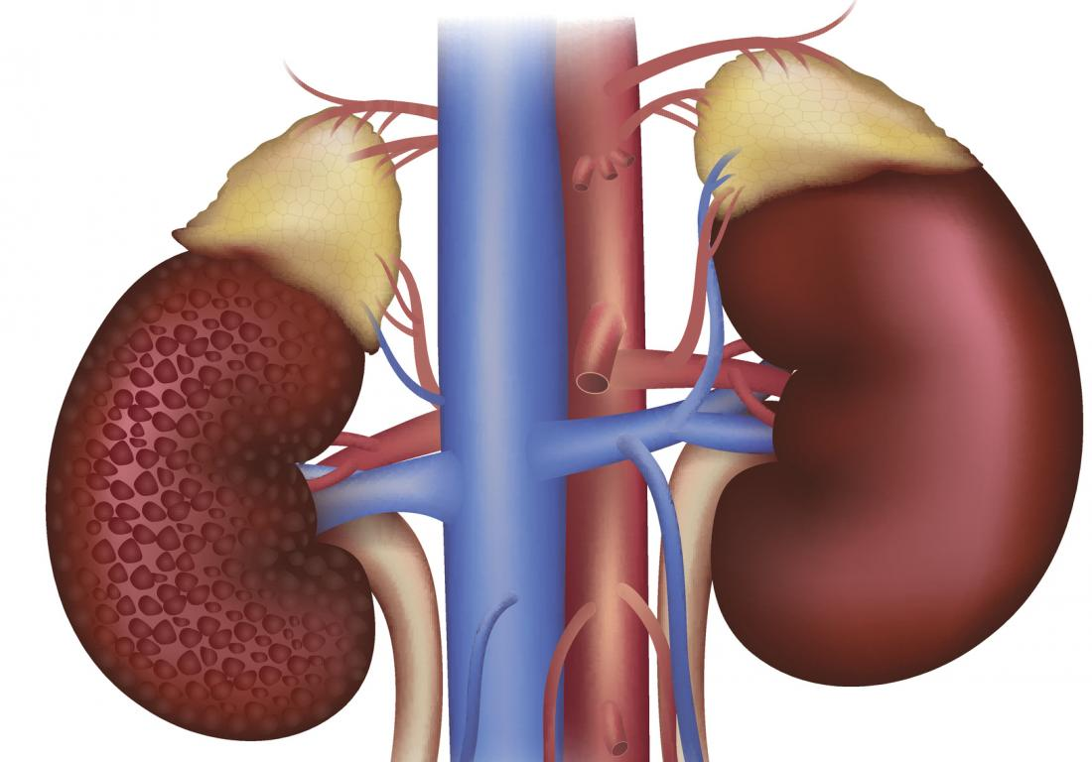
Image 5: Left kidney affected from diabetes nephropathy
Kidney problems are comparatively more evident in the individuals suffering from diabetes type 1 and 2. Due to diabetes, sugar gets accumulated into blood arteries of kidneys reducing their diameter and making it hard for them to reabsorb and continue their functioning normally. Diabetic nephropathy strongly disrupts kidney functioning regarding removal of waste products and extracellular fluids from the body (Cameron, 2016). This condition is treatable during the initial stages however chronic diabetics find it hard to get rid of this unless their diabetes gets treated completely.
Treatment of diabetic nephropathy includes medicines i.e., angiotensin-converting enzyme (ACE) inhibitors and angiotensin II receptor blockers (ARBs). These medicines are used for controlling high blood pressure which is the main cause of diabetic nephropathy. However, they carry devastating side effects and are prescribed with limited use. Their potential side effects include dry cough, increased blood-potassium level (hyperkalemia), fatigue, dizziness, headaches and loss of taste (Cameron, 2016).
Conclusion
Based on the above presented documentation, it can be deduced that kidneys are although small in structure yet perform vital functions for the body. They are an integral part of urinary system which is concerned with the elimination of water and waste substances from the body. They consist of two main parts; renal cortex and renal medulla. Renal cortex is the outer region of kidneys whereas renal medulla is the innermost part containing artery, vein and ureter.
Nephrons are the basic structural and functional unit of kidney and are present in millions. They contain specified filtration apparatus (Bowman’s capsule, islets of langerhans, glomerulus, tubules and collecting ducts) that carry and facilitate the process of absorption. When we eat food, oxidation of glucose takes place in into simpler substances i.e., amino acids, glycerol, lipids and carbohydrates. These molecules are used in the production of energy which is necessary for executing daily functions. The waste products in the blood reach kidneys where they are absorbed to the collecting duct and expelled out of the body through ureter and urethra.
In a nutshell, kidneys play primordial functioning in balancing body fluids and producing important products as mentioned above. They perform their functions utilizing their filtration mechanisms. Their important functions include water excretion, balance of water to electrolyte ratio, production of significant substances and hormones (rennin, anti-diuretic hormones, calctriol and Erythropoietin), maintenance of blood pH through absorbing and eliminating required molecules (amino acids, hydrochloric acids and sodium bicarbonate) and Osmoregulation.
This point does not require further elaboration that all the body systems are interrelated; for that matter structural or functional impairment in one system gravely affects the other ones. Diabetic nephropathy is a serious kidney impairment in which diabetes plays detrimental role. Hence, it is important to ensure the structural and functional normality of other organs while treating the impairment of one.

References
Cameron, J. S. (2016). The discovery of diabetic nephropathy: From small print to centre stage. J Nephrol, 19(10), S75–S87.
Challenges, Progress, and Possibilities. CJASN, 12 (12) 2032-2045. DOI: https://doi.org/10.2215/CJN.11491116
Oh, Y. S., Galis, Z. (2014). Anatomy of success: the top 100 cited scientific reports focused on hypertension research. Hypertension 63:641–7. Doi: 10.1161/hypertensionaha.113.02677
Piolanti, N., Nesti, A., Andreani, L. et al. (2015). The fifty most cited Italian articles in the orthopaedic literature. Musculoskelet Surg, 99, 105–111. 10.1007/s12306-015-0352-5
Radica, Z. A., Michele, T. R. and Katherine, R. T. (2017). Diabetic Kidney Disease
Seely, J. C. (2017). A brief review of kidney development, maturation, developmental abnormalities, and drug toxicity: juvenile animal relevancy. J Toxicol Pathol. 30(2), 125–133. doi: 10.1293/tox.2017-0006

