Student Name
Instructor Name
Course Number
Date
Introduction
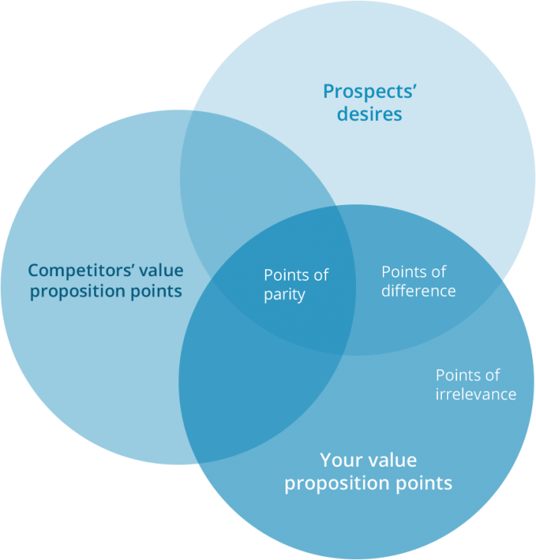
There are three circles when we consider the value proposition for any product. These circles relate to the competition, company itself and the needs of its customers. There are cases where competitor’s circle is shown as a separate circle from the other two and there are no common points between the company and its competitors (Camilleri). This is because the brands offered by company is a little different from the brands of other companies. The other two circles include the needs of customers and value proposition points of the company. The points which are common with competitors will be points of similarity. Points of difference are the ones on which company has to work. These points are those which are different between company and its competitors (Kellogg's). They can either provide a source of competitive advantage to any one of the companies. The points remaining in company’s own proposition will not be relevant in terms of this analysis.
Application
Raisin bran cereal is the product under consideration and the first aspect is brand name of Kellogg’s which is associated with it. This provides a positive difference for the company because other companies cannot match the brand power associated with Kellogg’s. A competitor who will give tough time to Kellogg’s is Nestle. The major reason for this is that the company has a stronger brand name in most parts of the world. The common points between Kellogg’s and its competitors are that they all provide breakfast cereals and at a competitive price as well. The points of difference between company and its competitors are the flavor which are offered by them. A little difference between packaging can also be seen between competitors. The major difference between competitors lies in their perception of customer values. The whole concept of value proposition is that companies see customer values differently (Urbany and H.Davis).
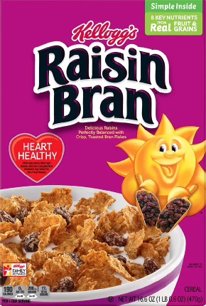

Works Cited
Camilleri, M.A. "Integrated Marketing Communications." Camilleri, M.A. Travel Marketing,Tourism Economics and the airline product,Tourism, hospitality and Event Management. Springer International Publishing, 2018. 85-103.
Kellogg's. "http://newsroom.kelloggs.com/2018-10-25-Kellogg-Announces-New-Global-Sustainable-Packaging-Goal." 25 October 2018. http://newsroom.kelloggs.com. 18 January 2020.
Urbany, Joel E and James H.Davis. "https://hbr.org/2007/11/strategic-insight-in-three-circles." November 2007. https://hbr.org/2007/11/strategic-insight-in-three-circles. 18 January 2020.

