Student Name
Instructor Name
Course Number
Date
Introduction
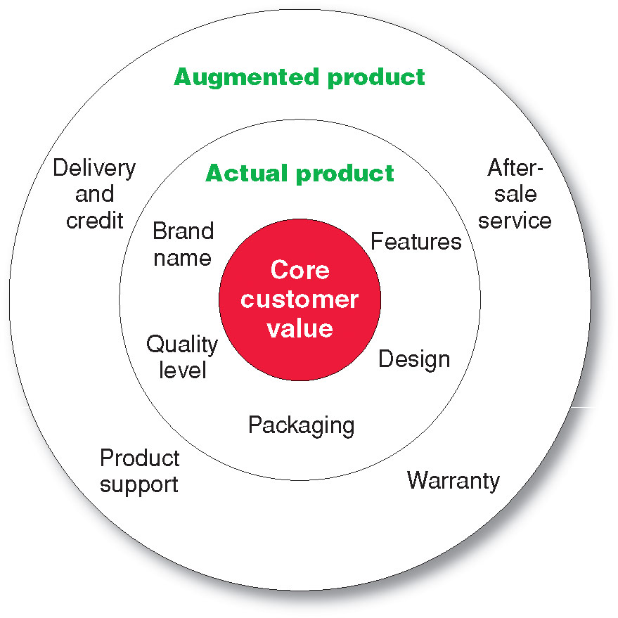
Product complexity refers to the match between an actual product and core customer value. The value from a product can be extracted by looking at the needs that it fulfills. Actual product includes the brand name which should be well known to the customers. The packaging should be such that it can be easily opened and saved after using the required quantity. The quality level should be consistent so that all packs of the product provide the same quality level to customers. Core customers value is the core benefit that a customer seeks to take out from any particular product (Friesner). The various characteristics of products which have been discussed above help a company to provide core value to its customers (Camilleri). Basically, it is the need which is satisfied by a product.
Figure 1
There can be different aspects that a product fulfills. A company that is able to match the products with customer’s core values will be the most successful in its business.
Application
Kellogg’s is a renowned brand name which is working in many countries. The company knows the main purpose of its Brand Raisin Cereal. The core value of the customers is breakfast that energizes people and keeps them healthy as well. The packaging is also done to make sure that the product is easy to use, and can be kept fresh after opening. Another important aspect is that the packaging is done with renewable materials (Kellogg's). The different variants of product satisfy different needs especially the flavors which are for sugar patients. The quality of this product has been consistent because it has been sold over a longer period of time. The company should come up with the new flavors which will add further value for customers. This may include new designs of packaging and new flavors which will increase the number of customers for the company.
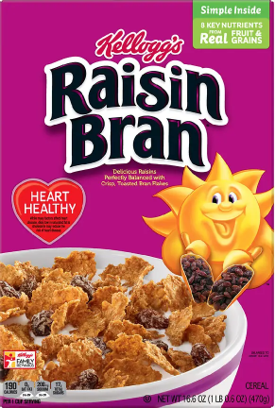

Works Cited

Camilleri, M.A. "Integrated Marketing Communications." Camilleri, M.A. Travel Marketing,Tourism Economics and the airline product,Tourism, hospitality and Event Management. Springer International Publishing, 2018. 85-103.
Friesner, Tim. "https://www.marketingteacher.com/three-levels-of-a-product/." 8 May 2014. https://www.marketingteacher.com. 18 January 2019.
Kellogg's. "http://newsroom.kelloggs.com/2018-10-25-Kellogg-Announces-New-Global-Sustainable-Packaging-Goal." 25 October 2018. http://newsroom.kelloggs.com. 18 January 2020.

