Term Project
Balbiany Pulice
[Name of the Institution]

Term Project
Abstract
Austria which is officially known as the Republic of Austria is a Central European country with 9 federated states. Vienna is its capital city and also one of its nine states. Austria is a relatively small country with an area of 83,879 sq.km with 9 million population and $477 billion as its nominal GDP. It's neighboring countries with which it shares its borders include Germany and the Czech Republic in north, Slovakia, and Hungary to the east, Italy and Slovenia to the south, and Liechtenstein and Switzerland to the west. It has a high mountainous terrain with only 32% of country height below 500m. It is one of the growing economies and developed country with tremendous potential for high-end sports gear winter sale because it has many spots as compared to others for snow-related sports and tourism. This thing along with its compatibility with the American environment makes it a perfect way to look for established businesses.
Economic Overview
Austria's robustly growing economy and consumption of the private sector has gone up in a considerable amount. In 2017 GDP increases by 2.6 % and is expected to expand in 2018 slightly to 2.7%. It has been forecasted that it would be slow thereafter. Rising private consumption helps in making domestic demand main growth driver. This thing reflects that labor development in markets are favorable and wages would increase, as well it is predicted that investment growth is solid in construction and business sector. In 2018 strong export growth has been seen despite international market dynamic growth was less. Expected domestic demand remains firm in the coming years.
Investment is the main contributor to growth in GDP but with an economic slowdown, it would also slow down in line. Investment in 2017 grew by 3.9 %. Expansion capacity needs in accordance with the strong growth of the economy also results in increasing equipment and machinery acquisition, which increases by 4.6%. Total investment in 2018 is at a mildly slower pace have grown expectedly. This is the reflection of economic growth overall moderation in years second half, mainly driven by external demands reduction. Economic growth in the long term will be ensured depending on investment sufficiency will move towards factors of productivity-enhancement which includes skills, digitalization, innovation, and research.
Rate of inflation in Austria is to stay approximately around 2% according to expectations in years to come, which is above the level of Europeans countries average. The economy strengthening with core inflation and robust headline mirroring it, which is 2.1% in the first half and 1.9% in the second half of 2018. Service prices are rising due to the thriving tourism sector especially in restaurants and hotels, but rents increase also contribute to price increase overall. Industrial goods and service sectors mainly domestic price pressure is boosting expectedly due to strong domestic demands and rising wages. Inflation in Austria is to remain at 2% which is more than the average of euro area inflation average of 1.4% for the year 2019 and for 2020, 1.5 %.
Improvement has been reported in the Austrian labor market which is in continuity. In 2018, it has been forecast that growth in employment would be 1.5%, driven by mainly industrial, services and public sector. Consequently, unemployment is pushed down to 4.9% in 2018 third quarter, which is its structural level. Labour shortage has been expected because of this environment of increasing labor demand and reduction of unemployment. Performance of the labor market led to wage growth. Nominal expected compensation per employee increases in 2018 by 2.5% and is expected to do so in the year 2019. It implies at the same time in mild appreciation of effective real exchange rate. As inflation slightly decreased, the growth of real wage improved in 2018 to 0.8 % from 02 % in 2017.
According to world bank indicator of ease of doing business, Austria remains on 26th position overall the world with the score of 78.57 as shown below.
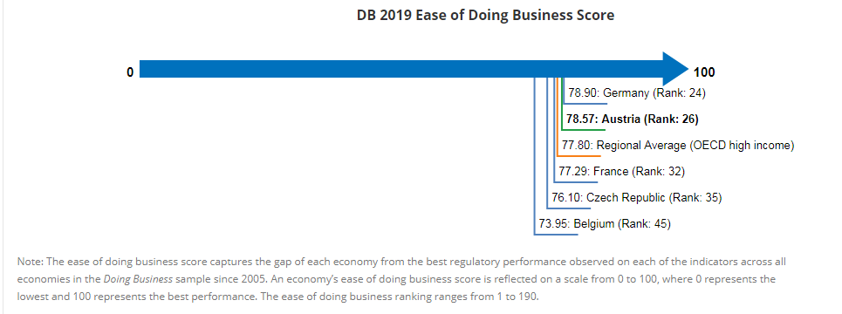

Political Overview
Austrian politics historically is divided and dominated by Austrian’s grand coalitions of two centrist main political parties i.e. (Social Democrats the center-left and People’s Party the center right). “Proporz” is the system which dictates the control of ministries by either party, which businesses (state-controlled or owned) and which bureaucracies would be controlled. This results in the creation of tightly-knit patronage and contacts fabrics which results often in management decisions that are politicized and people without the affiliation of the right party are most frustrating. Due to deadlocks, mismanagements due to refugees problem and stagnation of economic system contributes in sentiments of anti-establishment in 2017 October election in advance of parliamentary elections, which brought the center-right(current) government into the power ending the grand coalition. Lead by Sebastian Kurz, People's Party conservative entered into government made of a coalition with Freedom Party the right populist party in 2017 December with a promise to control migration, economic deregulation and modernization, and “proporz” system jettison.
Certain trends are identified with this change in political change in perspective of an American company doing business in Austria. Digitalizing public services, which could result in building smart government expansion program throwing out an inadequate network of fiber-optics. Another move is size reduction of government by various competencies merging between the provinces, bureaucracies and the federal government. Finally, proposals are put into loose weekly and daily limits of working hours. However, these proposals are met with great opposition and new regulations until now will be closely looked to see how they impact the environment of the business.
Legal System Overview
There are many aspects to consider depending on investor preferred business organization. For an investment of the long term, a foreign investor has a choice between three legal forms which are different from one another of Austrian entities of business:
- Company of Limited-liability (GmbH)
The GmbH is a form of company which is very flexible and one or more founders can be set up this type as well as it can be set up by the legal entities, foreign and Austrian shareholders.
Since 1st March 2014 a new GmbH was founded which has the option in share capital limit to EUR 10,000 for up to 10 years of which contribution of EUR 5000 has to be made. It is estimated that by 1st March 2024, an increase in share capital must be done from EUR 35,000 from which at least contribution of EUR 17,500 has to be contributed. At the Commercial Register, with its registration, GmbH is established legally.

Joint-stock Company (AG)
One or more than one shareholders can establish a joint stock company. EUR 70,000 is the minimum stock capital of which contribution of at least EUR 35,000 has to be made. The executive board and supervisory board are included in its structure.
Partnerships
Two parties at least can establish a partnership on a certain objective agreement. Full legal capacity is given to the partnership. A limited and general partnership has a distinction between them. At least general partnership consists of two shareholders, who are fully liable personally for the company's any debt. While in limited partnership at least one limited and one general partner is required. Commercial Register records the scope of partner's liability of the limited partnership.
Private Foundation
Managing beneficiary funds are taken by a legal person in a private foundation. For its establishment, declaration of foundation's purpose is required along with a minimum contribution of EUR 70,000 in property or cash form need to be made. Beneficiaries of the private foundation are not publically disclosed which is its advantage.
Non-resident individuals and companies can also use their branches to operate rather than from their subsidiaries. Since no paid up capital so there are low start-up costs. Taxation of the branches is at the income tax rate of a corporation based on Austrian-source income. Companies that are non-European Union as contrary to companies of European Union countries have a local representative to appoint.

Working Conditions and Employment Law
Numerous acts cover the Labor law and it is Austrian legislation most complex area. Same working conditions are applied as that of any other European Union countries. Contract of regulation is applied if no other applicable regulations are there. 40 hours is the maximum statutory work week. By collective agreement extension of up to 10 hours can be made although the maximum statutory work is 8 hours per day. 14 salaries have to be paid per year and paying less than the wage set is illegal. Countries citizen that are of non-European origin needs resident title and as well as a visa to stay in Austria.
Finance and Investment
The business license is a demand for several businesses. District administration is responsible for permit issuance if plans of investor are in premises and plants of that area. It is very positive for a foreign investor that legislation of Austria sets a liberalization high level in capital transactions happening in cross-borders. No exchange control is exercised by Austria since it falls in Eurozone. Client identification and reporting requirements are used to avoid anti-money laundering purposes.
Accounting and Audit
Austrian Commercial Code is the legal financial accounting foundation. Partnership with lower turnout than EUR 700,000 must cash account carry.
Technological Environment
The ICT sector in Austria made 3.9% of Austria total GDP and Austria's 7% comes from total trades in goods. Majority of ICT products are supplied by foreign companies in Austria, with imports of ICT goods that make up to $13.4 billion in the year 2017. U.S. companies use major opportunities selling the products that are related to health IT, cybersecurity and mobile telecommunications. Austrians successive governments made their priority of digitalization for public funding. It has been noted that 68% of the population of Austria in the year 2017 live in Austria's urban areas. Public funds are allocated to the technologies and research that has its focus on “smart cities”. As for the environment, programs are a concern, every year investments up to $170 million are provided in environmental programs. Efforts are also made in the sectors of transportation, digitalization, and smart energies to meet the technological advancements demand.
CSR and Sustainability Plan
As for my recommendation, Austria has a great wake for adopting sustainability and social responsibility at a slower pace though, therefore it is necessary for us not to make abrupt new plans on their culture. I have plan and implementation in my mind, yet it would not undergo its due course until I get a positive start signal from the environmental department of Austria. The plan that I have put forward is related to an impact and necessity of safeguarding environment and natural resources, but our investment economic benefits are also stressed that will bring prosperity in the economic market of Austria.
Following objectives will be there according to our plan:
- First Ethics: Values, Morals, Beliefs, and Custom has importance standing in every culture. Our organization keeps its track to keep our business development in line with Austria regulation affairs and culture.
- Community Support: As of today, there is much emphasis put on environmental wellbeing. We would help people educate on how to preserve the environment and make programs contributing to the recycling system, park building, and help people in achieving their endeavors.
- Employee Support Program: Supportive environment will be provided by our company to the employees, where it would be easy for our upcoming employees to contribute and develop their skills for their own success.
- Sustainable Measures: To preserve and protect the environment, our organization will take social responsibility on its own shoulders along with profitable progress

Austria Profile Hofsteade
Power Distance
The score of Austria is very low in this field (score 11) which means that Austrian side has following style characteristics: Being independent, equal rights, coaching leaders, convenience hierarchy only, empowers and management facilitates. Power is mainly decentralized and team members experience is required for a manager to count in. Consultation of employees is expected. Control is not liked. Direct communication and participation are done.
In this field, America scores 40.
Individualism
In this regards, Austria scores 55 and thus it is the society of individuals. High preference for a social framework is loosely-knit in which it is expected that individuals only take care of their family members and themselves. In a society of individualism, low self-esteem and guilt are caused by the offense, the relationship of employer/employee is based on a contract of mutual advantage, merit is supposed to be the sole reason for promotion and hiring, individualistic management is the type of management exercised.
America scores 90 in this field with having a highly individualistic society. Its society is very loosely knit. Only immediate families and the person itself is concerned. Americans are very difficult in developing a deep friendship.
Masculinity
Austria scores 79 in this regards which means that its society is based on Masculinity which is highly driven and success oriented. In countries of Masculine nature, people live to work, decision-making skills are expected of the managers, equity, performance, and competition are emphasized. Fighting the conflicts is the only way out. ‘
America in this scores 62 which is in accordance with the American behavioralism. American show their masculinity drive individually.
Uncertainty Avoidance
In this regard, Austria scores 70 and thus regarded as a country which avoids uncertainty. Countries having this index high maintains behaviors and beliefs with rigid codes and ideas and behavior that turns out to be unorthodox is not tolerated. Cultures exhibiting high scores in this regards needs emotional rules even if no purpose is served by the rules like time is money, the inner urge of the people to be hardworking and busy, punctuality and precision are the norms, registration to the innovation, individual motivation pays importance to security. Academic titles usage with peoples name is another indication why Austria rank high in this factor.
America in this context scores low on 46, which means that new ideas are encouraged, products are innovated and trying different is also encouraged. They allow freedom of expression and tend to be flexible with their perceptions.

Long Term Orientation
Score in this index for Austria is 60, making it a culture of pragmatism. In such societies having pragmatic cultures, people believe that context, situation and time are factors that show what truth is. This thing shows that Austrian people easily adapt traditions with changing circumstances and conditions.
American, on the other hand, is not a pragmatic culture. They have a very strong "good" and "evil" ideals. Americans evaluate their businesses on a short basis with a quarterly check on their loss and profit statements. They strive for quick and working results.
Indulgence
In this regard, Austria scores high with 63. People of this society exhibits their responsibilities with regards to their need for enjoying life. Mostly these people are tending towards positivity. High leisure time and money spent as they want is present in a higher degree.
In this regard, America scores 68 which is closed to Austria in this parameter showing its similarity. Below is the graphical representation of Hofstede scores.
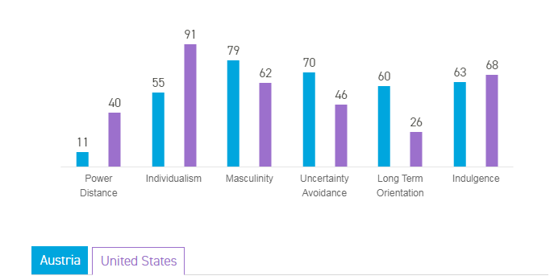
Recommendations for Cross-Cultural Communication and Negotiations
The difference between the culture of Austria and America exist but not very polarized. For example, both are individualistic societies and their culture reflect that too. However certain things should be known about Austrian culture prior to getting in contact with Austrian companies. Austrian like Germans value punctuality, privacy, and order. Mostly they are conservative people with moderation in their behavior and give value to moderation. Perfectionism is respected in all areas of private life and business, and their approach is to achieve the set goals. Their well-defined structure is coupled with their perfectionism which is an implication that secondary role is served by interpersonal communication. Austrian do compartmentalize their life and organize according to it. The separation between work and their private life is strict and to get into a personal relationship with them takes time.
In Austria communication is very formal and direct speech is mostly used in their way of communication. Trust can be enhanced and strongly recommended in Austria if introductions are made through the third party. Once the trust develops, they would tend to build a personal relationship in conducting business.
Vertical structured Austrian business hierarchy has a strict and well-defined culture, with roles distinction and responsibilities closely defined. Expertise and achievement is the main reason for the place in the hierarchy in Austrian business culture. It is very important to remember that Austrians value their background and academic titles that convey their expertise and knowledge of a particular field. It is generally customary in Austria to tell your name when answering the phone. Corporate trends of identity require you to answer the phone by stating your company name, your name and then greetings.

Political Risk Profile of Austria
Austria shifts its course to the right with selecting the Austrian People's Party in 2017 election which is a Christian, conservative democrat party. It won the election in the Nationalrat with third of the total seats. Alexander Van der Bellen is selected as a president and he appointed Sebastian Kurz who is a former foreign affairs minister as Chancellor. Austria and the United States are trading partners with 4th largest trading and after Germany the second largest market for exports. In the year 2017, U.S. exports goods worth $4.3 billion which is 13% more than in 2016. Austria exports goods to the United States with twice that number which goes around $11.7 billion also up by 7% as compared to the year 2016. So politically risk associated with Austria is very less and there is an ample opportunity for our company to work in Austria as the relationship of every government with the USA were also mutually beneficial and based on trades and cooperation.
Austrian Workers Leading and Motivational Plan
In order to motivate Austrian employees and to lead them, the knowledge about their culture is very important along with incentives fitting their profile that motivates them. As for now, we have learned about Austrian cultures and their trademarks like their society values, respect, communication, punctuality, and business strategies that help them in profiting their goods, products, investments, and services. The following plan is suggested in motivating and leading Austrian employees fitting their culture and values, that would result in the growth of the organization.
- Give titles and rewards: As we now know that Austrian people like to call by their titles based on knowledge and field of expertise, so it would be a good strategy to give them titles and rewards on their endeavors which would make them proud and motivated.
- Maintain open, clear and formal conversation as it is known by their culture that formality is liked. Hear the employees and reward them based on their cultural norms of punctuality, time management, and positive intercommunication.
- Give benefits and regards to Austrian employees because they like to enjoy life with their earnings. A couple of incentives can be:
- Birthday off
- Financial help for medical and education
- Punctuality based employee of the month
- Different areas of training such as modeling, design, and extra payment made for skiing with sports gear.
Planning for Selecting Expatriate as VP, Operations
For an expatriate plan which would be fair in Vice President Operations position, the following plan is proposed:
- Salary of the expatriate is raised to 25% of the base salary.
- A package of compensation will be given as previously given when working in the United States. Medical and health insurance of expatriate and its family would be added using company overseas fund which would also cover vision and dental coverage.
- TADA: Relocation to a European country will include travel and transportation expenditures. Passports, residence fees, permits would be provided. The agent would be given that helps in finding an apartment or house, schools for children and all tools to get along.
- Allowances: Transportation allowance in the form of the car will be provided along with a fully loaded apartment for first 30 days. Expat along with family is going to get an allowance for twice a year paid vacation to their own location.

References

Austria - Market Overview | export.gov. (2019). Export.gov. Retrieved 15 May 2019, from https://www.export.gov/article?id=Austria-Market-Overview

Austria - Political Environment | export.gov. (2019). Export.gov. Retrieved 15 May 2019, from https://www.export.gov/article?id=Austria-Political-Environment

Austria / Economic Studies - Coface. (2019). Coface.com. Retrieved 15 May 2019, from https://www.coface.com/Economic-Studies-and-Country-Risks/Austria

AUSTRIA, S. (2019). Statistics. Statistik.at. Retrieved 15 May 2019, from http://www.statistik.at/web_en/statistics/index.html

Compare countries - Hofstede Insights. (2019). Hofstede Insights. Retrieved 15 May 2019, from https://www.hofstede-insights.com/product/compare-countries/

Doing business in Austria. (2019). Icaew.com. Retrieved 15 May 2019, from https://www.icaew.com/technical/by-country/europe/austria/austria

The Austrian Legal System and Laws: a Brief Overview - GlobaLex. (2019). Nyulawglobal.org. Retrieved 15 May 2019, from https://www.nyulawglobal.org/globalex/Austria.html

