Strategic Management
[Author Name(s), First M. Last, Omit Titles and Degrees]
[Institutional Affiliation(s)]

Author Note
[Include any grant/funding information and a complete correspondence address.]

Strategic Management
About the Organization (Walmart)
Walmart Incorporation formerly known as Wal-Mart Stores Inc is a US-based multinational retail corporation that operates in a large number of regions or locations around the world. Walmart mainly operates a large chain of hypermarkets, grocery stores, and discount department stores as well as operates Sam’s Club retail warehouse. In the current time, Walmart has existence and operates in 27 countries around the world. The company can be found as a highly efficient and well-performing organization or business entity. Walmart is so well-performing and efficient in its business operations and organizational performance. The company is also impressively performing when it comes to the financial results of the company almost in every financial year. In short, Walmart is a highly and efficient company or organization in terms of its operations and performance (Nghia, 2020).
Products and Services Offered By Walmart
The key products and services offered by Walmart ensure the ultimate satisfaction of its consumers and customers. It means that the quality of the products offered by the company or organization known as Walmart is of high quality. While the services they offer with their products or items they sell to the customer (e.g. customer services) are also highly recognized all over the world (Nghia, 2020).
The products that Walmart offers to its customers around the globe in the current time are divided into categories by the company that mainly include but not only;
- Meat, produce, deli, bakery, dairy, frozen foods, floral, and dry grocery
- Health and beauty aids, household chemicals, paper goods, and pet supplies
- Electronics, toys, cameras and supplies, photo processing services, cellular phones, cellular service plan contracts, and prepaid service
- Fabrics and crafts, stationery and books, automotive accessories, hardware and paint, horticulture and accessories, sporting goods, outdoor entertaining, and seasonal merchandise
- Apparel, shoes, and jewelry
- Pharmacy and optical services
- Home furnishings, housewares, and small appliances (through discount stores, supercenters, and neighborhood markets)
- Hard goods, soft goods, and selected private-label items under the member’s mark, bakers & chefs, and Sam’s club brands
These products and services offered by Walmart are categorized into the following categories.
- Retail goods and products.
- Photo services inside the stores.
- Pharmacy
- Financial services
- Wireless services
The customer services department of Walmart is one of the most critical and important departments of Walmart. It is an important department because it deals with customers. The customer service department deals with the customers through the sales representatives and retailers of the company all over the world (Nghia, 2020).
The activities that the customers' services department of Walmart performs include returning merchandise to their position on the shelf, ensuring and accepting the change and return of the products and commodities sold, making a refund to the customers in case of any problem or issue regarding products. The refund of money is almost happily done by the department because Walmart always works to ensure high level customers’ satisfaction in terms of product quality and keep them on the safe side in case of any issue. The department also works to handle the delivery process and procedure to ensure the on-time delivery of products and items to the customers and consumers.
In terms of sales, sales are done through the stores in different locations as well as through the retailers of the company. It means that a direct sales by Walmart or the sales department of Walmart do not make sales. While the department ensures the availability of products and commodities to stores and retailers as well as shops of the company (IBISWorld, 2020). In addition to this, the sales department of Walmart plays a vital role in customers’ satisfaction after the production department.
Walmart Service Delivery Process Flowchart
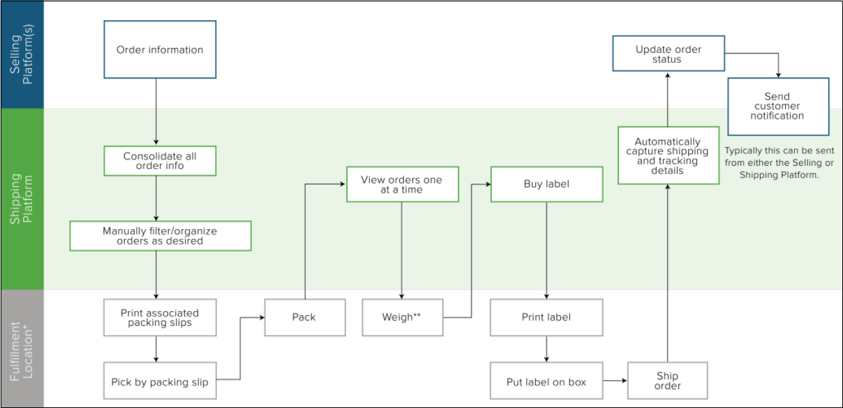
As Walmart is the company that has operations in around 27 countries around the world and operates via different stores in these regions, the importance of the Service Delivery Process is very crucial. It means that the company (Walmart) has to ensure an efficient service delivery process so that the on-time delivery to the customers would be ensured. Similarly, the company put most of its efforts to improve and enhance its service delivery process. The flowchart of the service delivery process has been developed enough clear and possibly simple to eliminate any issue that leads to any complexity and then may harm the delivery process of the company (Nghia, 2020). The role of each contact is also highly important in the service delivery process of the company.
Roles of the Contact Points and People
- Order Information
The very first step and contact point in the service delivery system of Walmart is the order information. At this point, the buyer of the product gives the order while the employee (order taker) takes the information about the order of the customer. At this point, the step includes the consolidation of all information about the order. At this point, this information is also consolidated by the order taker. This is almost the most important process and contact points of the delivery service because of wrong information of the order has not been collected and forwarded by the order taking employee(s) then there is a possibility of delivery of the wrong product which is almost terrible if happened. After that, the orders are organized manually by the concerned employee of Walmart and its stores as per the details of each order (Nghia, 2020). It means that the orders for ice cream products are listed in one list while the order given for other food items are listed into another list accordingly.
- Packaging
The next and one of the important contact points in the service delivery process of Walmart is the packaging. This is the step where a particular department and a team of employees are involved. This means that the packaging department and employees of the department work on the packaging of the products or items ordered by the customers and have been sold by the seller. This contact point is also an important point because proper packaging is a part of an effective marketing mix of Walmart. As well as Walmart consider packaging is a part of the Ps of their marketing mix.
After the packaging, the next operations in the service delivery process of the company includes weighting the products or item sold and then putting the label on the box, the item is packed in. In the case of outside delivery of the product, the details, and address, etc. of the customer are listed on the label. While in case the customer purchases and consume the product such as ice cream at the store location then the product is offered to them in a bit different way (Nghia, 2020). For example, the ice cream is offered to the customer as per the order by the table man or woman.
- Shipment
After the packaging, shipment is the next contact point. At this point, the product is put in the queue for the shipment to the end customer. Walmart and the concerned management and department track all details in the process of shipment. As well as they update the status of the order during it gets shifted to the customer.
- Customer Collection
The last contact point in the service delivery process of Walmart is the collection of products and services by customers. At this contact point, the final services and products sold to the customer are offered by the delivery boy. While at the location of Walmart, this service is offered by the store seller (Nghia, 2020). This is an important contact point in the service delivery process because customers provide their final feedback regarding their satisfaction and dissatisfaction from the company and service as well as products offered by Walmart.
Contact Point Failures in the Service Delivery Process of Walmart
The service delivery process of Walmart is enough efficient and well-designed process that ensures on-time delivery and customers’ satisfaction for the company. But there is a possibility that failure may occur at any time anywhere. Hence it is good to list some contact points failures that may come to see. The contact point failures may be;
- Packaging Problem
- Shipment Issues(s)
- Tracking Problem
The above three contact point failures have been considered to be the possible contact point failures because these are the areas where the chance of problems is higher as compared to other steps in the service delivery process of Walmart.
In detail, the packaging is an important part of the delivery process of the company but it sometimes depends on the preferences of customers. Hence, there is a possibility that a type of packaging may not be preferred or even dislike by the customers due to any possible reason. So in those cases¸ this can be the failing point in the service delivery process of Walmart. Beyond this, the other points are considered as the possible failing points because it is almost a fact that there is a possibility of shipment and tracking issues such as failing to deliver the service and product ordered and purchased by the customer as well as there is a possibility that the tracking of the delivery may not be done as required (Mullen, 2017). So because of these issues, these areas or points can be a possible failure point in the service delivery process or delivery process of Walmart.
Recommendations
Recommendations for addressing contact point failures and enhancing the service delivery process is one of the critical tasks to be done but it is very important when it comes to the role it plays in improvement and betterment. Hence some of the recommendations for addressing contact point failures and enhancing the service delivery process are as follows.
- Strengthening Customer Service Team
It is very important for companies like Walmart that have a presence in a different location to have a highly trained and strengthened customer service teams. For the purpose of so, the company should train and develop the salespeople with the right skills and required competencies. It would benefit customers because well trained and highly skilled sales and delivery professionals are more likely to ensure on-time delivery (Mullen, 2017).
- Seeking Customers Feedback and Improve Accordingly
As the contact point failures such as shipment and tracking issues are highly associated with customers and their experience with the company. So it is recommended to Walmart that they should seek their feedbacks in this era as well and improve the areas accordingly so that improvement may be ensured for the long term (Mullen, 2017). It would benefit customers because no issues in shipment would lead to guaranteed on-time delivery and tracking would ensure both on-time delivery and efficient delivery process.

References
IBISWorld. (2020). Walmart’s Annual Earnings Cut Highlights Online Opportunities | IBISWorld. Industry Insider. Retrieved 30 January 2020, from https://www.ibisworld.com/industry-insider/analyst-insights/walmart-s-annual-earnings-cut-highlights-online-opportunities
Mullen, R. (2017). Ways to improve service delivery in your organization - Replicon. Retrieved 30 January 2020, from https://www.replicon.com/blog/5-ways-improve-service-delivery-organization/
Nghia, D. (2020). Walmart Strategy Analysis | Walmart | Retail. Retrieved 30 January 2020, from https://www.scribd.com/document/124629656/Walmart-Strategy-Analysis

