Business Report: Company Analysis

Name of Writer

Date

Contents
Executive Summary 4
Company Description 4
Background 4
Products 5
Financial Performance 5
Current news 5
Community Involvement 6
Company’s international strategy 6
Current Strategy 6
Competitors and comparative advantage 7
Critics of strategy 7
Marketing Approach 7
Sale Territory 7
Customization 8
Distribution Channels 8
Communication method 8
Logistic Approach 9
Production Location 9
Country Factors 9
Technological Factors 9
Product factors 10
Human Resource Management Approach 10
International employee 10
Staffing Policy 10
Incentive policy 11
HR philosophy 11
Impact on Host Country 11
Analysis 12
Benefits 12
Costs and Risks 13
Recommendation and Conclusion 13
Bibliography 15
Appendix 16
Appendix 1 Products and services 16
Appendix 2 Trend of share price 17
Appendix 3 Revenue Growth rate 17
Appendix 4 Global Merchants Growth 18

Executive Summary
The Chinese smartphone vendors, “Xiaomi” is known because of its tremendous progression by selling mobile phones and other electronic products in different parts of the world. Today, the company is managing to sell millions of products along with cellphones and other gadgets of daily use that can facilitate tasks of daily life. Along with the golden success of the company, there are a lot of gaps that the corporation needs to cover. These gaps include managing product diversity and its approach in different areas of the world, where the product is supplied. The company also needs to manage its pricing strategies and mold them in a way that branding stance is not tarnished by the comparison with other brands.

Company Description

Background
Xiaomi Corporation is a Chinese electronics company that was founded by Lei Jun in 2010. The headquarter of the company is in Beijing. There are about 15000 employees working for Xiaomi in different countries such as the Philippines, Indonesia, and South Africa. According to the Forbes magazine, the founder and the CEO of the company has a net worth of US$12.5 billion. He is China’s 11 richest person and 18 the richest person in the world. Xiaomi is known as the world’s 4 most valuable technology company making a valuation of more than US$46 billion. Xiaomi Inc is a privately-owned company that deals in Chinese electronics particularly smartphones. Xiaomi is one of the youngest companies on the Fortune Global 500 list reported in 2019. The first smartphone of Xiaomi was released in 2011 in August and by 2014, Xiaomi was known as the country's largest smartphone company. By the start of the second quarter of 2018, Xiaomi was the fourth-largest smartphone manufacturer company, being a central market in China and the second-largest smartphone brand in India.

Products
Xiaomi deals in mobile apps, bags, fitness bands, smartphones, shoes, trimmers, bags, MI Televisions, and earphones. Xiaomi produces a number of smartphones such as Mi Series, Mi Max Series, Mi Note Series, and Redmi Series. There are a wide range of categories in each of the product that is produced by the company, such as the collection of smart home products, varieties in smart bands and smartwatches, and smartboard.

Financial Performance
Xiaomi's fourth-quarter profit is more than triples to 1.85 billion yuan ($ 275.59 million). This revenue exceeded by 1.7 billion yuan at an average estimate of 10 analysts. According to the annual report of 2018, the total revenue of the company has increased by up to 27% and it made 4.4 billion yuan that is lower than the average estimate of 13 analysts i.e. 47.4 billion yuan.

Current news
Currently, Xiaomi has launched its new smart TVs also called Mi TV 4x 65-inch. Also, the overall offline business of the company grew by 70% in 2019 and this year is termed as festive as compared to the last year. However, the smartphone business is also found to be growing by 50% month to month while the offline TV business grew by 400% every year.

Community Involvement
Xiaomi manufactures products that are equally useable for all the generations and age groups, such as women using electronics, teenagers using phones and officials using office electronics.

Company’s international strategy

Current Strategy
Xiaomi’s international revenue accounts for about 43.9% of the total revenue that is made by the company by now. In the present year, the major global market of the company is in Latin America and European countries. Today, there are more than 80 markets. There are a lot of opportunities that the company has, in order to grow in the global market. There are a lot of challenges that are faced by the company. Firstly, the company has temporarily left the Brazilian market that has imparted economic instability and some operational issues. By the resignation of Hugo Barra who initiated international expansion, Xiaomi has lost its trademark case to Apple over the name of its tablets known as Mi Pad. Today, the stock of the company has fallen to 45% since the development and growth in the Hong Kong Exchange in July in 2018. it is important to note that the smartphone shipment has also declined in China over time. The reason given by the company is, people are holding on to devices for longer as compared to the past. It is considered that Xiaomi’s patent portfolio is very thin as compared to the large companies who are its major competitors and it ultimately paved the way for a risk of lawsuits that hold patent rights in the countries that Xiaomi wants to enter.

Competitors and comparative advantage
There are a lot of competitors of the company, taking into account the impact of the international market. It is observed that the ten major competitors are Motorola Mobility, Huawei, HTC, OPPO, Vivo, Samsung, Lenovo, Apple, and Sony. Taking into account the global expansion, the company has sold about 70 million mobile phones in 2015. Adhering to the aim of selling quality at cheap rates, the company has built a robust ecosystem. Even today, the company was expected to about 80 to 100 million units every year, but the plan failed because of the decline in the domestic market and increased competition.

Critics of strategy
Taking into account the short-term strategy, Xiaomi needs to empower needs to update the products that can be used by a variety of people. Also, the company needs to be diverse because people are holding on telephones for long terms so there is a need to introduce some new products. Long term strategy highlights that Xiaomi needs to strengthen its international market so that a large number of customers can be attracted.

Marketing Approach

Sale Territory
Xiaomi, a Chinese smartphone company has expanded internationally as well. The company is operating in different countries i.e. South Africa, the Philippines, and Indonesia. Today, Xiaomi is one of the international brands, that is why company has laid out special strategies but there are some barriers that are faced by the company. Xiaomi's international growth was initiated by Hugo Barra, one of the top Android executives. The international plan of Xiaomi comprises ten countries in Europe, Asia, and Latin America.

Customization
There is no apparent or evident customization adopted by Xiaomi, almost all the smartphones belonging to a particular model have the same features. Although products are used by diverse people, still there are no specific changes that are made for particular people. It would not be wrong to say that there is no particular customization that is being made or embedded.

Distribution Channels
Xiaomi has always used something unique and different in its strategies and one of its examples is the distribution channel. It is highlighted that the company does not have any offline retailer store so all the distribution is made through online stores. All the products are distributed by using the same online stores and there is no physical source through which these products can be supplied to the customers.

Communication method
All communication is performed with the help of online sources. It is highlighted that communication through online sources is evident from the non-physical existence of the company. Moreover, the company uses social media account and its official website to communicate with its customers and deals with the issues that the company faces.

Logistic Approach

Production Location
Today, Xiaomi is termed as the fourth-largest smartphone manufacturer in Singapore, China, Malaysia, and India. Xiaomi is planning to expand to some other countries as well but major locations for production are those, mentioned above.

Country Factors
There are a lot of factors affecting Xiaomi, such as political, economic and sociocultural factors. Xiaomi is more confined to the Chinese political system which can promote the maximum selling of services within the country. Economic factors refer to the rising disposable incomes where consumers have a majority of options to spend on their own. Sociocultural perspectives refer to the desire of buying and producing affordable gadgets. It is one of the reasons for the consumer electronics manufacturer like Xiaomi to be celebrated. Unfortunately, Xiaomi being a Chinese brand presents its own problems all-around poor quality is associated with the label of “Made in China”.

Technological Factors
In a general context, Xiaomi products are considered to be technologically advanced. There are a lot of users who are impressed by the high technical specifications that are one of the major sources of packing critical specifications into wallet-friendly devices. It is asserted that there is a wave of technology that can be used by the company in a far better way. There are a lot of technological options with which Xiaomi is presented, software areas and wearable technology. The areas of the software include artificial intelligence and machine learning that can show and represent the immediate use cases for the personal assistant technology available on mobile devices. New hardware is also reaching the market, accompanied by the fifth generation of mobile communication technology 5G that would be implemented in the new devices. Wearable products such as headbands and smartwatches are also technological advances.

Product factors
There are a lot of factors that, make the product both credible and within the reach of the consumers. It is highlighted that the product (smartphones) are sold with comparatively low prices along with affordable and advanced specs that can make this product both affordable and effective to use. Also, the product is available in different geographical areas, highlighting the broad range of supply of the product.

Human Resource Management Approach

International employee
There are a lot of employees who are international, belonging to different areas. The total number of international employees is 12,550. Taking into account the global progression of the company, it is evident that there are a lot of employees who belong to the different areas of the world.

Staffing Policy
Xiaomi applies and uses a geocentric policy. The company hires employees who belong to different backgrounds with an aim to promote diversity and multi-cultural attitude. Xiaomi wants to maintain a balance across the teams and people that are hired from different backgrounds. Also, the staffing policy includes the versatile experience of the employees so that the quality maxims can be encouraged and maintained. According to Saha, (2019) Xiaomi is one of those companies that is incorporating not only experience but also other aspects and features that can improve the quality of the company along with the maintenance of the brand.

Incentive policy
There are a lot of incentives that are offered by the company for the employees, taking into account the retention of employees and maintenance of “Employee satisfaction”. It is asserted that Xiaomi has introduced incentives for the achievement of employment goals not only to encourage the working of the employee but also assert the enforcement of career. There are several compensation plans for the employees such as fixed cash compensation, long term equity incentives, and retirement benefits.

HR philosophy
The HR philosophy of Xiaomi is more like employee-oriented. The company plans and makes efforts for the learning of the employees by allowing employees to work in a diverse environment and develop modern skills. As a result, not only the company is positioned at the height of success and innovation but also, the employees are given the opportunities to add to their knowledge and learn more. In a nutshell, the philosophy of HR is to focus on employees, their culture and the avenues that can help them to grow.

Impact on Host Country
Taking into account the geocentric staffing policy of the company, the diverse recruitment and versatile culture creates a lot of job opportunities that are well paying for the people of the host company. It is highlighted that the company will be welcomed and there would be a positive approach towards the employees so that the company can get its roots strengthened in the other part of the world. Also, the country’s economy would grow along with the appraisal of the economy of the host company. Thus, a two-way progression can be evaluated out of the analysis of the impact on the host country.

Analysis

Benefits
There are a lot of businesses that are associated with allowing the company to operate in different countries. Firstly, it would enhance the economy of the country because of the diverse and multi-cultural approach of the company. It will enable people to get jobs and lift the country from the edge of poverty. Allowing Xiaomi to do business in a country will help people to use products that are made in the country itself, reflecting a competitive market. After that, the HR philosophy and the staffing company will help the company (Xiaomi) to empowers not only itself in terms of its essence but employees will be benefited in different ways, there would be more options for learning for the employees along with the compensations that can support employees. Also, the company would get an option to build its infrastructure that can benefit the local market.

Costs and Risks
There are some risks and costs that are associated with Xiaomi Corporation. These risks refer to the risks that the company can face in terms of its products, the resources available and the market that the company will be facing. It is highlighted that one of the greatest risks is the unacceptance of products. As observed in the year, 2015-2017, there was a tragic fall of the company from a unicorn to unicorpse, this fall would have been derived from the market so the company might be at a risk. Xiaomi is known for selling cheap products so the stance and essence of branding are hampered because people prefer things that are expensive along with credibility.
The costs are also considerable, firstly, Xiaomi has to spend a lot of money to intervene in the other region and make its place because not all the geographic locations are supporting a brand. Also, the company would have to invest a lot and any unfortunate risk, as mentioned above can cause a long-term loss to the revenue of the company.

Recommendation and Conclusion
It is recommended that the company should try to develop strong and applicable strategies that can help Xiaomi to be strong enough to face any of the obstacles in the market. The company should manage the pricing policy as per the geographic area because the economic status of the people of the country plays a major role in defining the market value of the company.
It is concluded that Xiaomi is one of the companies that has bagged a lot of praise and worth in the market with the entry in market, Xiaomi is positioned at a different and unique level in market because of the positive impact. The company needs to grow and increase its range of products and the availably of product at different locations in order to be consistent with the already set image. In a nutshell, Xiaomi is one of the companies that have a lot of options to grow and make up the mark in the world.

Bibliography
" Mi Global Home". 2019. Mi.Com. Accessed November 21 2019. https://www.mi.com/global/about.

"Xiaomi Global official Website丨mi.Com - Mi Global Home". 2019. Mi.Com.
Li, Mingle, Suling Jia, and Wenyu Derek Du. "Fans as a source of extended innovation capabilities: A case study of xiaomi technology." International Journal of Information Management 44 (2019): 204-208.
Putra, Vio Bangkit Hani, Andi Tri Haryono, and Azis Fathoni. "ANALYSIS THE FACTORS INFLUENCING PURCHASE DECISION OF PRODUCT OF SMARTPHONE XIAOMI AND OPPO WITH THE TOP OF MIND AS INTERVENING VARIABLE (Case Study on Smartphone User Community Xiaomi and OPPO in Semarang)." Journal of Management 4, no. 4 (2018).
Saha, Sudipta. "An Analysis of the Marketing Activities of Xiaomi Mobile." (2019).
Shujie, Yuan. "Driving Factors for Successful Brand Extensions in Chinese Market: The Case of Chinese Brand Xiaomi Tech." (2017).

Appendix

Appendix 1 Products and services
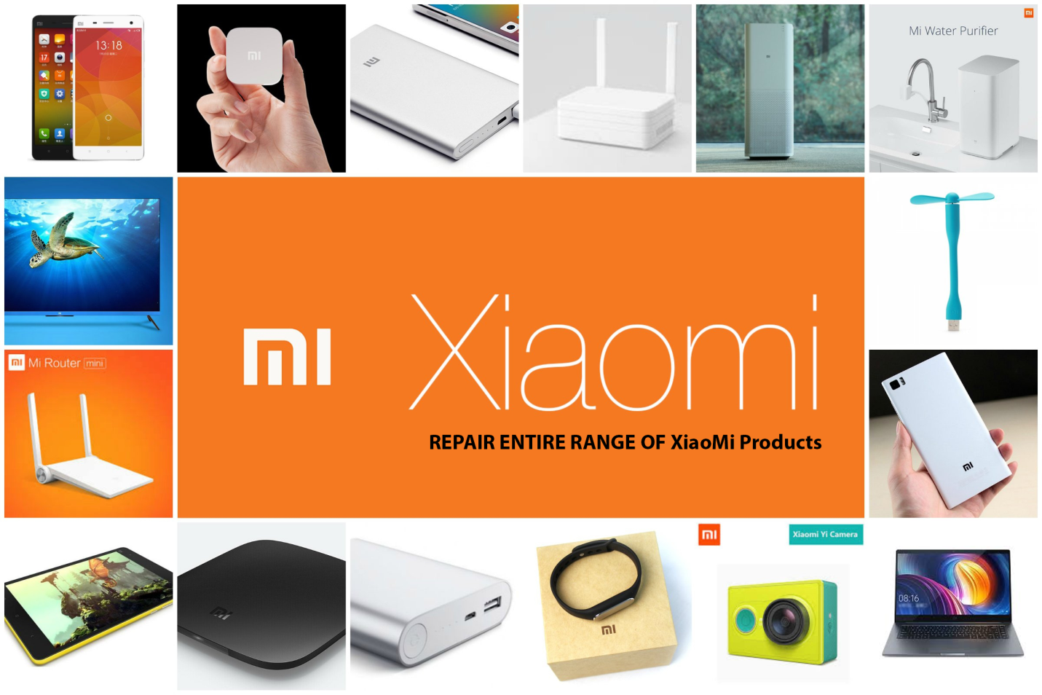
https://www.google.com/search?q=products+and+services+of+xiaomi&source=lnms&tbm=isch&sa=X&ved=2ahUKEwim2eykoPvlAhXD26QKHZKZALkQ_AUoAXoECA8QAw&biw=1440&bih=789#imgrc=7OfAotDXFO3pfM:

Appendix 2 Trend of share price

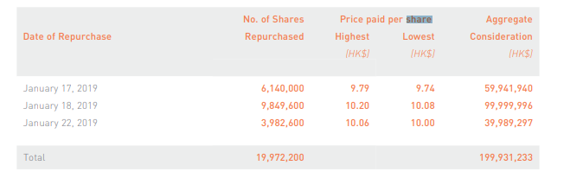
https://i01.appmifile.com/webfile/globalweb/company/ir/announcement_us/2018_ANNUAL_REPORT.pdf

Appendix 3 Revenue Growth rate

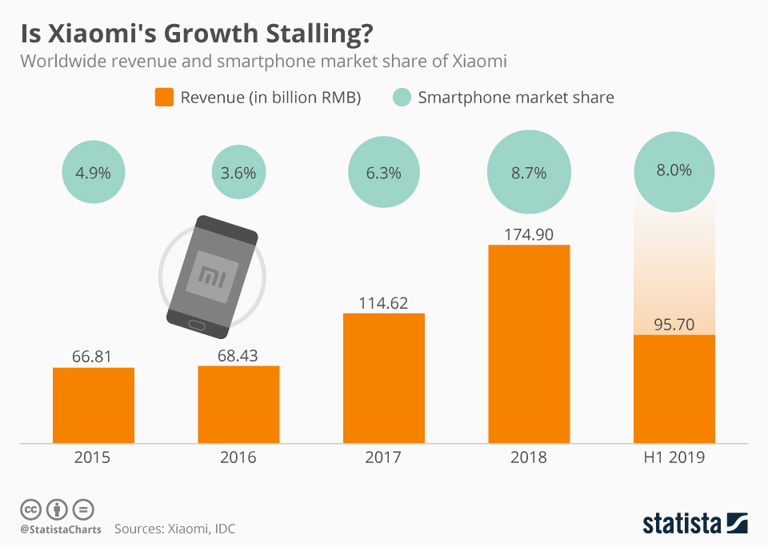
https://www.google.com/search?q=xiaomi++Revenue+Growth+Rate&source=lnms&tbm=isch&sa=X&ved=2ahUKEwj4nI_WofvlAhVHyoUKHbgiAT4Q_AUoAXoECA4QAw&biw=1440&bih=740#imgrc=MJi8QT5_8A1DqM:

Appendix 4 Global Merchants Growth

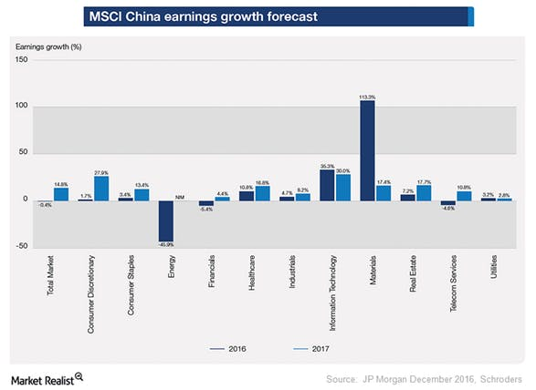
https://www.google.com/search?biw=1440&bih=740&tbm=isch&sa=1&ei=Zn3WXYatCsOIacuXoKgI&q=xiaomi+++Global+Merchants+Growth&oq=xiaomi+++Global+Merchants+Growth&gs_l=img.12...64922.64922..65911...0.0..0.204.204.2-1......0....2j1..gws-wiz-img.h6l_c0dX0zc&ved=0ahUKEwiG-MDXofvlAhVDRBoKHcsLCIUQ4dUDCAc#imgrc=aOopN0NMvUK-0M:

Mi Global Home". 2019. Mi.Com. Accessed November 21, 2019. https://www.mi.com/global/about.
Mi Global Home". 2019. Mi.Com. Accessed November 21, 2019. https://www.mi.com/global/about.
Mi Global Home". 2019. Mi.Com. Accessed November 21 2019. https://www.mi.com/global/about.
Xiaomi Global official Website丨mi.Com - Mi Global Home". 2019. Mi. Com
Xiaomi Global official Website丨mi. Com - Mi Global Home". 2019. Mi. Com
Mi Global Home". 2019. Mi.Com. Accessed November 21 2019. https://www.mi.com/global/about.
Xiaomi Global official Website丨mi. Com - Mi Global Home". 2019. Mi. Com
Li, Mingle, Suling Jia, and Wenyu Derek Du. "Fans as a source of extended innovation capabilities: A case study of Xiaomi technology." International Journal of Information Management 44 (2019): 204-208.
Li, Mingle, Suling Jia, and Wenyu Derek Du. "Fans as a source of extended innovation capabilities: A case study of Xiaomi technology." International Journal of Information Management 44 (2019): 204-208.
Li, Mingle, Suling Jia, and Wenyu Derek Du. "Fans as a source of extended innovation capabilities: A case study of xiaomi technology." International Journal of Information Management 44 (2019): 204-208.
Li, Mingle, Suling Jia, and Wenyu Derek Du. "Fans as a source of extended innovation capabilities: A case study of xiaomi technology." International Journal of Information Management 44 (2019): 204-208.
Li, Mingle, Suling Jia, and Wenyu Derek Du. "Fans as a source of extended innovation capabilities: A case study of xiaomi technology." International Journal of Information Management 44 (2019): 204-208.
Li, Mingle, Suling Jia, and Wenyu Derek Du. "Fans as a source of extended innovation capabilities: A case study of xiaomi technology." International Journal of Information Management 44 (2019): 204-208.
Li, Mingle, Suling Jia, and Wenyu Derek Du. "Fans as a source of extended innovation capabilities: A case study of xiaomi technology." International Journal of Information Management 44 (2019): 204-208.
Li, Mingle, Suling Jia, and Wenyu Derek Du. "Fans as a source of extended innovation capabilities: A case study of xiaomi technology." International Journal of Information Management 44 (2019): 204-208.
Li, Mingle, Suling Jia, and Wenyu Derek Du. "Fans as a source of extended innovation capabilities: A case study of xiaomi technology." International Journal of Information Management 44 (2019): 204-208.
Shujie, Yuan. "Driving Factors for Successful Brand Extensions in Chinese Market: The Case of Chinese Brand Xiaomi Tech." (2017).
Shujie, Yuan. "Driving Factors for Successful Brand Extensions in Chinese Market: The Case of Chinese Brand Xiaomi Tech." (2017).
Li, Mingle, Suling Jia, and Wenyu Derek Du. "Fans as a source of extended innovation capabilities: A case study of xiaomi technology." International Journal of Information Management 44 (2019): 204-208.
Saha, Sudipta. "An Analysis of the Marketing Activities of Xiaomi Mobile." (2019).
Saha, Sudipta. "An Analysis of the Marketing Activities of Xiaomi Mobile." (2019).
Shujie, Yuan. "Driving Factors for Successful Brand Extensions in Chinese Market: The Case of Chinese Brand Xiaomi Tech." (2017).
Saha, Sudipta. "An Analysis of the Marketing Activities of Xiaomi Mobile." (2019).
Saha, Sudipta. "An Analysis of the Marketing Activities of Xiaomi Mobile." (2019).
Shujie, Yuan. "Driving Factors for Successful Brand Extensions in Chinese Market: The Case of Chinese Brand Xiaomi Tech." (2017).
Saha, Sudipta. "An Analysis of the Marketing Activities of Xiaomi Mobile." (2019).
Putra, Vio Bangkit Hani, Andi Tri Haryono, and Azis Fathoni. "ANALYSIS THE FACTORS INFLUENCING PURCHASE DECISION OF PRODUCT OF SMARTPHONE XIAOMI AND OPPO WITH THE TOP OF MIND AS INTERVENING VARIABLE (Case Study on Smartphone User Community Xiaomi and OPPO in Semarang)." Journal of Management 4, no. 4 (2018).
Putra, Vio Bangkit Hani, Andi Tri Haryono, and Azis Fathoni. "ANALYSIS THE FACTORS INFLUENCING PURCHASE DECISION OF PRODUCT OF SMARTPHONE XIAOMI AND OPPO WITH THE TOP OF MIND AS INTERVENING VARIABLE (Case Study on Smartphone User Community Xiaomi and OPPO in Semarang)." Journal of Management 4, no. 4 (2018).
Putra, Vio Bangkit Hani, Andi Tri Haryono, and Azis Fathoni. "ANALYSIS THE FACTORS INFLUENCING PURCHASE DECISION OF PRODUCT OF SMARTPHONE XIAOMI AND OPPO WITH THE TOP OF MIND AS INTERVENING VARIABLE (Case Study on Smartphone User Community Xiaomi and OPPO in Semarang)." Journal of Management 4, no. 4 (2018).
Putra, Vio Bangkit Hani, Andi Tri Haryono, and Azis Fathoni. "ANALYSIS THE FACTORS INFLUENCING PURCHASE DECISION OF PRODUCT OF SMARTPHONE XIAOMI AND OPPO WITH THE TOP OF MIND AS INTERVENING VARIABLE (Case Study on Smartphone User Community Xiaomi and OPPO in Semarang)." Journal of Management 4, no. 4 (2018).

